

|  |  |
| --- | --- |

| **FPT UNIVERSITY** |
| --- |
| **Requirement & Design Specification** |
| Pickleball System Court Management |

| **SWP391_G9** | |
| --- | --- |
| **Group Members** | Le Ba Hai Ha - Leader - HE1766  Le Ba Ha - Member - HE1766  Nguyen Van Ruan - Member - HE1603  Tran Quoc Viet - Member - HE1611  Nguyen Tuan Dung - Member - HE1409 |
|  |  |

– Hanoi, April 2025 –

**Table of Contents**

Acknowledgement 4

Definition and Acronyms 4

I. Project Introduction 6

1. Overview 6

III. Software Requirement Specification 7

1. Requirement Overview 7

2. Functional Specifications 37

4. Non-Functional Requirements 91

5. Requirement Appendix 94

IV. Software Design Description 95

1. System Design 95

2. Database Design 102

3. Detailed Design 113

# Acknowledgement

First and foremost, we would like to express our deepest gratitude to our supervisor, Mr. Nguyen Quang Hung, for his invaluable guidance, dedicated support, and constant encouragement throughout the development of this Capstone Project. His expertise and constructive feedback greatly contributed to the successful completion of the Pickleball Court Management System.

We would also like to thank the FPT University, our instructors, and the Capstone Project Committee for providing us with the opportunity and the framework to apply our knowledge in a practical and challenging environment.

Special thanks go to all our team members for their hard work, commitment, and teamwork during the past months. Each member has contributed significantly to every phase of the project, from planning, designing, developing to testing.

Finally, we extend our appreciation to our families and friends for their continuous support and understanding, which motivated us to overcome the challenges encountered during this project journey.

Hanoi, April 2025  
**Group SWP391_G9**

# Definition and Acronyms

| **Acronym** | **Definition** |
| --- | --- |
| PWM | Psychology website |
| AWS | Amazon Web Services |
| BA | Business Analysis |
| BR | Business Rule |
| ERD | Entity Relationship Diagram |
| GUI | Graphical User Interface |
| PM | Project Manager |
| SDD | Software Design Description |
| SPMP | Software Project Management Plan |
| SRS | Software Requirement Specification |
| UAT | User Acceptance Test |
| UC | Use Case |
| API | Application Program Interface |

# I. Project Introduction

## 1. Overview

### 1.1 Project Information

* Project name: **Pickleball Court Management System**
* Project code: **PBS**
* Vietnamese name: **Hệ thống quản lý sân Pickleball**
* Group name: **SWP391_G9**
* Software type: **Web application, Mobile application**

### 1.2 Project Team

| **Full Name** | **Role** | **Email** | **Mobile** |
| --- | --- | --- | --- |
| Nguyen Quang Hung | Supervisor | hungnq40@fe.edu.vn | 0919684368 |
| Le Ba Hai Ha | Leader | halbhhe176636@fpt.edu.vn | 0352565658 |
| Le Ba Ha | Member | halbhe176637@fpt.edu.vn | 0332526273 |
| Nguyen Van Ruan | Member | ruannvhe160301@fpt.edu.vn | 0981604658 |
| Nguyen Quoc Viet | Member | viettqhe161146@fpt.edu.vn | 0867990063 |
| Nguyen Tuan Dung | Member | dungnthe140967@fpt.edu.vn | 0984405148 |

3.2 Pickleball Court Management System

**Description:** Pickleball Booker is an online pickleball court reservation software designed to help facilities manage their courts efficiently. It offers a clean and simple interface with powerful calendar scheduling features, enabling facilities to handle all online appointment bookings effectively. ​Pickleball Booker

**System Actors:**

* **Facility Administrators:** Manage booking schedules, set up pricing and booking rules, and track facility performance and revenue.​
* **Players:** Use the system to view availability and book courts online easily, and manage their bookings.​

**Key Features:**

* **Online Court Booking Management:** Provides an intuitive interface for players to view availability and book courts anytime, anywhere.​
* **Schedule Management:** Allows administrators to easily manage the operating schedule of courts and maximize utilization.​
* **Flexible Pricing:** Supports setting up pricing based on various rules (e.g., by time, day of the week) to optimize revenue.​
* **Integrated Payments:** Enables the integration of online payment methods, facilitating the collection of court booking fees.​
* **Workflow Automation:** Supports the creation of custom booking rules, booking quotas, integrations with other systems, and setting up recurring bookings to minimize manual work.​

**Benefits:**

* **For Facility Administrators:** Simplifies the management of bookings and schedules, optimizes revenue through flexible pricing, and reduces manual tasks through automation.​
* **For Players:** Easily find and book courts that fit their schedule anytime, anywhere, providing a convenient booking experience.​

# III. Software Requirement Specification

## 1. Requirement Overview

### 1.1 Context Diagram

The **Pickleball Court Management System** is a digital platform designed to facilitate court reservations and equipment rentals. It connects users, guests, owners, staff, and managers to ensure a seamless booking experience and efficient court operations.

The system's main features include real-time court booking, dynamic pricing management, intelligent scheduling suggestions, and automated notifications via the system and email. Users can book courts, rent equipment, and receive booking updates directly through the platform or email notifications.

Owners and staff manage court bookings, monitor user memberships, configure court availability, and handle maintenance schedules. The platform supports integrated payment processing, automatic deposit handling, and streamlined refund management to improve transaction transparency.

By leveraging automation and structured workflows, the system aims to optimize court utilization, enhance user convenience, and provide a complete pickleball playing and management experience without relying on SMS-based communication.

The context diagram below illustrates the system architecture for version 1.0.  
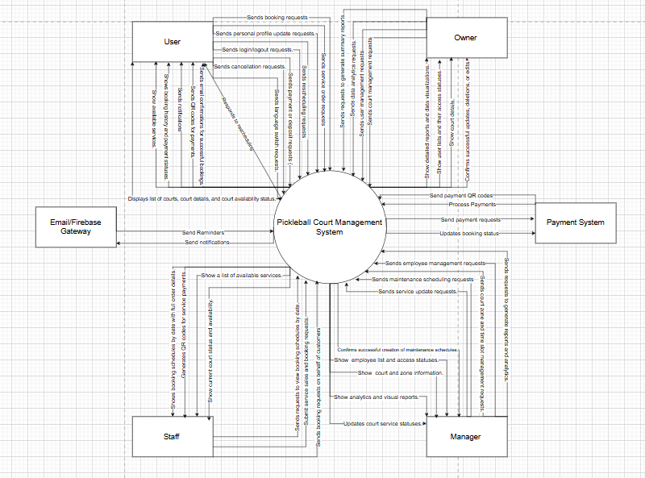

***Figure 4.1****: Context Diagram*

### 1.2 User Requirements

#### 1.2.1 Actors

**Actors:** Guest, User, Owner, Manager, Notification System, Payment System, Staff

| **#** | **Actor** | **Description** |
| --- | --- | --- |
| 1 | User | A registered and logged-in individual who can fully interact with the system. Users can book courts and services, manage personal profiles, track their order history, and make payments. |
| 2 | Guest | A visitor who has not logged in or registered. Guests can browse available courts and services, view details, and make bookings. However, some features are limited until they register or log in. |
| 3 | Owner | The system Owner with full access to all features. Owners manage the entire platform, user permissions, and ensure system integrity. |
| 4 | Staff | An internal team member responsible for assisting customer bookings, handling payments, and monitoring court availability. Staff also support service sales and perform real-time scheduling. |
| 5 | Manager | A management-level user who oversees staff, operations, and service performance. The manager handles facility configurations, reporting, and maintenance scheduling. |
| 6 | Payment System | The module responsible for generating QR codes linked to each booking or service order. It facilitates user payments by providing secure QR codes but does not directly process or hold funds. Once a user completes payment via external banking apps (e.g., MB Bank,TP Bank, Viettel Money, ...), the Payment System verifies the transaction status, updates the associated order in the system, and triggers confirmation notifications. |
| 7 | Notification System | The module responsible for sending real-time notifications to users, guests, staff, managers, and owners. Notifications are triggered by key events such as booking confirmations, payment completions, cancellations, maintenance updates, and promotional messages. Notifications are delivered via in-app alerts, emails, depending on the user’s configured preferences. |

***Table 4.1****: Actors*

#### 1.2.2 Use Cases (UC)

| **ID** | **Use Case** | **Feature** | **Use Case Description** |
| --- | --- | --- | --- |
| 01 | Register New User | Common | Allows new users to create an account. |
| 02 | Register Student Account | Common | Students can register an account by providing required information (e.g, email(@edu.vn). The system verifies their student status before account creation is completed. |
| 03 | Login | Common | This use case allows users to log in and access the system. The system will authenticate and authorize the user. |
| 04 | Logout | Common | This use case allows users to securely terminate their current session and log out of the system. |
| 05 | Forgot Password | Common | This use case allows a user who has forgotten their password to reset their password. The system generates a new random string of 8 characters (e.g. uppercase, numeric). The new password is sent to the user's registered email address and the user must use the new password to log in. |
| 06 | Update User Profiles | User Management | This use case allows users to update personal information (e.g, image, birthday, first name, last name) |
| 07 | Update Role User by Owner | Role Management | Owner updates the user's role(Manager, Staff, User, Student ) |
| 08 | Update Role User by Manager | Role Management | Manager updates the user's role (Staff, User, Student ) |
| 09 | Create Role | Role Management | Owner creates the user's role. |
| 10 | Delete Role | Role Management | Owner deleted the user's role. |
| 11 | View Role | Role Management | Owner views the user's role. |
| 12 | View List of Users | User Account Management | Displays all registered users with filtering options. |
| 13 | Create New User by Owner | User Account Management | Allows the Owner to create a new user account, assign a role (Manager, Staff, User, Student), and set the account status (active/inactive). |
| 14 | Create New User by Manager | User Account Management | Allows the Manager to create a new user account, assign a role( Staff, User, Student), and set the account status (active/inactive). |
| 15 | Deactivate User | User Account Management | Allows Owner/Manager to deactivate accounts. |
| 16 | Activate User | User Account Management | Allows Owner/Manager to deactivate accounts. |
| 17 | Booking Service On Mobile | Booking Management | This use case allows User or Guest book service on mobile apps (e.g., drink, snack,...) from the list of available services. |
| 18 | Change Booking | Booking Management | Users can modify their booking date/time or court once (within allowed time frame). |
| 19 | Cancel Booking | Booking Management | Users can cancel bookings, which may result in deposit loss. |
| 20 | View Booking Personal | Booking Management | This use case allows a User to view their complete order history, including court bookings and service purchases. Orders are listed chronologically with key details like order type, amount, status, and timestamps. The user can filter by date, status, or type, and click each entry for detailed viewing. |
| 21 | View Booking Detail Personal | Booking Management | Shows detailed information about a specific order. |
| 22 | Confirm Booking | Booking Management | Allows confirmation of purchase orders before processing. |
| 23 | Deposit Booking | Booking Management | Users deposit to reserve a spot, the system generates a QR code for deposit. |
| 24 | Payment Booking | Booking Management | Users deposit to reserve a spot, the system generates a QR code for payment. |
| 25 | Refund on cancellation | Booking Management | Refund system (minus deposit) when canceling booking |
| 26 | Refund for rescheduling | Booking Management | Refund system for difference (deposit) when changing booking. |
| 27 | Refund without check in | Booking Management | Refund system (minus deposit) if the user does not check-in. |
| 28 | Book Court Daily | Booking Management | Users book courts daily, multiple time slots and days. |
| 29 | Book Court Regular | Booking Management | Users book courses on a recurring basis for multiple days. |
| 30 | Book Court Optimal | Booking Management | The system suggests alternative venues if schedules overlap. |
| 31 | Hold Court While Booking | Booking Management | The system temporarily remains in the same state while the user completes the payment. |
| 32 | View Booking History User by Owner | Booking Management | This use case allows the Owner to view the entire booking history of a user, for example, within a specific time period, by venue, by day, by month, etc. This information helps the owner track the customer's booking behavior and provide better services. |
| 33 | View Booking History User by Manager | Booking Management | This use case allows allowed to view the entire booking history of a user, for example, within a specific time period, by venue, by day, by month, etc. This information helps the owner track the customer's booking behavior and provide better services under the Owner's authority |
| 34 | View Reservation | Booking Management | Users can select time slots by selecting the date. |
| 35 | View Schedule occupancy analysis by Owner | Court Management | Owner views all court usage analysis over time. |
| 36 | View Schedule occupancy analysis by Manager | Court Management | Manager views all court usage analysis over time under the Owner's authority |
| 37 | View Peak hours analysis by Owner | Court Management | Owner views peak hour analysis of all courts. |
| 38 | View Peak hours analysis by Manager | Court Management | Owner views peak hour analysis all courts under the Owner's authority |
| 39 | Create Court | Court Management | Owner adds a new court with details like name, type, location. |
| 40 | Update Court | Court Management | Owner updates existing course information. |
| 41 | Active Court | Court Management | This use case allows Owners to activate a court that was previously set as inactive, making it visible and available for booking by users. This is commonly used after court maintenance or administrative review. |
| 42 | Deactivate Court | Court Management | This use case allows the Owner to deactivate a court, making it unavailable for user bookings. This action is typically taken when the court is under maintenance, unavailable due to events, or retired from regular use. Deactivated courts are not visible to users but remain in the system for editing or future reactivation. |
| 43 | Create Court Slot by Owner | Court Management | This use case allows the Owner to define available time slots for each court, including start/end times, duration, and availability rules (e.g., day of week, custom pricing). Once created, these time slots appear in the booking calendar for users. |
| 44 | Create Court Slot by Manager | Court Management | This use case allows the Manager to define available time slots for each court, including start/end times, duration, and availability rules (e.g., day of week, custom pricing). Once created, these time slots appear in the booking calendar for users under the Owner's authority |
| 45 | Update Court Slot by Owner | Court Management | This use case allows **Owners** to update information related to a specific court slot, including its start time, end time, price, availability status, or applicable days. Updates are reflected immediately and can affect upcoming booking availability. |
| 46 | Update Court Slot by Manager | Court Management | This use case allows **Managers** to update information related to a specific court slot, including its start time, end time, price, availability status, or applicable days. Updates are reflected immediately and can affect upcoming booking availability under the Owner's authority |
| 47 | Active Sub-Court by Owner | Court Management | This use case allows the **Owner** to activate an existing sub-court that was previously set as **inactive**. Once activated, the sub-court becomes available for booking and is visible to users in the booking interface. |
| 48 | Active Sub-Court by Manager | Court Management | This use case allows the **Manager** to activate an existing sub-court that was previously set as **inactive**. Once activated, the sub-court becomes available for booking and is visible to users in the booking interface under the Owner's authority |
| 49 | Deactivate Sub-Court by Owner | Court Management | This use case allows Owners to deactivate a specific sub-court, making it unavailable for booking. This can be done due to maintenance, low demand, or scheduling changes. |
| 50 | Deactivate Sub-Court by Manager | Court Management | This use case allows Managers to deactivate a specific sub-court, making it unavailable for booking. This can be done due to maintenance, low demand, or scheduling changes under the Owner's authority |
| 51 | Create Maintenance by Owner | Court Management | This use case allows **Owners** to schedule maintenance periods for specific courts or court areas. During the maintenance window, the court will be **unavailable for booking**. The maintenance record includes a description, duration, and affected court(s), and ensures proper scheduling and communication to users and staff. |
| 52 | Create Maintenance by Manager | Court Management | This use case allows **Managers** to schedule maintenance periods for specific courts or court areas. During the maintenance window, the court will be **unavailable for booking**. The maintenance record includes a description, duration, and affected court(s), and ensures proper scheduling and communication to users and staff under the Owner's authority |
| 53 | Update Maintenance by Owner | Court Management | This use case enables Owners to modify an existing maintenance record for a court, including changes to time, description, or affected court area. Updating maintenance ensures accuracy and allows for changes due to scheduling conflicts or work delays. |
| 54 | Update Maintenance by Manager | Court Management | This use case enables Managers to modify an existing maintenance record for a court, including changes to time, description, or affected court area. Updating maintenance ensures accuracy and allows for changes due to scheduling conflicts or work delays under the Owner's authority |
| 55 | View Maintenance by Owner | Court Management | This use case allows Owners to view a list of all scheduled and completed maintenance records for courts or court areas. Maintenance entries include time period, status, description, and affected courts. This supports operational visibility and planning. |
| 56 | View Maintenance by Manager | Court Management | This use case allows Managers to view a list of all scheduled and completed maintenance records for courts or court areas. Maintenance entries include time period, status, description, and affected courts. This supports operational visibility and planning under the Owner's authority |
| 57 | Create Court Image by Owner | Court Management | This use case allows Owners to upload and assign one or more images to a specific court. These images will be displayed on the booking interface, giving users a visual preview of the court (e.g., surface, lighting, surroundings). |
| 58 | Create Court Image by Manager | Court Management | This use case allows Managers to upload and assign one or more images to a specific court. These images will be displayed on the booking interface, giving users a visual preview of the court (e.g., surface, lighting, surroundings) under the Owner's authority |
| 59 | Delete Court Image by Owner | Court Management | This use case enables Owners to delete one or more images associated with a specific court. Removing outdated or irrelevant images ensures the court’s visual representation is accurate and up to date for users browsing or booking courts. |
| 60 | Delete Court Image by Manager | Court Management | This use case enables Managers to delete one or more images associated with a specific court. Removing outdated or irrelevant images ensures the court’s visual representation is accurate and up to date for users browsing or booking courts under the Owner's authority |
| 61 | View Court Image by Owner | Court Management | This use case enables Owners to delete one or more images associated with a specific court. Removing outdated or irrelevant images ensures the court’s visual representation is accurate and up to date for users browsing or booking courts. |
| 62 | View Court Image  by Manager | Court Management | This use case enables Managers to delete one or more images associated with a specific court. Removing outdated or irrelevant images ensures the court’s visual representation is accurate and up to date for users browsing or booking courts under the Owner's authority |
| 63 | View Court Details | Court Management | Users can see court details, service, position on map, images, and pricing by time slot |
| 64 | View Court | Court Management | This use case allows **Users** and **Guests** to view available courts for booking, along with relevant details such as court type, location, available time slots, price, and court images. **Owners** and **Managers** can view all courts with additional management details, including maintenance status and booking statistics. |
| 65 | View Court Slot | Court Management | This use case allows **Users/Guests** to view available **court time slots** for booking. Time slots show detailed scheduling, availability, and pricing information. |
| 66 | View Court Slot by Owner | Court Management | This use case allows **Owners** to view the full list of time slots associated with each court, including inactive, booked, or under maintenance slots. Time slots show detailed scheduling, availability, and pricing information. |
| 67 | View Court Slot by Manager | Court Management | This use case allows **Managers** to view the full list of time slots associated with each court, including inactive, booked, or under maintenance slots. Time slots show detailed scheduling, availability, and pricing information. |
| 68 | Create Service by Owner | Service Management | This use case enables **Owners** to create new services that will be available for users to purchase. Services can include food and drinks, pickleball racket rental, or coaching sessions. Each service includes a name, description, price, status, and optional images or categories. |
| 69 | Create Service by Manager | Service Management | This use case enables **Managers** to create new services that will be available for users to purchase. Services can include food and drinks, pickleball racket rental, or coaching sessions. Each service includes a name, description, price, status, and optional images or categories under the Owner's authority |
| 70 | Active Status Service by Owner | Service Management | This use case allows Owners to change the status of a service (e.g., water, rental, coaching) that is no longer needed or available. Changing the status will hide the service from both the user interface and the administrative dashboard. If the service is linked to past orders, the system may archive it or mark it as inactive instead of removing it permanently. |
| 71 | Active Status Service by Manager | Service Management | This use case allows Managers to change the status of a service (e.g., water, rental, coaching) that is no longer needed or available. Changing the status will hide the service from both the user interface and the administrative dashboard. If the service is linked to past orders, the system may archive it or mark it as inactive instead of removing it permanently under the Owner's authority |
| 72 | Deactive Status Service by Owner | Service Management | This use case allows Owners to deactivate a service (e.g., water, rental, coaching) that is no longer needed or available. Deactivating the service will hide it from both the user interface and the administrative dashboard. If the service is linked to past orders, the system may archive it or mark it as inactive instead of removing it permanently. |
| 73 | Deactive Status Service by Manager | Service Management | This use case allows Managers to deactivate a service (e.g., water, rental, coaching) that is no longer needed or available. Deactivating the service will hide it from both the user interface and the administrative dashboard. If the service is linked to past orders, the system may archive it or mark it as inactive instead of removing it permanently under the Owner's authority |
| 74 | Update Service by Owner | Service Management | This use case allows the **Owner** to edit details of an existing service (e.g., equipment rental, snacks, water). Updates can include changes to the name, price, description, availability status, category, or associated image. |
| 75 | Update Service by Manager | Service Management | This use case allows the **Manager** to edit details of an existing service (e.g., equipment rental, snacks, water). Updates can include changes to the name, price, description, availability status, category, or associated image under the Owner's authority |
| 76 | View Service | Service Management | This use case enables **Users** and **Guests** to view available services such as drinks, snacks, rentals, |
| 77 | View List of Service by Owner | Service Management | Displays a list of all available services |
| 78 | View List of Service by Manager | Service Management | Displays a list of all available services under the Owner's authority |
| 79 | View List Order for Staff | Staff Management | This use case allows Staff to view a complete list of court and service orders created by users, including booking details, order status, payment status, and time. Staff can use this list to manage on-site service preparation, verify arrivals, and prepare resources for each time slot. |
| 80 | Perform Check-In | Staff Management | This use case allows Staff to mark a booking or service order as "Checked-in" when the user arrives at the facility. This helps ensure proper scheduling, prepare the court, and confirm attendance for reporting and billing purposes. |
| 81 | Create Booking for Customer | Staff Management | This use case enables **Staff** to manually create a court booking on behalf of a **Customer**. This is useful when the customer books directly at the facility, via phone call, or doesn’t have access to the website or app. Staff can select courts, time slots, and input basic customer details. |
| 82 | View Staff Dashboard | Staff Management | This use case allows **Staff** to access the centralized dashboard after logging in. The dashboard provides a summary of daily bookings, service orders, check-in status, upcoming schedules, and quick actions such as creating bookings or processing payments. |
| 83 | Generate QR for Payment | Payment Management | This use case allows Users or Guests to generate a QR code linked to their booking or service order. The QR code contains transaction details and can be scanned using supported banking or e-wallet apps to complete payment or deposit. |
| 84 | Online Payment Processing | Payment Management | Allows users to complete transactions via MB Bank integration. |
| 85 | Receive Notifications | Notification Management | Users receive notifications via email (booking, password reset) and app/web (order status). |
| 86 | View All Transaction History by Owner | Financial Management | This use case allows Owners to access and review the full list of all payment transactions that occurred in the system, including those related to court bookings, service purchases, deposits, and refunds. Transactions include payment method, status, amount, and are filterable for financial reporting and auditing |
| 87 | View All Transaction History by Manager | Financial Management | This use case allows Managers to access and review the full list of all payment transactions that occurred in the system, including those related to court bookings, service purchases, deposits, and refunds. Transactions include payment method, status, amount, and are filterable for financial reporting and auditing under the Owner's authority |
| 88 | View Revenue Report by Owner | Financial Management | This use case enables Owners to access a visual and/or tabular summary of total revenue generated from court bookings, service purchases, and other transactions within a selected time frame. The revenue report helps monitor business performance, identify trends, and support financial decision-making. |
| 89 | View Revenue Report by Manager | Financial Management | This use case enables Managers to access a visual and/or tabular summary of total revenue generated from court bookings, service purchases, and other transactions within a selected time frame. The revenue report helps monitor business performance, identify trends, and support financial decision-making under the Owner's authority |
| 90 | Export Revenue Report by Owner | Financial Management | This use case allows Owners to export the full list of registered users into an Excel file (.xlsx). The export includes essential user data such as name, role, contact information, account status, and registration date. This feature is typically used for administrative review, backups, or reporting. |
| 91 | Export Revenue Report by Manager | Financial Management | This use case allows Managers to export the full list of registered users into an Excel file (.xlsx). The export includes essential user data such as name, role, contact information, account status, and registration date. This feature is typically used for administrative review, backups, or reporting under the Owner's authority |
| 92 | Export Booking Orders by Owner | Financial Management | Enables exporting booking order data to Excel. |
| 93 | Export Booking Orders by Manager | Financial Management | Enables exporting booking order data to Excel under the Owner's authority |
| 94 | Export Transaction by Owner | Financial Management | Export transaction data to Excel. |
| 95 | Export Transaction by Manager | Financial Management | Export transaction data to Excel under the Owner's authority |

***Table 4.1****: Use Cases*

#### 1.2.3 Use Case Diagrams

##### **1.2.3.1 UseCase for Pickleball Court Management System**

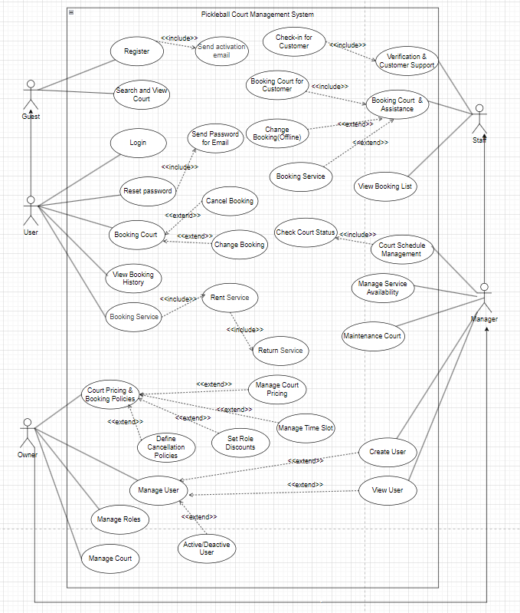

***Figure 4.2****: UseCase for Pickleball Court Management System*

##### **1.2.3.2 UseCase for Users**

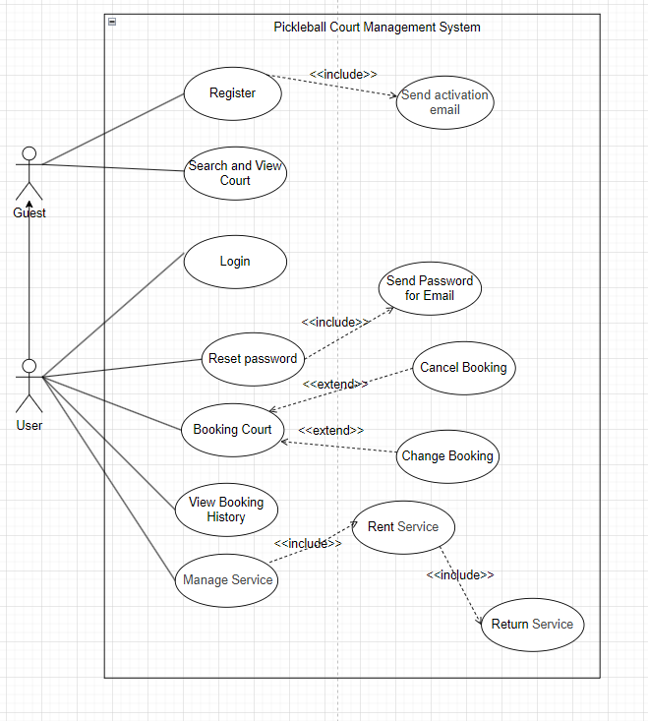

***Figure 4.3****: UseCase for Users*

##### **1.2.3.3 UseCase for Managers**

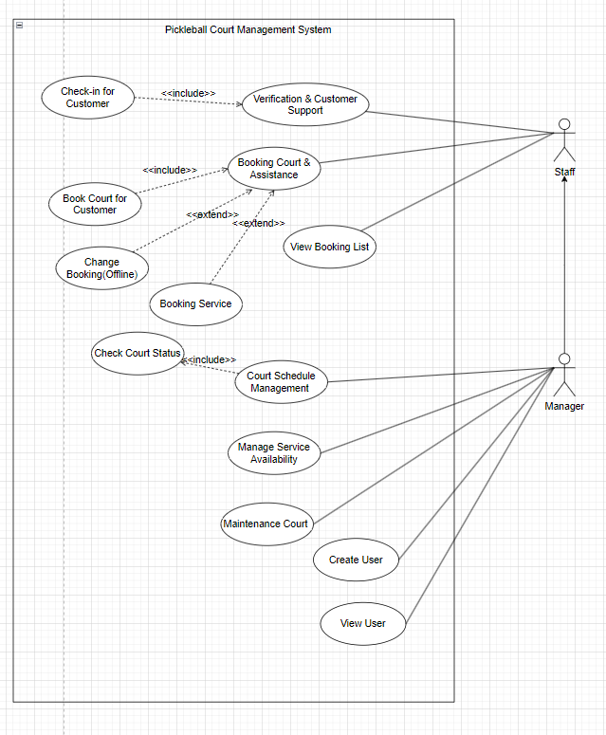

***Figure 4.4****: UseCase for Managers*

##### **1.2.3.4 UseCase for Staff**

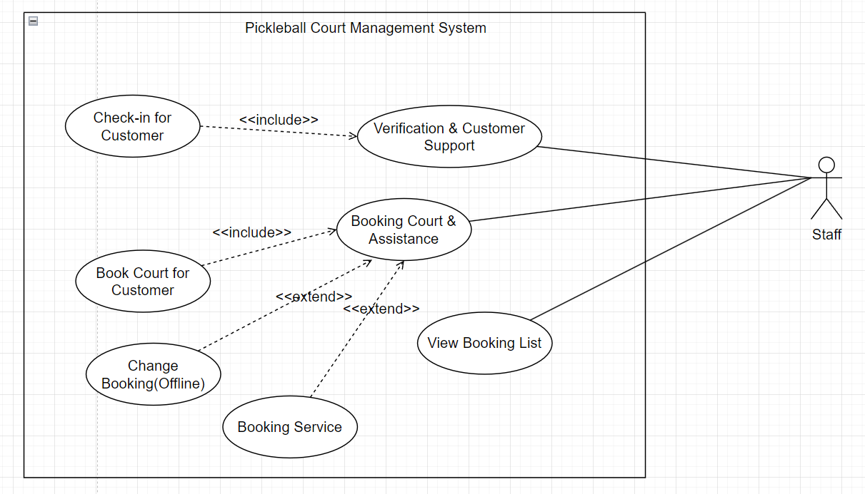

***Figure 4.5****: UseCase for Staff*

##### **1.2.3.5 UseCase for Owner**

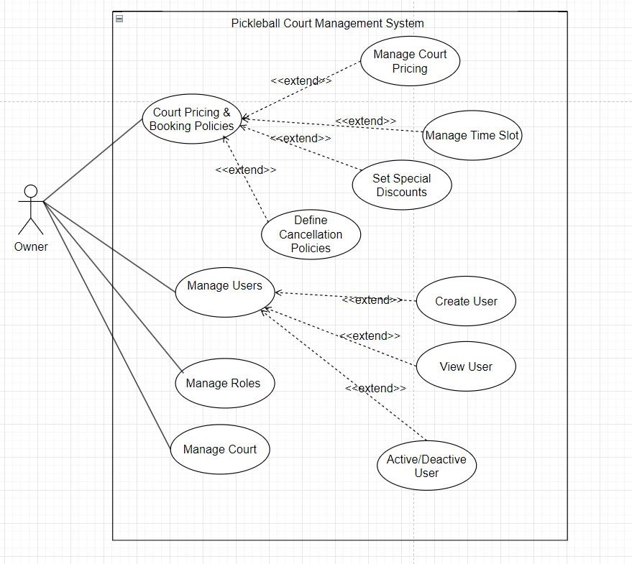

***Figure 4.6****: UseCase for Owner*

### 1.3 System Functionalities

#### 1.3.1 Screens Flow

##### **1.3.1.1 Screens Flow User**

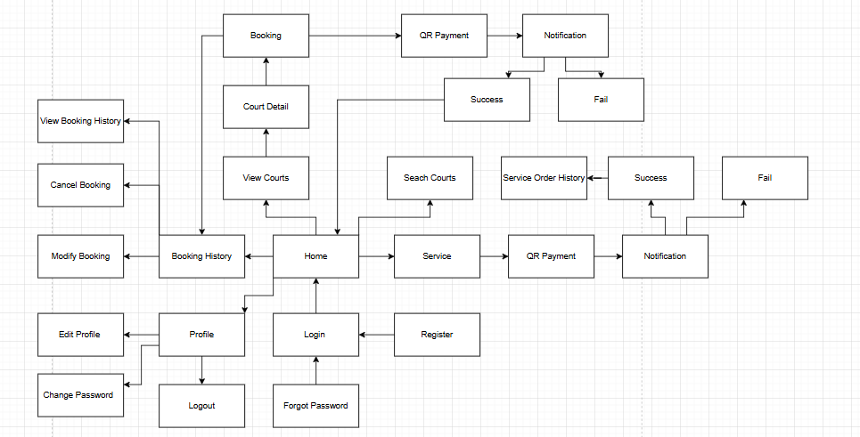

***Figure 4.7****: Screens Flow User*

##### **1.3.1.2 Screens Flow Owner**

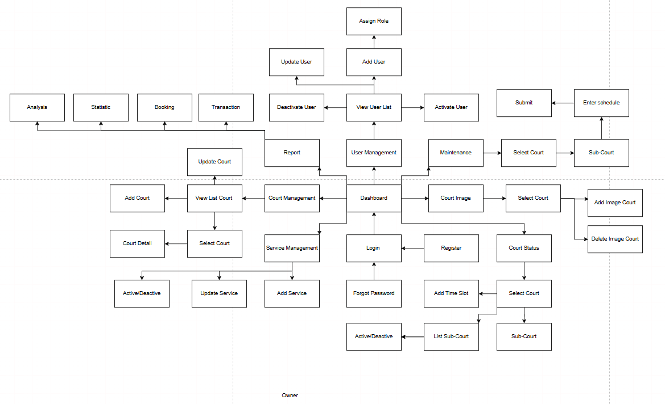

***Figure 4.8****: Screens Flow Owner*

##### **1.3.1.3 Screens Flow Manager**

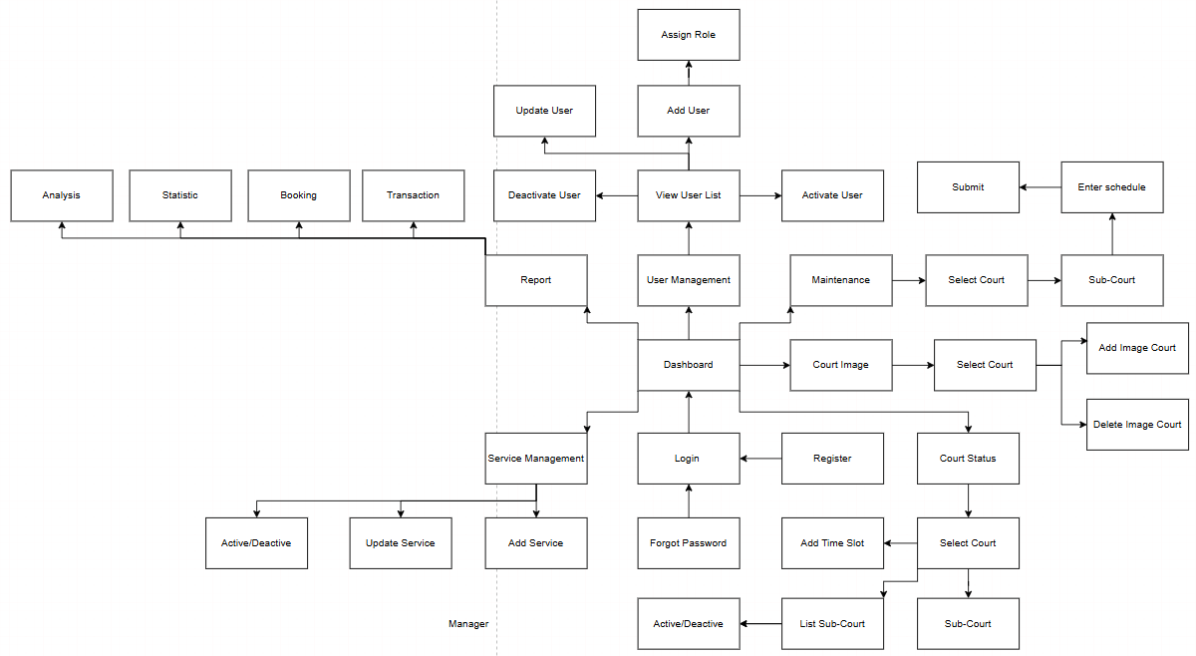

***Figure 4.9****: Screens Flow Manager*

##### **1.3.1.4 Screens Flow Staff**

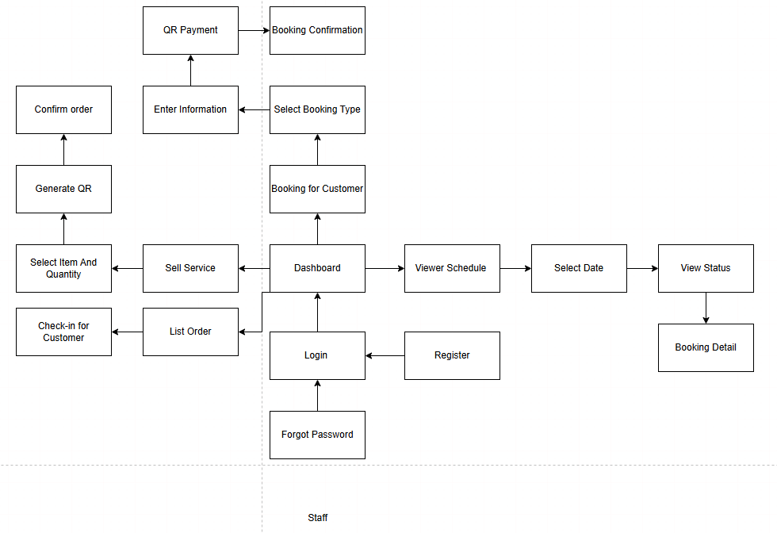

***Figure 4.9****: Screens Flow Staff*

#### 1.3.2 Screen Authorization

| **Screen** | **Owner** | **Staff** | **Manager** | **User** | **Guest** |
| --- | --- | --- | --- | --- | --- |
| Home | X | X | X | X | X |
| Login | X | X | X | X | X |
| Register |  |  |  | X | X |
| Forgot Password | X | X | X | X | X |
| Court Detail | X | X | X | X | X |
| Booking Screen |  | X |  | X | X |
| View Booking History | X |  | X |  |  |
| Change Booking |  | X |  | X | X |
| Cancel Booking | X | X | X | X | X |
| Payment (QR Generation) | X | X | X | X | X |
| Service Screen | X | X | X | X | X |
| Sell Service | X | X | X | X | X |
| Personal / Profile Screen | X | X | X | X |  |
| Edit Profile | X | X | X | X |  |
| Change Password | X | X | X | X | X |
| Language Switch | X | X | X |  |  |
| Notification Center | X | X | X | X | X |
| Report / Analytics | X |  | X |  |  |
| Court Management | X |  | X |  |  |
| Add/Edit Court | X |  | X |  |  |
| Court Zone & Time Slot Management | X |  | X |  |  |
| Add/Edit Time Slot | X |  | X |  |  |
| Service Management | X |  | X |  |  |
| Image Management (Court images) | X |  | X |  |  |
| Maintenance Scheduling | X |  | X |  |  |
| Add/Edit Role & Permissions | X |  |  |  |  |
| Staff Management |  |  |  |  |  |
| User Management | X |  | X |  |  |
| Register Student | X |  |  | X | X |

***Table 4.2****: Screen Authorization*

#### 1.3.3 Non-UI Functions

| **#** | **Feature** | **System Function** | **Description** |
| --- | --- | --- | --- |
| 1 | User Management | User Role Assignment Service | Assigns roles to users and updates their permissions accordingly. |
| 2 | Authentication | Login Service | Handles user authentication and token generation. |
| 3 | Data Processing | User Data Sync Batch | A scheduled batch job that synchronizes user data across different services. |
| 4 | Notifications | Notification Service | Sends system notifications based on user actions and scheduled events. |
| 5 | Reporting | User Activity Report API | Retrieves user activity logs for Owneristrative review. |
| 6 | Access Control | Permission Validation API | Validates user permissions before granting access to restricted areas. |

***Table 4.3****: Non-UI Functions*

### 1.3 Entity Relationship Diagram

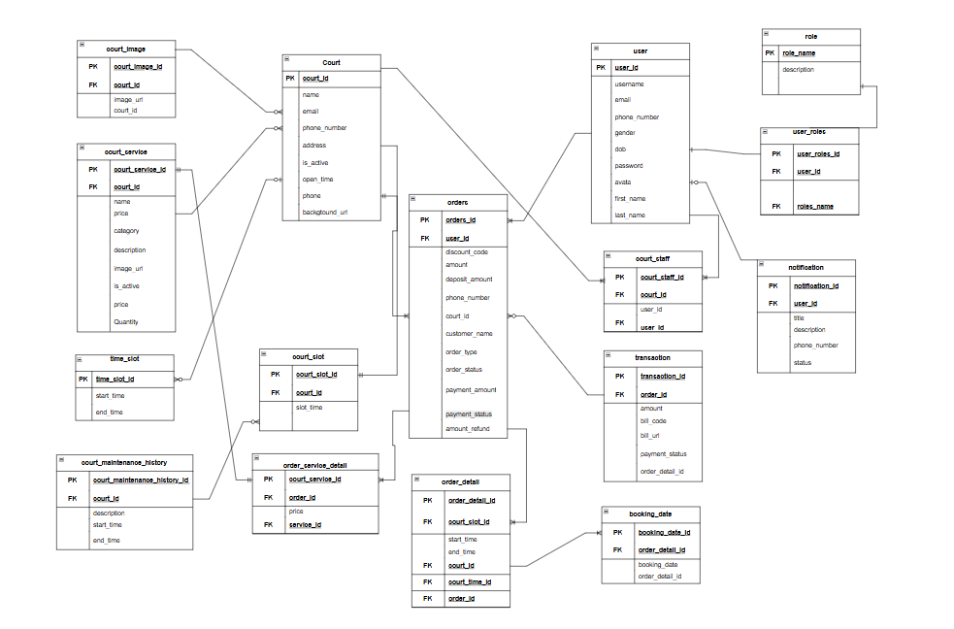

***Entities Description***

| ***#*** | ***Entity*** | ***Description*** |
| --- | --- | --- |
| *1* | *Court* | *Information about sports courts, including name, address, email, phone number, description, background image, and activity status.* |
| *2* | *Court_Service* | *Additional services provided by the court (e.g., equipment rental, beverages, coaching).* |
| *3* | *Court_Slot* | *Time slots available for court booking.* |
| *4* | *Court_Price* | *Pricing details for court bookings depending on the day (weekday, weekend) and customer type (student, adult).* |
| *5* | *Court_Image* | *Images related to each court (a court can have multiple images).* |
| *6* | *Court_Maintenance_History* | *Maintenance history of courts, recording the start time, end time, and description of the maintenance work.* |
| *7* | *Time_Slot* | *Standard defined time ranges (e.g., 7 AM - 8 AM, 8 AM - 9 AM).* |
| *8* | *User* | *Information about system users, including email, phone number, password, date of birth, gender, and avatar.* |
| *9* | *Role* | *Different user roles in the system (e.g., Admin, Staff, User, Manager).* |
| *10* | *User_Roles* | *Relationship linking users and their assigned roles (one user can have multiple roles).* |
| *11* | *Court_Staff* | *Court staff information, linking users who are employees of a specific court.* |
| *12* | *Orders* | *Court booking orders, capturing customer information, total amount, discount code, and payment method.* |
| *13* | *Order_Detail* | *Details of court booking orders: which court, which time slot, start and end times.* |
| *14* | *Order_Service_Detail* | *Additional services booked within an order (e.g., ball rental, coach rental).* |
| *15* | *Booking_Date* | *Specific booking dates associated with an order detail.* |
| *16* | *Notification* | *Notifications sent to users regarding orders, payments, or other events.* |
| *17* | *Transaction* | *Payment transaction details for an order, including amount, bill code, and payment status.* |

## 2. Functional Specifications

#### 2.1.1 Schedule Screen

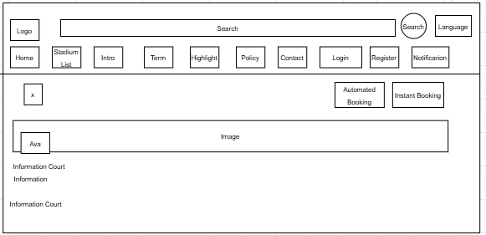

This screen allows the User to:

* View Detail Court: View Information detail court, image court, avatar court, price, service.
* Select Booking Type: choose between different booking options (Booking Daily or Booking Regular).

On the screen, s/he can also:

* Navigate Back: return to the previous screen using the Back button.
* Navigate to Key Pages: access main sections like Home, Stadium List, Introduction, Terms, Highlights, Policy, Contact, Login, Register, Notification, and Filter through the top navigation bar.
* Change Language: switch the website language by clicking the "Language" button.

**Field Description**

| **Field Name** | **Description** |
| --- | --- |
| Search | Data type: date, format (e.g., MM/DD/YYYY). Specifies the booking start date. |
| Language | Allows the user to select the language of the application (e.g., English, Vietnamese). |
| Notification | Displays notifications for the user, sourced from the database (DB). |
| Home | Navigation button to access the Home section (current screen). |
| Stadium List | Navigation button to access the list of stadiums or courts. |
| Intro | Navigation button to access the introduction section of the application. |
| Term | Navigation button to access the terms and conditions section. |
| Highlight | Navigation button to access the highlights or featured content section. |
| Pilicy | Navigation button to access the policy section. |
| Contact | Navigation button to access the contact information section. |
| Login | Navigation button to access the login page for user authentication. |
| Register | Navigation button to access the registration page for new users |
| Avatar | Displays the user's profile picture. The avatar is a static image and not interactive. |
| Information Court | Displays textual information or updates relevant to the court. |
| Image | A large area that can be used for background images or to highlight important content. |
| Automated Booking | Navigation button to initiate an automated booking process. |
| Instant Booking | Navigation button to initiate an instant booking process. |

#### 

#### 2.1.2 Schedule screen, the schedule right is the date selection button

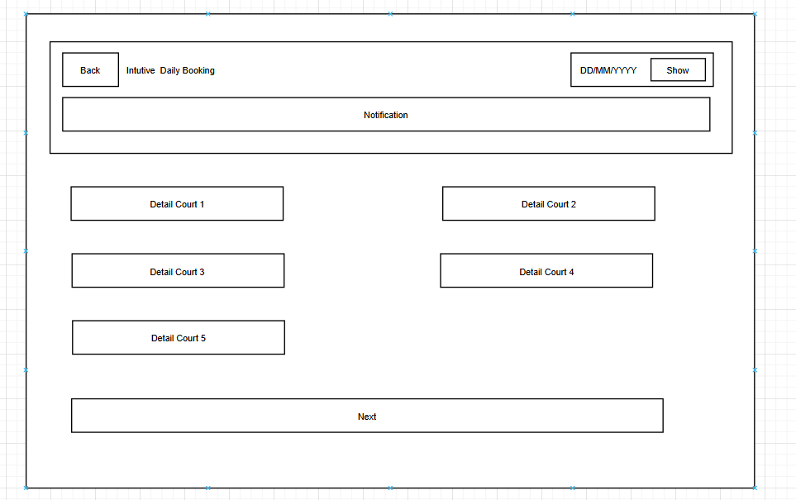

This screen allows the User to:

* View List Court: View list court.
* View Time Slot: View list timeslot and price.
* Select Court and Timeslot, Day: choose a day, court and specific time slot for booking..

On the screen, s/he can also:

* Navigate Back: return to the previous screen by clicking the Back button.
* Proceed to Next Step: move to the next step of the booking process by clicking the Next button

**Field Description**

| **Field Name** | **Description** |
| --- | --- |
| Back | Button to return to the previous screen |
| Notification | Displays notifications related to the schedule, sourced from the database (DB). |
| Date | Data type: date, format (e.g., DD/MM/YYYY). Displays the selected date for viewing the schedule. |
| Show | Button to open a calendar for selecting the date (format: DD/MM/YYYY) to view the court schedule. |
| Detail Court 1, 2 ,3,4 ,5 | Displays the schedule details for Court 1,2 ,3, 4 ,5,..., such as booking times and availability, sourced from the database (DB). |
| Next | Button to proceed to the next step, such as booking confirmation or payment. |

#### 

#### 2.1.3 Payment screen

This screen allows the User to:

* View Order Summary: view the court and booking information on the main interface.
* Enter Order Details: input personal details such as full name, phone number, and notes for the booking.
* Agree to terms: Agree to the terms of pickleball court booking.

On the screen, s/he can also:

* Navigate Back: return to the previous screen by clicking the Back button.
* • Proceed to Next Step: move to payment of the booking process by clicking the Confirm and pay button

**Field Description**

| **Field Name** | **Description** |
| --- | --- |
| Back | Button to return to the previous screen. |
| Information | Displays booking details, such as court name, date, or time, sourced from the database (DB). |
| Total | Displays the total cost of the booking, sourced from the database (DB). |
| Name | Data type: non-digit string, max length of 50 characters. Allows the user to input their name |
| Phone | Data type: string, max length of 15 characters. Allows the user to input their phone number. |
| Note | Data type: any string, max length of 200 characters. Allows the user to add additional notes for the booking. |
| Click | Button to initiate an additional action (e.g., selecting payment method or additional options). |
| Confirm and Pay | Button to confirm the booking and proceed to payment. |

#### 

#### 2.1.4 Full payment screen

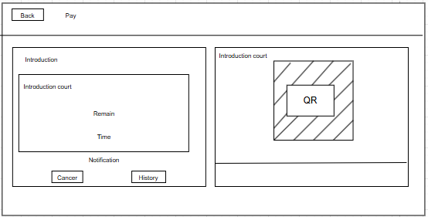

**Screen Name: QR Code Payment Screen**

This screen allows the User to:

* View Order Summary: view the court and booking information on the main interface.
* View QR Code: view the QR code for scanning on the main interface.
* Scan QR Code: use the displayed QR code to complete a booking or verification process.

On the screen, s/he can also:

* Navigate Back: return to the previous screen by clicking the Back button.
* Navigate History: Go to order history screen.
* Cancel Order: Cancel the current booking or payment process by clicking the Cancel button.

**Field Description**

| **Field Name** | **Description** |
| --- | --- |
| Back | Button to return to the previous screen. |
| Pay | Title indicating the payment process. |
| Introduction Court | Displays court information, such as name or location, sourced from the database (DB) |
| Remain Time | Displays the remaining time for completing the payment, sourced from the database (DB). |
| QR | Displays a QR code for the user to scan and complete the payment. |
| Notification | Displays notifications related to the payment process, sourced from the database (DB). |
| Cancel | Button to cancel the payment process. |
| History | Button to view the payment history. |

#### 

#### 2.1.5 Schedule details screen

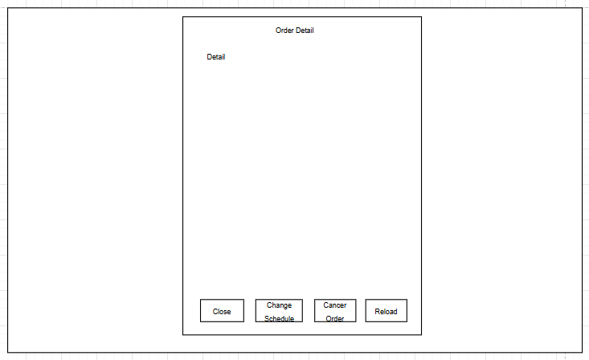  
**Screen Name: Court Reservation Details Screen**

This screen allows the User to:

* View Order Details: view detailed information about the booking.
* View QR Code:view the QR code for scanning on the main interface.
* Scan QR Code: use the displayed QR code to complete a booking or verification process.

On the screen, s/he can also:

* Navigate Back: close the order detail view and return to the order history screen.
* Reschedule Booking: modify the booking time by clicking the "Change Schedule" button.
* Cancel Booking: cancel the booking by clicking the "Cancel Order" button.
* Reload Data: refresh the booking detail information by clicking the "Reload" button.

**Field Description**

| **Field Name** | **Description** |
| --- | --- |
| Change Schedule | Button to modify the booking schedule for the order, possibly opening a schedule configuration dialog. |
| Cancer Order | Button to cancel the selected order, which may update the order status in the database (DB) |
| Reload | Button to refresh the order details displayed in the dialog, fetching the latest data from the database (DB). |
| Close | Button to close the order detail dialog without making any changes |

#### 

#### 2.1.6 Notification Screen

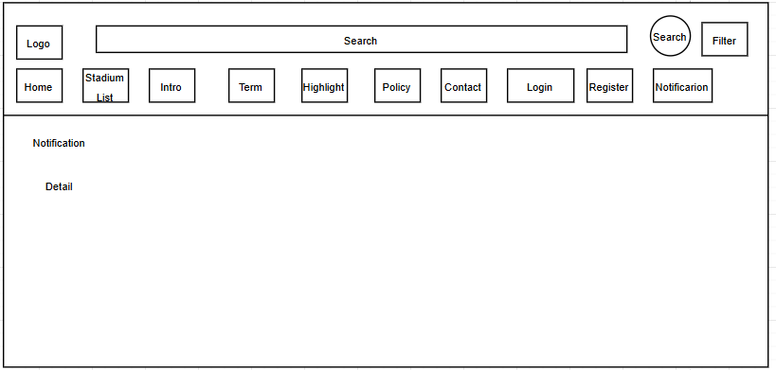

This screen allows the User to:

* View notification: view detailed notification about the booking.

On the screen, s/he can also:

* Navigate to Key Pages: access main sections like Home, Stadium List, Introduction, Terms, Highlights, Policy, Contact, Login, Register, Notification, and Filter through the top navigation bar.
* Change Language: switch the website language by clicking the "Language" button.

**Field Description**

| **Field Name** | **Description** |
| --- | --- |
| Search | Data type: any string, max length of 100 characters. Allows keyword search for courts or content. |
| Language | Allows the user to select the language of the application (e.g., English, Vietnamese). |
| Notification | Displays notifications for the user, sourced from the database (DB). |
| Home | Navigation button to access the Home section |
| Stadium List | Navigation button to access the list of stadiums or courts. |
| Term | Navigation button to access the terms and conditions section. |
| Highlight | Navigation button to access the highlights or featured content section. |
| Policy | Navigation button to access the policy section. |
| Contact | Navigation button to access the contact information section. |
| Login | Navigation button to access the login page for user authentication. |
| Register | Navigation button to access the registration page for new users. |
| Filter | Button to filter search results based on user-defined criteria. |
| Arrange | Button to arrange search results (e.g., by relevance, name). |
| Information Court | Displays court information, such as location, phone, or time, sourced from the database (DB). |
| Notification | Show details of notifications. |

#### 

#### 2.1.7 Weekly Recurring Booking Setup Screen

#### 

**Screen Name: *Weekly Recurring Booking Setup Screen***

• View Booking Details: view the interface for selecting booking days and times.

• Select Days: choose specific days (Mon, Tue, Wed, Thu, Fri, Sat, Sun) for booking.

• Set Booking Time: specify the start day, end day, start time, and end time for the booking.

On the screen, s/he can also:

• Check Availability: click the Check button to verify court availability for the selected days and times.

**Field Description**

| **Field Name** | **Description** |
| --- | --- |
| Back | Button to return to the previous screen. |
| Day Of The Weekend | Allows the user to select days of the week for the schedule using checkboxes (e.g., Mon, Tue). |
| Start Day | Data type: date, format (e.g., DD/MM/YYYY). Specifies the start date of the schedule |
| End Day | Data type: date, format (e.g., DD/MM/YYYY). Specifies the end date of the schedule |
| Start Time | Data type: time, format (e.g., HH:MM). Specifies the start time of the schedule. |
| End Time | Data type: time, format (e.g., HH:MM). Specifies the end time of the schedule. |
| Filter | Button to filter dates or times, possibly opening a calendar or predefined options. |
| Check | Button to check court availability for the configured schedule. |

#### 

#### 2.1.8 Fixed Weekly Booking Confirmation Screen

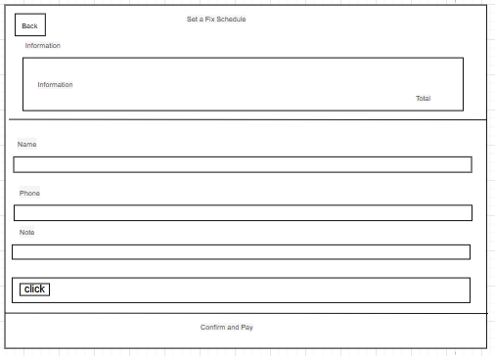

**Screen Name: Fixed Weekly Booking Confirmation Screen**

This screen allows the User to:

* View Order Summary: view the court and booking information on the main interface.
* Enter Order Details: input personal details such as full name, phone number, and notes for the booking.
* Agree to terms: Agree to the terms of pickleball court booking.

On the screen, s/he can also:

* Navigate Back: return to the previous screen by clicking the Back button.
* • Proceed to Next Step: move to payment of the booking process by clicking the Xác nhận và thanh toán button

**Field Description**

| **Field Name** | **Description** |
| --- | --- |
| Back | Button to return to the previous screen. |
| Information | Displays booking details, such as court name, date, or time, sourced from the database (DB). |
| Total | Displays the total cost of the booking, sourced from the database (DB). |
| Name | Data type: non-digit string, max length of 50 characters. Allows the user to input their name |
| Phone | Data type: string, max length of 15 characters. Allows the user to input their phone number. |
| Note | Data type: any string, max length of 200 characters. Allows the user to add additional notes for the booking. |
| Click | Button to initiate an additional action (e.g., selecting payment method or additional options). |
| Confirm and Pay | Button to confirm the booking and proceed to payment. |

#### 

#### 2.1.9 Login Screen

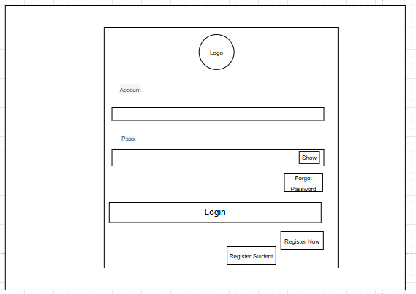

**Screen Name: Login Screen**

This screen allows the User to:

* Log In: access the application by entering a username and password.
* Navigate Back: return to the Home screen using the Home button.

On the screen, s/he can also:

* Access Forgot Password: navigate to the Forgot Password screen using the Forgot Password link.
* Register: navigate to the Register screen using the Register button.
* Toggle Password Visibility: show or hide the password input field using the Show button.
* Sign Up Student: navigate to the Sign Up screen using the Register Student button.

**Field Description**

| **Field Name** | **Description** |
| --- | --- |
| Account | Data type: any string, max length of 50 characters. Allows the user to input their account name or email. |
| Pass | Data type: any string, max length of 50 characters. Allows the user to input their password. |
| Show | Button to toggle the visibility of the password field. |
| Forgot Password | Link to navigate to the password recovery page. |
| Login | Button to submit the login credentials and access the application. |
| Register now | Link to navigate to the registration page for new users. |
| Register Student | Link to navigate to the registration page for student. |

#### 

#### 2.1.10 Sign Up Screen

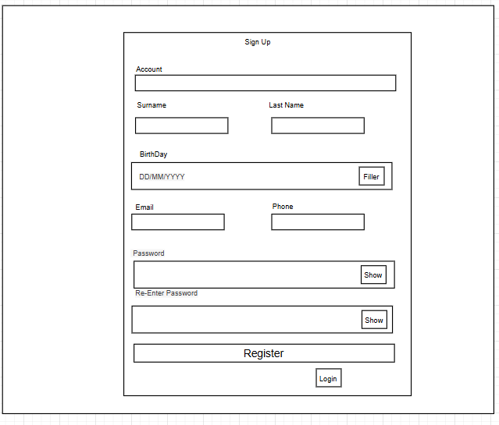

**Screen Name: Sign Up Screen**

This screen allows the User to:

* Create a New Account: enter required personal information.
* Toggle Password Visibility: show or hide the password input field using the Show button.

On the screen, s/he can also:

* Submit Registration: click the "Register" button to submit the registration form and create a new account.
* Navigate to Login: click the "Login" button to move to the login screen if the user already has an account.

**Field Description**

| **Field Name** | **Description** |
| --- | --- |
| Surname | Data type: non-digit string, max length of 50 characters. Allows the user to input their surname |
| Last Name | Data type: non-digit string, max length of 50 characters. Allows the user to input their last name. |
| Birth Day | Data type: date, format (e.g., DD/MM/YYYY). Allows the user to input their birthday, with a "Filter" button to select from a calendar. |
| Email | Data type: string, max length of 100 characters. Allows the user to input their email address. |
| Phone | Data type: string, max length of 15 characters. Allows the user to input their phone number. |
| Password | Data type: any string, max length of 50 characters. Allows the user to input their password |
| Re-Enter Password | Data type: any string, max length of 50 characters. Allows the user to re-enter their password for confirmation. |
| Show | Button to toggle the visibility of the password and re-entered password fields. |
| Filter | Button to select the birthday from a calendar. |
| Register | Button to submit the registration form and create a new account. |
| Login | Link to navigate to the login page for existing users. |

#### 

#### 2.1.11 Court List Screen

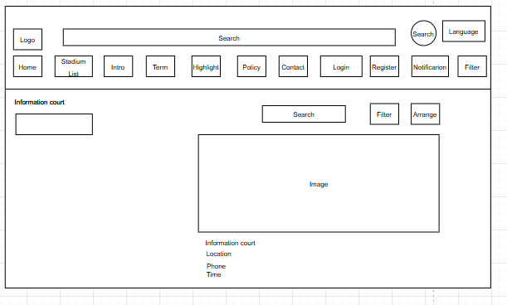

**Screen Name: *Court List Screen***

This screen allows the User to:

* Search Stadiums: search courts by name.
* View Court Information: see detailed court information.
* View Court List: View list of active courses

On the screen, s/he can also:

* Navigate to Key Pages: access main sections like Home, Stadium List, Introduction, Terms, Highlights, Policy, Contact, Login, Register, Notification, and Filter through the top navigation bar.
* Change Language: switch the website language by clicking the "Language" button.

| **Field Name** | **Description** |
| --- | --- |
| Search | Data type: any string, max length of 100 characters. Allows keyword search for bookings or content. |
| Language | Allows the user to select the language of the application (e.g., English, Vietnamese). |
| Notification | Displays notifications for the user, sourced from the database (DB). |
| Home | Navigation button to access the Home section. |
| Stadium List | Navigation button to access the list of stadiums or courts. |
| Intro | Navigation button to access the introduction section of the application. |
| Term | Navigation button to access the terms and conditions section. |
| Highlight | Navigation button to access the highlights or featured content section. |
| Policy | Navigation button to access the policy section. |
| Contact | Navigation button to access the contact information section. |
| Register | Navigation button to access the registration page for new users. |
| See Detail | Button to view detailed information about a specific booking. |
| Image | A large area that can be used for background images or to highlight court-related content. |
| Info | Displays additional information, possibly about the booking process or policies. |
| Contact | Displays contact information for support or inquiries |
| Arrange | Button to arrange search results (e.g., by relevance, name). |
| Login | Navigation button to access the login page for user authentication. |

#### 

#### 2.1.12 Order List

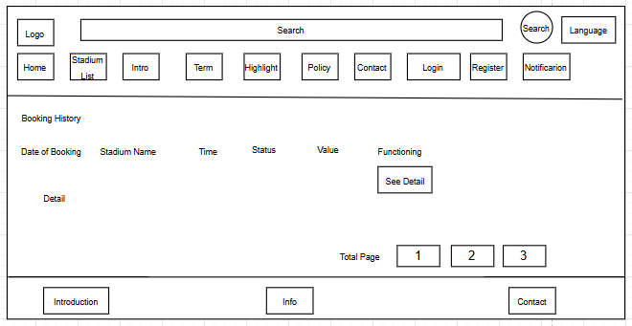

**Screen Name: *Order List Screen***

This screen allows the User to:

* View Order History: View Order history list.
* View Detailed Order Information: click the "See Detail" button to open more detailed information about a specific Order .

On the screen, s/he can also:

* Navigate Pages: move between pages of booking history using the pagination buttons (1, 2, 3).
* Navigate to Key Pages: access main sections like Home, Stadium List, Introduction, Terms, Highlights, Policy, Contact, Login, Register, Notification, and Filter through the top navigation bar.
* Change Language: switch the website language by clicking the "Language" button.

**Field Description**

| **Field Name** | **Description** |
| --- | --- |
| Search | Data type: any string, max length of 100 characters. Allows keyword search for bookings or content. |
| Language | Allows the user to select the language of the application (e.g., English, Vietnamese). |
| Notification | Displays notifications for the user, sourced from the database (DB). |
| Home | Navigation button to access the Home section. |
| Stadium List | Navigation button to access the list of stadiums or courts. |
| Intro | Navigation button to access the introduction section of the application. |
| Term | Navigation button to access the terms and conditions section. |
| Highlight | Navigation button to access the highlights or featured content section. |
| Policy | Navigation button to access the policy section. |
| Contact | Navigation button to access the contact information section. |
| Register | Navigation button to access the registration page for new users. |
| See Detail | Button to view detailed information about a specific booking. |
| Total Page | Displays the total number of pages in the booking history list for pagination purposes. |
| Info | Displays additional information, possibly about the booking process or policies. |
| Contact | Displays contact information for support or inquiries |
| Introduction | Displays introductory information about the application or service. |
| Login | Navigation button to access the login page for user authentication |

#### 

#### 2.1.13 Personal information editing screen

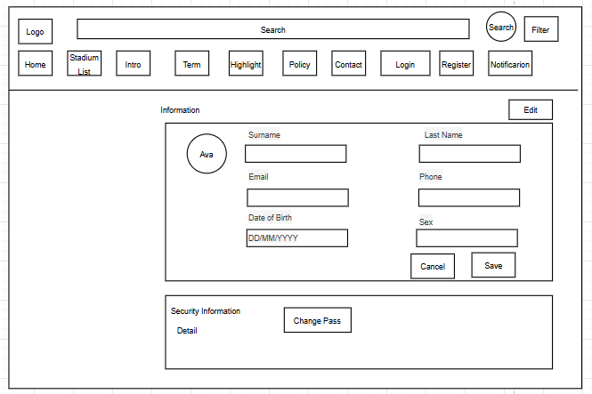

**Screen Name:** ***Personal Information Editing Screen***

This screen allows the User to:

* View Personal Information: see personal details information.
* Edit Personal Information: click the "Edit" button to editing of personal details.
* Save or Cancel Changes: after editing, the user can either click "Save" to update the information or "Cancel" to discard any changes.

On the screen, s/he can also:

* Change Password: click the "Change Pass" button to initiate the password change process.
* Navigate to Key Pages: access main sections like Home, Stadium List, Introduction, Terms, Highlights, Policy, Contact, Login, Register, Notification, and Filter through the top navigation bar.
* Change Language: switch the website language by clicking the "Language" button.

**Field Description**

| **Field Name** | **Description** |
| --- | --- |
| Search | Data type: any string, max length of 100 characters. Allows keyword search for bookings or content. |
| Language | Allows the user to select the language of the application (e.g., English, Vietnamese). |
| Notification | Displays notifications for the user, sourced from the database (DB). |
| Home | Navigation button to access the Home section. |
| Stadium List | Navigation button to access the list of stadiums or courts. |
| Intro | Navigation button to access the introduction section of the application. |
| Term | Navigation button to access the terms and conditions section. |
| Highlight | Navigation button to access the highlights or featured content section. |
| Policy | Navigation button to access the policy section. |
| Contact | Navigation button to access the contact information section. |
| Register | Navigation button to access the registration page for new users. |
| Login | Navigation button to access the login page for user authentication. |
| Ava | Displays the user’s avatar or profile picture, sourced from the database (DB). |
| Surname | Data type: non-digit string, max length of 50 characters. Allows the user to edit their surname. |
| Last Name | Data type: non-digit string, max length of 50 characters. Allows the user to edit their Last name. |
| Email | Data type: string, max length of 100 characters. Allows the user to edit their email address. |
| Phone | Data type: string, max length of 15 characters. Allows the user to edit their phone number. |
| Date Of Birth | Data type: date, format (e.g., DD/MM/YYYY). Allows the user to edit their date of birth. |
| Sex | Data type: predefined options (e.g., Male, Female). Allows the user to edit their sex |
| Edit | Button to enable editing mode for the personal information fields. |
| Change Pass | Button to navigate to the password change screen. |
| Cancel | Button to discard changes and return to the previous state. |
| Save | Button to save the updated personal information to the database (DB). |

#### 

#### 

#### 2.1.14 Password change screen

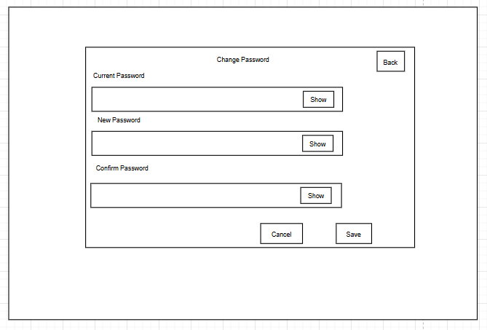

**Screen Name: *Change Password Screen***

This screen allows the User to:

* Change Password: update account security by entering the current password, a new password, and confirming the new password.
* Show/Hide Passwords: show or hide the password input field using the Show button.

On the screen, s/he can also:

* Save Changes: after filling in all required fields correctly, click the "Save" button to apply the new password.
* Cancel Changes: click the "Cancel" button to discard the changes and remain on the current screen.
* Navigate Back: click the "Back" button to return to the previous screen.

**Field Description**

| **Field Name** | **Description** |
| --- | --- |
| Back | Button to return to the previous screen. |
| Change Password | Title of the screen, indicating the password change process. |
| Current Password | Data type: any string, max length of 50 characters. Allows the user to input their current password. |
| New Password | Data type: any string, max length of 50 characters. Allows the user to input their new password. |
| Confirm Password | Data type: any string, max length of 50 characters. Allows the user to confirm their new password |
| Show | Button to toggle the visibility of the password fields (Current Password, New Password, Confirm Password). |
| Cancel | Button to discard changes and return to the previous screen. |
| Save | Button to save the new password to the database (DB), after validating that the new password matches the confirmation. |

#### 

#### 2.1.15 Intro screen

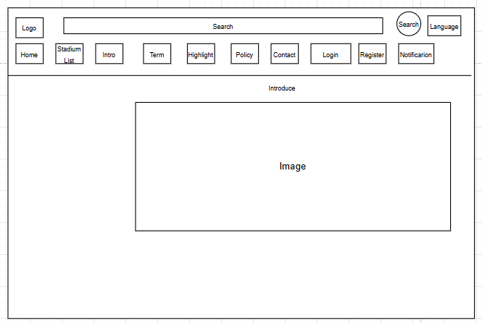

**Screen Name: *Intro Screen***

This screen allows the User to:

* View Intro: See detailed information about the website

On the screen, s/he can also:

* Navigate to Key Pages: access main sections like Home, Stadium List, Intro, Terms, Highlights, Policy, Contact, Login, Register, Notification, and Filter through the top navigation bar.
* Change Language: switch the website language by clicking the "Language" button.

**Field Description**

| **Field Name** | **Description** |
| --- | --- |
| Search | Data type: any string, max length of 100 characters. Allows keyword search for bookings or content. |
| Language | Allows the user to select the language of the application (e.g., English, Vietnamese). |
| Notification | Displays notifications for the user, sourced from the database (DB). |
| Home | Navigation button to access the Home section. |
| Stadium List | Navigation button to access the list of stadiums or courts. |
| Intro | Navigation button to access the introduction section of the application. |
| Term | Navigation button to access the terms and conditions section. |
| Highlight | Navigation button to access the highlights or featured content section. |
| Policy | Navigation button to access the policy section. |
| Contact | Navigation button to access the contact information section. |
| Introduce | Displays introductory content about the application or service, sourced from the database (DB). |
| Image | A large area that displays a banner or image highlighting key features or promotions, sourced from the database (DB). |

#### 

#### 2.1.16 Terms of Booking screen

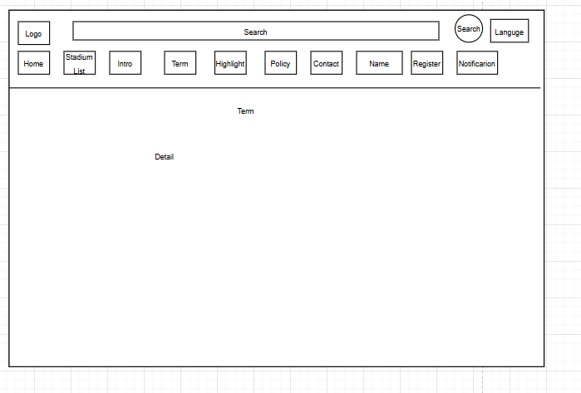

**Screen Name: *Terms of Booking Screen***

This screen allows the User to:

* View Booking Terms: View booking terms details on the website.

On the screen, s/he can also:

* Navigate to Key Pages: access main sections like Home, Stadium List, Introduction, Terms, Highlights, Policy, Contact, Login, Register, Notification, and Filter through the top navigation bar.
* Change Language: switch the website language by clicking the "Language" button.

**Field Description**

| **Field Name** | **Description** |
| --- | --- |
| Search | Data type: any string, max length of 100 characters. Allows keyword search for bookings or content. |
| Language | Allows the user to select the language of the application (e.g., English, Vietnamese). |
| Notification | Displays notifications for the user, sourced from the database (DB). |
| Home | Navigation button to access the Home section. |
| Stadium List | Navigation button to access the list of stadiums or courts. |
| Intro | Navigation button to access the introduction section of the application. |
| Term | Navigation button to access the terms and conditions section. |
| Highlight | Navigation button to access the highlights or featured content section. |
| Policy | Navigation button to access the policy section. |
| Contact | Navigation button to access the contact information section. |
| Name | Username currently logged in |
| Register | Navigation button to access the registration page for new users. |
| Term | Displays the terms and conditions for booking, sourced from the database (DB) |
| Detail | Displays detailed terms and conditions |

#### 

#### 2.1.17 Highlight screen

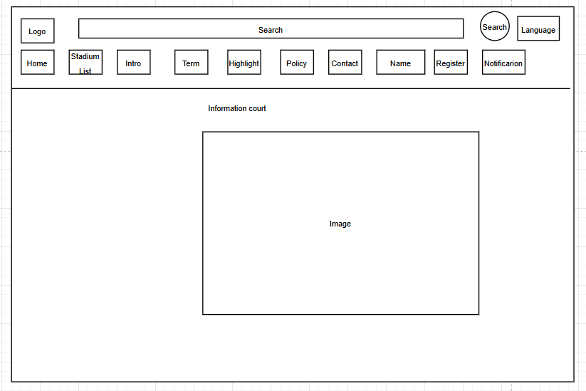

**Screen Name: *Highlight Screen***

This screen allows the User to:

* View Highlight: View Highlight on the website.

On the screen, s/he can also:

* Navigate to Key Pages: access main sections like Home, Stadium List, Introduction, Terms, Highlights, Policy, Contact, Login, Register, Notification, and Filter through the top navigation bar.
* Change Language: switch the website language by clicking the "Language" button.

**Field Description**

| **Field Name** | **Description** |
| --- | --- |
| Search | Data type: any string, max length of 100 characters. Allows keyword search for bookings or content. |
| Language | Allows the user to select the language of the application (e.g., English, Vietnamese). |
| Notification | Displays notifications for the user, sourced from the database (DB). |
| Home | Navigation button to access the Home section. |
| Stadium List | Navigation button to access the list of stadiums or courts. |
| Intro | Navigation button to access the introduction section of the application. |
| Term | Navigation button to access the terms and conditions section. |
| Highlight | Navigation button to access the highlights or featured content section. |
| Policy | Navigation button to access the policy section. |
| Contact | Navigation button to access the contact information section. |
| Name | Username currently logged in |
| Register | Navigation button to access the registration page for new users. |
| Information Court | Displays highlighted content, such as featured courts or promotions |
| Image | A large area that displays a banner or image highlighting key content |

#### 

#### 2.1.18 Contact Us screen

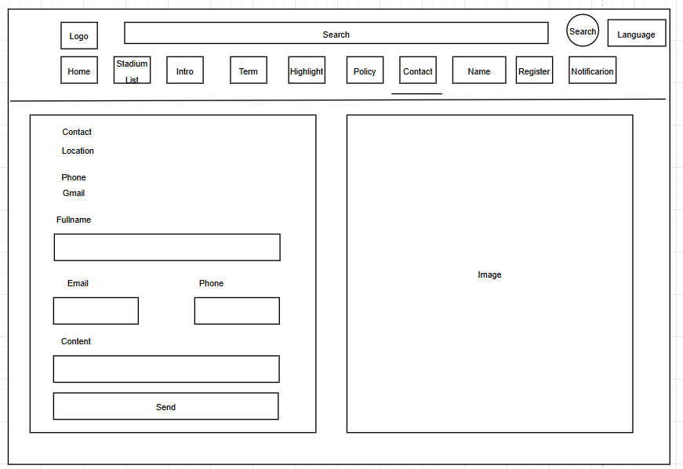

**Screen Name: *Highlight Screen***

This screen allows the User to:

* View Contact Information: See basic contact details such as Location, Phone number, and Email
* Contact Us: Fill out a contact form with Full Name, Email, Phone, and Content fields to send inquiries or messages.
* View Image: See an image displayed on the right side of the contact section.

On the screen, s/he can also:

* Navigate to Key Pages: access main sections like Home, Stadium List, Introduction, Terms, Highlights, Policy, Contact, Login, Register, Notification, and Filter through the top navigation bar.
* Change Language: switch the website language by clicking the "Language" button.

**Field Description**

| **Field Name** | **Description** |
| --- | --- |
| Search | Data type: any string, max length of 100 characters. Allows keyword search for bookings or content. |
| Language | Allows the user to select the language of the application (e.g., English, Vietnamese). |
| Notification | Displays notifications for the user, sourced from the database (DB). |
| Home | Navigation button to access the Home section. |
| Stadium List | Navigation button to access the list of stadiums or courts. |
| Intro | Navigation button to access the introduction section of the application. |
| Term | Navigation button to access the terms and conditions section. |
| Highlight | Navigation button to access the highlights or featured content section. |
| Policy | Navigation button to access the policy section. |
| Contact | Navigation button to access the contact information section. |
| Name | Username currently logged in |
| Register | Navigation button to access the registration page for new users. |
| Location | Data type: any string, max length of 100 characters. Displays the organization’s location. |
| Phone | Data type: string, max length of 15 characters. Displays the organization’s contact phone number. |
| Gmail | Data type: string, max length of 100 characters. Displays the organization’s Gmail address. |
| Fullname | Data type: non-digit string, max length of 50 characters. Displays the contact person’s name. |
| Email | Data type: string, max length of 100 characters. Allows the user to input their email address for sending a message |
| Phone | Data type: string, max length of 15 characters. Allows the user to input their phone number for sending a message. |
| Content | Data type: any string, max length of 500 characters. Allows the user to input their message content. |
| Send | Button to submit the message to the system, storing it in the database (DB) |
| Image | A large area that displays a map or image related to the contact location, sourced from the database (DB). |

#### 

#### 2.1.19 Manage Account Screen

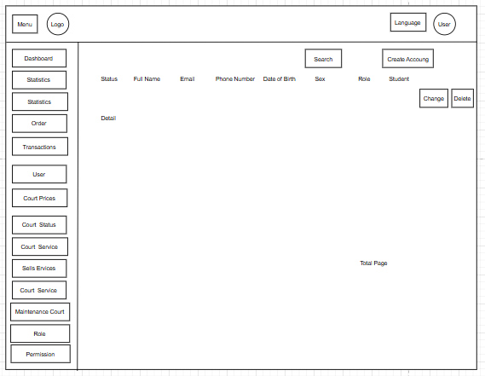

**Screen Name: *Manage Account Screen***

This screen allows the User to:

* View Information User: View detailed information of each user.
* Search Users: Use the Search bar to find specific users based on keywords.
* Create Account: Click the "Create Account" button to add a new user.
* Edit or Delete Accounts: Click "Change" to edit or "Delete" to remove a user.

On the screen, s/he can also:

* Navigate to Key Management Sections: Access different management areas through the left sidebar, including Dashboard, Statistics, Order, Transactions, User, Court Prices, Court Status, Court Service, Sell Services, Maintenance Court, Role, and Permission.
* Change Language: switch the website language by clicking the "Language" button.

**Field Description**

| **Field Name** | **Description** |
| --- | --- |
| Menu | Sidebar menu with navigation options: Dashboard, Statistics, Order, Transactions, User, Court Prices, Court Status, Court Service, Maintenance Court, Role, Permission. |
| Logo | Displays the application's logo. The logo is a static image and not interactive. |
| Language | Allows the user to select the language of the application (e.g., English, Vietnamese). |
| User | Displays the current user’s profile or logout option. |
| Search | Data type: any string, max length of 100 characters. Allows keyword search for accounts. |
| Create Account | Button to navigate to the account creation screen. |
| Status | Displays the account status (e.g., Active, Inactive), sourced from the database (DB). |
| Full Name | Data type: non-digit string, max length of 50 characters. Displays the account’s full name. |
| Email | Data type: string, max length of 100 characters. Displays the account’s email address. |
| Phone Number | Data type: string, max length of 15 characters. Displays the account’s phone number. |
| Date Of Birth | Data type: date, format (e.g., DD/MM/YYYY). Displays the account’s date of birth. |
| Sex | Displays the account’s sex (e.g., Male, Female) |
| Role | Displays the account’s role (e.g., Admin, User) |
| Student | Displays whether the account belongs to a student (e.g., Yes, No) |
| Change | Button to modify the selected account’s details, possibly opening an edit dialog. |
| Delete | Button to delete the selected account |
| Detail | Displays detailed information about the selected account |
| Total Page | Displays the total number of pages in the account list for pagination purposes. |

#### 

#### 2.1.20 Manage Court Screen

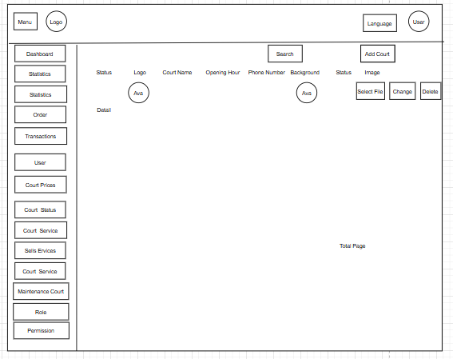

**Screen Name: *Manage Court Screen***

This screen allows the User to:

* View Information Court: View detailed information of each Court.
* Search Court: Use the Search bar to find specific court based on keywords.
* Create Court: Click the "Add Court" button to add a new Court.
* Edit or change status Court: Click "Edit" to edit or "Status" to change status a court.

On the screen, s/he can also:

* Navigate to Key Management Sections: Access different management areas through the left sidebar, including Dashboard, Statistics, Order, Transactions, User, Court Prices, Court Status, Court Service, Sell Services, Maintenance Court, Role, and Permission.
* Change Language: switch the website language by clicking the "Language" button.

**Field Description**

| **Field Name** | **Description** |
| --- | --- |
| Menu | Sidebar menu with navigation options: Dashboard, Statistics, Order, Transactions, User, Court Prices, Court Status, Court Service, Maintenance Court, Role, Permission. |
| Logo | Displays the application's logo. The logo is a static image and not interactive. |
| Language | Allows the user to select the language of the application (e.g., English, Vietnamese). |
| User | Displays the current user’s profile or logout option. |
| Search | Data type: any string, max length of 100 characters. Allows keyword search for accounts. |
| Create Account | Button to navigate to the account creation screen. |
| Status | Displays the account status (e.g., Active, Inactive) |
| Add Court | Button to navigate to the add new court screen. |
| Status | Displays the court’s status (e.g., Active, Inactive) |
| Court Name | Data type: any string, max length of 100 characters. Displays the court’s name. |
| Opening Hour | Data type: time, format (e.g., HH:MM). Displays the court’s opening hours. |
| Phone Number | Data type: string, max length of 15 characters. Displays the court’s phone number. |
| Background | Displays the court’s background image |
| Select File | Button to upload a new background image for the court |
| Change | Button to modify the selected court’s details, possibly opening an edit dialog. |
| Delete | Button to delete the selected court |
| Detail | Displays detailed information about the selected court |
| Total Page | Displays the total number of pages in the court list for pagination purposes. |

#### 

#### 2.1.21 Add New Court Screen

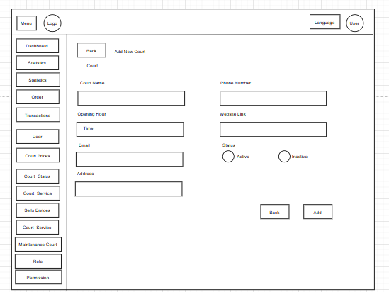

**Screen Name: *Add New Court Screen***

This screen allows the User to:

* Add New Court: Fill out a form to create a new court by providing information .
* Proceed to Add: Proceed to add new field based on entered information

On the screen, s/he can also:

* Navigate Back: return to the previous screen by clicking the Back button.
* Navigate to Key Management Sections: Access different management areas through the left sidebar, including Dashboard, Statistics, Order, Transactions, User, Court Prices, Court Status, Court Service, Sell Services, Maintenance Court, Role, and Permission.
* Change Language: switch the website language by clicking the "Language" button.

**Field Description**

| **Field Name** | **Description** |
| --- | --- |
| Menu | Sidebar menu with navigation options: Dashboard, Statistics, Order, Transactions, User, Court Prices, Court Status, Court Service, Maintenance Court, Role, Permission. |
| Logo | Displays the application's logo. The logo is a static image and not interactive. |
| Language | Allows the user to select the language of the application (e.g., English, Vietnamese). |
| User | Displays the current user’s profile or logout option. |
| Back (top) | Button to return to the previous screen (top of the screen). |
| Add New Court | Title of the screen, indicating the process of adding a new court. |
| Court Name | Data type: any string, max length of 100 characters. Allows the user to input the court’s name. |
| Phone Number | Data type: string, max length of 15 characters. Allows the user to input the court’s phone number. |
| Website Link | Data type: string, max length of 200 characters. Allows the user to input the court’s website URL. |
| Email | Data type: string, max length of 100 characters. Allows the user to input the court’s email address. |
| Time | Data type: time, format (e.g., HH:MM). Allows the user to input the court’s operating hours. |
| Status | Data type: predefined options (Active, Inactive). Allows the user to set the court’s status using radio buttons. |
| Address | Data type: any string, max length of 200 characters. Allows the user to input the court’s address. |
| Back (Bottom) | Button to discard changes and return to the previous screen (bottom of the screen). |
| Add | Button to save the new court |

#### 

#### 2.1.22 Add New Court Screen

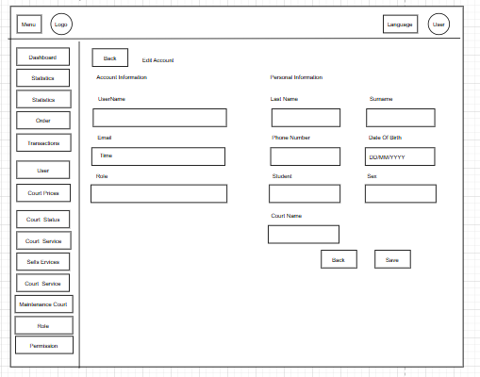

This screen allows the User to:

* Edit Account: Edit Account information.
* Proceed to Save: Proceed to update based on the information entered

On the screen, s/he can also:

* Navigate Back: return to the previous screen by clicking the Back button.
* Navigate to Key Management Sections: Access different management areas through the left sidebar, including Dashboard, Statistics, Order, Transactions, User, Court Prices, Court Status, Court Service, Sell Services, Maintenance Court, Role, and Permission.
* Change Language: switch the website language by clicking the "Language" button.

**Field Description**

| **Field Name** | **Description** |
| --- | --- |
| Menu | Sidebar menu with navigation options: Dashboard, Statistics, Order, Transactions, User, Court Prices, Court Status, Court Service, Maintenance Court, Role, Permission. |
| Logo | Displays the application's logo. The logo is a static image and not interactive. |
| Language | Allows the user to select the language of the application (e.g., English, Vietnamese). |
| User | Displays the current user’s profile or logout option. |
| Back (top) | Button to return to the previous screen (top of the screen). |
| Add New Court | Title of the screen, indicating the process of adding a new court. |
| Court Name | Data type: any string, max length of 100 characters. Allows the user to input the court’s name. |
| Phone Number | Data type: string, max length of 15 characters. Allows the user to input the court’s phone number. |
| Website Link | Data type: string, max length of 200 characters. Allows the user to input the court’s website URL. |
| Email | Data type: string, max length of 100 characters. Allows the user to input the court’s email address. |
| Time | Data type: time, format (e.g., HH:MM). Allows the user to input the court’s operating hours. |
| Status | Data type: predefined options (Active, Inactive). Allows the user to set the court’s status using radio buttons. |
| Address | Data type: any string, max length of 200 characters. Allows the user to input the court’s address. |
| Back (Bottom) | Button to discard changes and return to the previous screen (bottom of the screen). |
| Add | Button to save the new court |

#### 

#### 2.1.23 Edit Court Screen

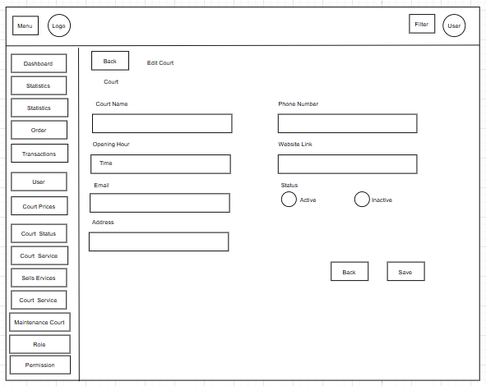

.  
This screen allows the User to:

* Edit Court: Edit Court Information.
* Proceed to Save : Proceed to update based on the information entered

On the screen, s/he can also:

* Navigate Back: return to the previous screen by clicking the Back button.
* Navigate to Key Management Sections: Access different management areas through the left sidebar, including Dashboard, Statistics, Order, Transactions, User, Court Prices, Court Status, Court Service, Sell Services, Maintenance Court, Role, and Permission.
* Change Language: switch the website language by clicking the "Language" button.

**Field Description**

| **Field Name** | **Description** |
| --- | --- |
| Menu | Sidebar menu with navigation options: Dashboard, Statistics, Order, Transactions, User, Court Prices, Court Status, Court Service, Maintenance Court, Role, Permission. |
| Logo | Displays the application's logo. The logo is a static image and not interactive. |
| Language | Allows the user to select the language of the application (e.g., English, Vietnamese). |
| User | Displays the current user’s profile or logout option. |
| Back(top) | Button to return to the previous screen (top of the screen). |
| Edit Court | Title of the screen, indicating the process of editing court details. |
| Court Name | Data type: any string, max length of 100 characters. Allows the user to edit the court’s name. |
| Phone Number | Data type: string, max length of 15 characters. Allows the user to edit the court’s phone number. |
| Website Link | Data type: string, max length of 200 characters. Allows the user to edit the court’s website URL. |
| Email | Data type: string, max length of 100 characters. Allows the user to edit the court’s email address. |
| Open Hour | Data type: time, format (e.g., HH:MM). Allows the user to edit the court’s opening hours. |
| Status | Data type: predefined options (Active, Inactive). Allows the user to set the court’s status using radio buttons |
| Address | Data type: any string, max length of 200 characters. Allows the user to edit the court’s address. |
| Back (bottom) | Button to discard changes and return to the previous screen (bottom of the screen). |
| Save | Button to save the updated court |

#### 

#### 

#### 2.1.24 Add Court Time Slot Screen

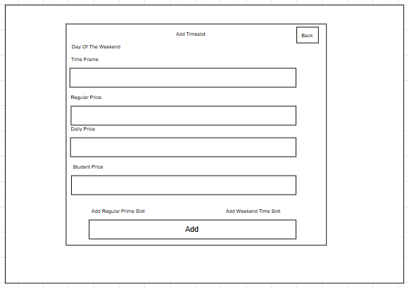

This screen allows the User to:

* Add New Time Slot: Fill out a form to create a new Time slot by providing time, price.
* Proceed to Add: Proceed to add new field based on entered information

On the screen, s/he can also:

* Navigate Back: return to the previous screen by clicking the Back button.

**Field Description**

| **Field Name** | **Description** |
| --- | --- |
| Back | Button to return to the previous screen. |
| Time Frame | Data type: time range, format (e.g., HH:MM-HH:MM). Allows the user to input the time frame for the slot. |
| Regular Price | Data type: number, max value of 999999. Allows the user to input the regular price for the time slot. |
| Daily Price | Data type: number, max value of 999999. Allows the user to input the daily price for the time slot. |
| Student Price | Data type: number, max value of 999999. Allows the user to input the student price for the time slot. |
| Add Regular Time Slot | Button to switch to the mode for adding a regular time slot (non-weekend). |
| Add Weekend Time Slot | Button to switch to the mode for adding a weekend time slot. |
| Add | Button to save the new time slot |

#### 

***3.3.25 Add Court Area Screen***

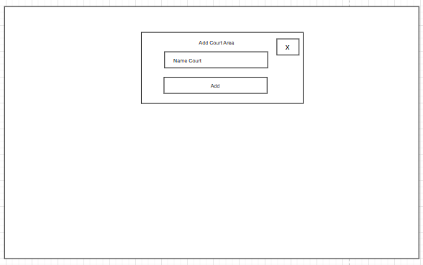

This screen allows the User to:

* Add New Court: Fill out a form to create a new court by providing information .
* Proceed to Add: Proceed to add new field based on entered information

On the screen, s/he can also:

* Navigate Back: return to the previous screen by clicking the Back button.

**Field Description**

| **Field Name** | **Description** |
| --- | --- |
| Name Court | Data type: any string, max length of 100 characters. Allows the user to input the court area’s name. |
| X | Button to close the dialog without saving. |
| Add | Button to save the new court area |

#### 

#### 2.1.26 Edit Sub Court Screen

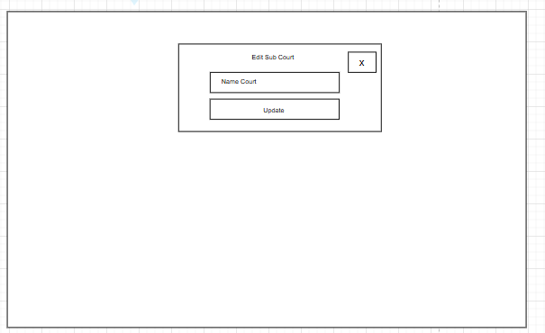

This screen allows the User to:

* Edit Sub-Court: Edit information about the sub court.
* Proceed to Update: Proceed to update new field based on entered information

On the screen, s/he can also:

* Navigate Back: return to the previous screen by clicking the Back button.

**Field Description**

| **Field Name** | **Description** |
| --- | --- |
| Name Court | Data type: any string, max length of 100 characters. Allows the user to edit the sub court’s name |
| X | Button to close the dialog without saving. |
| Update | Button to save the updated sub court name |

#### 

#### 2.1.27 Add Service Screen

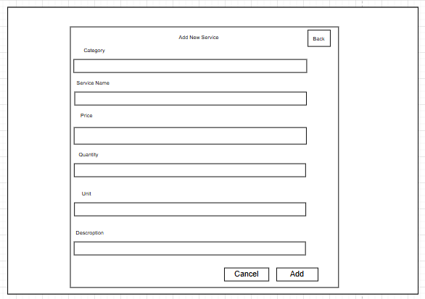

This screen allows the User to:

* Add New Court: Fill out a form to create a new court by providing information.
* Proceed to Add: Proceed to add new field based on entered information

On the screen, s/he can also:

* Navigate Back: return to the previous screen by clicking the Back button.

**Field Description**

| **Field Name** | **Description** |
| --- | --- |
| Back | Button to return to the previous screen. |
| Category | Data type: any string, max length of 50 characters. Allows the user to input the service category. |
| Service Name | Data type: any string, max length of 100 characters. Allows the user to input the service name. |
| Price | Data type: number, max value of 999999. Allows the user to input the service price |
| Quantity | Data type: number, max value of 9999. Allows the user to input the service quantity. |
| Unit | Data type: any string, max length of 50 characters. Allows the user to input the unit of the service. |
| Description | Data type: any string, max length of 500 characters. Allows the user to input the service description. |
| Cancel | Button to discard changes and return to the previous screen. |
| Add | Button to save the new service |

#### 

#### 2.1.28 Edit Service Screen

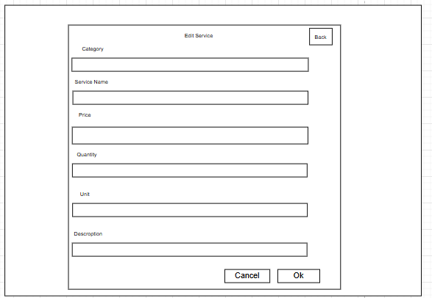

This screen allows the User to:

* Edit Service: Edit Service Information.
* Proceed to OK: Proceed to update based on the information entered

On the screen, s/he can also:

* Navigate Back: return to the previous screen by clicking the Back button.

**Field Description**

| **Field Name** | **Description** |
| --- | --- |
| Back | Button to return to the previous screen. |
| Category | Data type: any string, max length of 50 characters. Allows the user to edit the service category. |
| Service Name | Data type: any string, max length of 100 characters. Allows the user to edit the service name. |
| Price | Data type: number, max value of 999999. Allows the user to edit the service price. |
| Quantity | Data type: number, max value of 9999. Allows the user to edit the service quantity. |
| Unit | Data type: any string, max length of 50 characters. Allows the user to edit the unit of the service. |
| Description | Data type: any string, max length of 500 characters. Allows the user to edit the service description. |
| Cancel | Button to discard changes and return to the previous screen. |
| OK | Button to save the updated service |

#### 

#### 2.1.29 Sell Service Screen

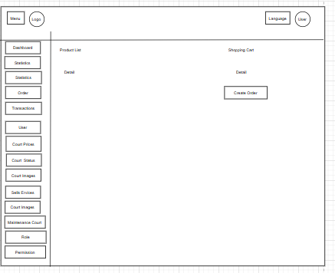

This screen allows the User to:

* View Service: view information service.
* Create Order: View the list of available products, add products to the shopping cart, and create a new order.

On the screen, s/he can also:

* Navigate to Key Management Sections: Access different management areas through the left sidebar, including Dashboard, Statistics, Order, Transactions, User, Court Prices, Court Status, Court Service, Sell Services, Maintenance Court, Role, and Permission.
* Change Language: switch the website language by clicking the "Language" button.

**Field Description**

| **Field Name** | **Description** |
| --- | --- |
| Menu | Sidebar menu with navigation options: Dashboard, Statistics, Order, Transactions, User, Court Prices, Court Status, Court Service, Maintenance Court, Role, Permission. |
| Language | Allows the user to select the language of the application (e.g., English, Vietnamese). |
| User | Displays the current user’s profile or logout option. |
| Product List | Displays a list of products or services available for sale |
| Shopping Cast | Displays the items selected for purchase |
| Detail( Cast) | Displays detailed information about the items in the shopping cart |
| Detail(Product) | Displays detailed information about the products or services |
| Create Order | Button to finalize the sale by creating an order with the selected items |

#### 

#### 2.1.30 QR Code Screen

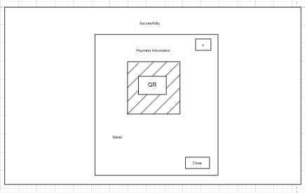

This screen allows the User to:

• View QR Code: view the QR code for scanning on the main interface.

• Scan QR Code: use the displayed QR code to complete a booking or verification process.

On the screen, s/he can also:

• Navigate Back: return to the previous screen by clicking the "Back" button.

**Field Description**

| **Field Name** | **Description** |
| --- | --- |
| Payment Information | Displays payment details related to the transaction |
| QR | Displays a QR code for payment or confirmation |
| Detail | Displays detailed information about the transaction |
| x | Button to close the dialog |
| Button | Button to close the dialog |

#### 

#### 

#### 2.1.31 View maintenance schedule Screen

#### 

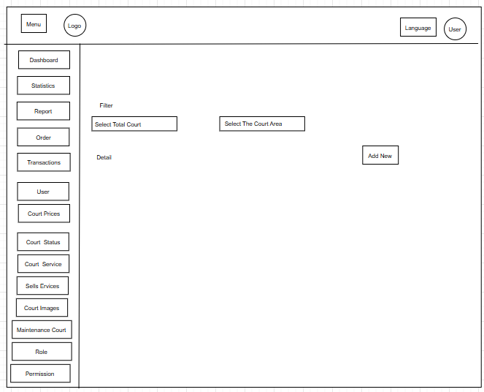

This screen allows the User to:

* Filter Courts: Filter courts by selecting court and court area.
* View Maintenance: View maintenance details of selected course.

On the screen, s/he can also:

* Navigate to Key Management Sections: Access different management areas through the left sidebar, including Dashboard, Statistics, Order, Transactions, User, Court Prices, Court Status, Court Service, Sell Services, Maintenance Court, Role, and Permission.
* Change Language: switch the website language by clicking the "Language" button.

**Field Description**

| **Field Name** | **Description** |
| --- | --- |
| Menu | Sidebar menu with navigation options: Dashboard, Statistics, Report, Order, Transactions, User, Court Prices, Court Status, Court Service, Maintenance Court, Role, Permission |
| Language | Allows the user to select the language of the application (e.g., English, Vietnamese). |
| User | Displays the current user’s profile or logout option. |
| Filter | Section to filter the maintenance schedule based on user-defined criteria. |
| Select Total Court | Data type: predefined options (e.g., list of courts). Allows the user to select a specific court. |
| Select The Court Area | Data type: predefined options (e.g., list of court areas). Allows the user to select a specific court area. |
| Add New | Button to navigate to the add new maintenance schedule screen. |
| Detail | Displays detailed maintenance schedule information |

#### 

#### 2.1.32 Create New Maintenance Screen

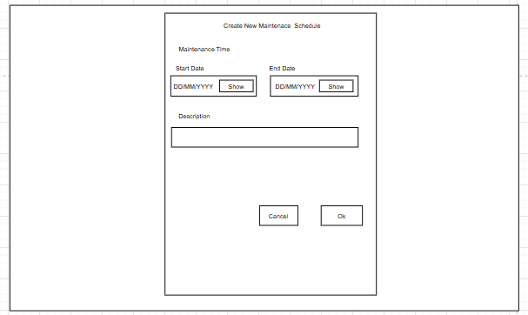

This screen allows the User to:

* Create New Maintenance Schedule: Select maintenance time and maintenance reason.

On the screen, s/he can also:

* Proceed to OK: Confirm and save the new maintenance schedule by clicking the "OK" button.
* Navigate Back: Cancel the action and return to the previous screen by clicking the "Cancel" button

**Field Description**

| **Field Name** | **Description** |
| --- | --- |
| Start Date | Data type: date, format (e.g., DD/MM/YYYY). Allows the user to select the start date of maintenance. |
| End Date | Data type: date, format (e.g., DD/MM/YYYY). Allows the user to select the end date of maintenance |
| Show | Button opens a calendar for selection. |
| Description | Data type: any string, max length of 500 characters. Allows the user to input a description of the maintenance. |
| Cancel | Button to discard changes and close the dialog. |
| Ok | Button to save the new maintenance schedule |

#### 

#### 2.1.33 Edit Maintenance Screen

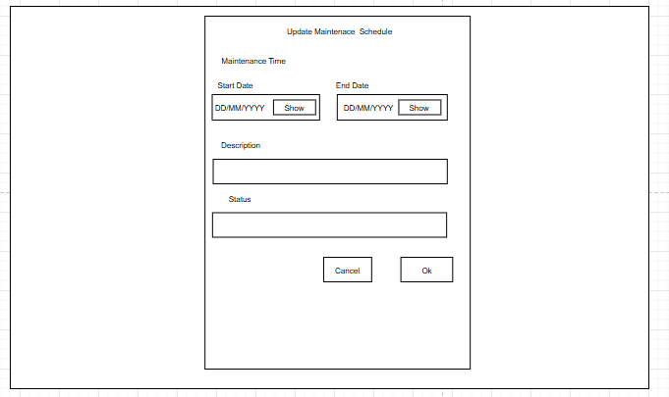

This screen allows the User to:

* Update Maintenance Schedule: update the maintenance information by editing the Start Date, End Date, Description, and Status fields.
* Proceed to OK: Confirm and save the new update maintenance schedule by clicking the "OK" button

On the screen, s/he can also:

* Navigate Back: Cancel the action and return to the previous screen by clicking the "Cancel" button

**Field Description**

| **Field Name** | **Description** |
| --- | --- |
| Start Date | Data type: date, format (e.g., DD/MM/YYYY). Allows the user to select the start date of maintenance. |
| End Date | Data type: date, format (e.g., DD/MM/YYYY). Allows the user to select the end date of maintenance |
| Show | Button opens a calendar for selection. |
| Description | Data type: any string, max length of 500 characters. Allows the user to input a description of the maintenance. |
| Status | Data type: any string, max length of 50 characters. Allows the user to edit the status of the maintenance (e.g., Pending, Completed). |
| Cancel | Button to discard changes and close the dialog. |
| Ok | Button to save the new maintenance schedule |

#### 

#### 2.1.34 Add Image Court Screen

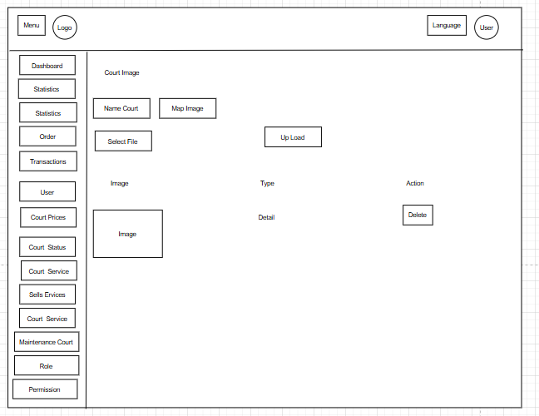

This screen allows the User to:

* View Image: View map and field photos of each field.
* Select Court: choose the court by entering the court name in the Name Court field.
* Select Map Image: optionally enter or select the court's map image in the Map Image field.
* Delete Image: Click "Delete" to remove an image.
* Upload Image: upload the selected image file to the system using the Upload button**.**

On the screen, s/he can also:

* Navigate to Key Management Sections: Access different management areas through the left sidebar, including Dashboard, Statistics, Order, Transactions, User, Court Prices, Court Status, Court Service, Sell Services, Maintenance Court, Role, and Permission.
* Change Language: switch the website language by clicking the "Language" button.

**Field Description**

| **Field Name** | **Description** |
| --- | --- |
| Menu | Sidebar menu with navigation options: Dashboard, Statistics, Order, Transactions, User, Court Prices, Court Status, Court Service, Maintenance Court, Role, Permission. |
| Language | Allows the user to select the language of the application (e.g., English, Vietnamese). |
| User | Displays the current user’s profile or logout option. |
| Court Image | Section title indicating the list of court images. |
| Name Court | Data type: any string, max length of 100 characters. Displays the name of the court associated with the image, sourced from the database (DB). |
| Map Image | Displays the image map or preview of the court image |
| Select File | Button to allow the user to select an image file for upload. |
| Upload | Button to upload the selected image file to the database (DB). |
| Type | Data type: any string, max length of 50 characters. Displays the type of image (e.g., Court Map) |
| Action | Contains actions for the image, such as the "Delete" button. |
| Delete | Button to remove the court image |
| Image | Displays the court image, sourced |
| Detail | Displays detailed information about the court images |

#### 

#### 2.1.35 View History Transaction Screen

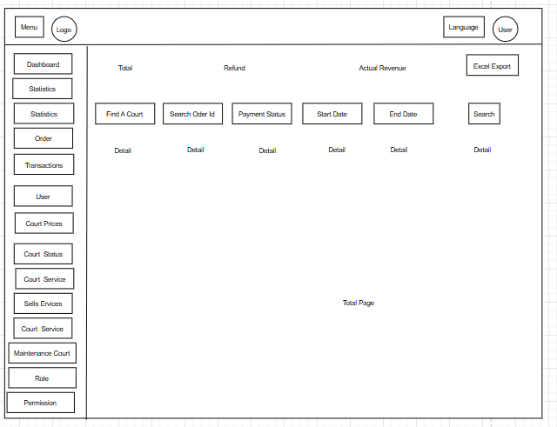

This screen allows the User to:

* View Statistics: view overall statistics including Total, Refund, and Actual Revenue
* Search and Filter Records: search and filter transaction statistics.
* Export to Excel: export the displayed data to an Excel file by clicking the Excel Export button.

On the screen, s/he can also:

* Navigate to Key Management Sections: Access different management areas through the left sidebar, including Dashboard, Statistics, Order, Transactions, User, Court Prices, Court Status, Court Service, Sell Services, Maintenance Court, Role, and Permission.
* Change Language: switch the website language by clicking the "Language" button.

**Field Description**

| **Field Name** | **Description** |
| --- | --- |
| Menu | Sidebar menu with navigation options: Dashboard, Statistics, Order, Transactions, User, Court Prices, Court Status, Court Service, Maintenance Court, Role, Permission. |
| Language | Allows the user to select the language of the application (e.g., English, Vietnamese). |
| User | Displays the current user’s profile or logout option. |
| Total | Displays the total amount of transactions |
| Refund | Displays the total refund amount |
| Actual Revenue | Displays the actual revenue after refunds |
| Find A Court | Data type: any string, max length of 100 characters. Allows the user to filter transactions by court name. |
| Search Order Id | Data type: any string, max length of 50 characters. Allows the user to search for a specific order ID. |
| Payment Status | Data type: predefined options (e.g., Paid, Pending). Allows the user to filter by payment status. |
| Start Date | Data type: date, format (e.g., DD/MM/YYYY). Allows the user to filter transactions by start date. |
| End Date | Data type: date, format (e.g., DD/MM/YYYY). Allows the user to filter transactions by end date. |
| Search | Button to apply the filters and search for transactions. |
| Excel Export | Button to export the transaction history as an Excel report. |
| Detail | Displays detailed information about the transactions |
| Total | Displays the total number of pages in the transaction list for pagination purposes |

#### 

#### 2.1.36 View History Order Screen

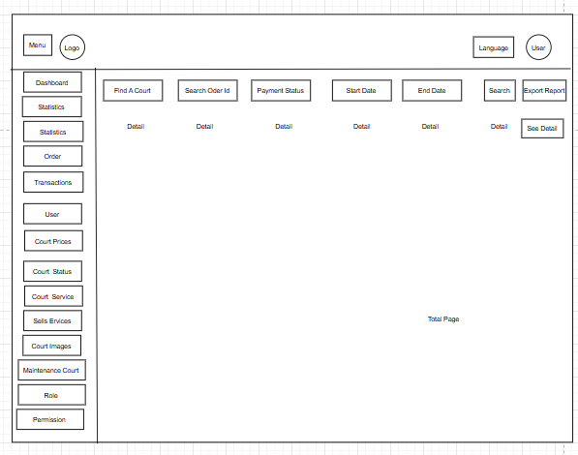

This screen allows the User to:

* View Order: View order history including information.
* Search and Filter Records: search and filter Order.
* Export to Excel: export the displayed data to an Excel file by clicking the Excel Export button.

On the screen, s/he can also:

* Navigate to Key Management Sections: Access different management areas through the left sidebar, including Dashboard, Statistics, Order, Transactions, User, Court Prices, Court Status, Court Service, Sell Services, Maintenance Court, Role, and Permission.
* Change Language: switch the website language by clicking the "Language" button.

**Field Description**

| **Field Name** | **Description** |
| --- | --- |
| Menu | Sidebar menu with navigation options: Dashboard, Statistics, Order, Transactions, User, Court Prices, Court Status, Court Service, Maintenance Court, Role, Permission. |
| Language | Allows the user to select the language of the application (e.g., English, Vietnamese). |
| User | Displays the current user’s profile or logout option. |
| Find A Court | Data type: any string, max length of 100 characters. Allows the user to filter orders by court name. |
| Search Order Id | Data type: any string, max length of 50 characters. Allows the user to search for a specific order ID. |
| Payment Status | Data type: predefined options (e.g., Paid, Pending). Allows the user to filter by payment status. |
| Start Date | Data type: date, format (e.g., DD/MM/YYYY). Allows the user to filter orders by start date. |
| End Date | Data type: date, format (e.g., DD/MM/YYYY). Allows the user to filter orders by end date. |
| Search | Button to apply the filters and search for orders. |
| Export Report | Button to export the order history as a report. |
| See Detail | Button to navigate to the detailed view of a specific order. |
| Detail | Displays detailed information about the orders |
| Total Page | Displays the total number of pages in the order list for pagination purposes. |

#### 

#### 2.1.37 View Data Analysis Screen

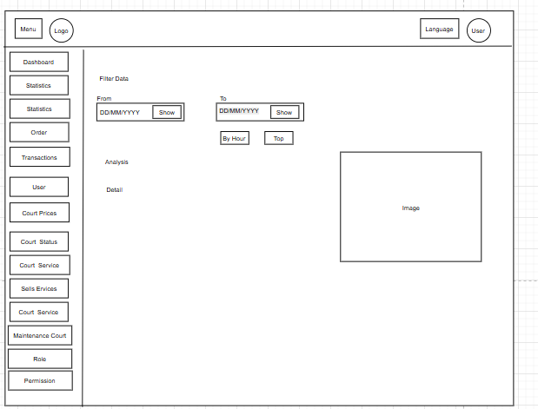

This screen allows the User to:

* Filter Data: Filter records by selecting a "From" and "To" date range and clicking the "Show" button.
* View Analysis and Details: View analysis results and detailed data after filtering.
* View by Hour or Top Records: Display data by hour or show the top records by clicking the "By Hour" or "Top" buttons.

On the screen, the User can also:

* Navigate to Key Management Sections: Access main management sections through the left sidebar, including Dashboard, Statistics, Order, Transactions, User, Court Prices, Court Status, Court Service, Sell Services, Maintenance Court, Role, and Permission.
* Change Language: Switch the website’s language by clicking the "Language" button.

**Field Description**

| **Field Name** | **Description** |
| --- | --- |
| Menu | Sidebar menu with navigation options: Dashboard, Statistics, Order, Transactions, User, Court Prices, Court Status, Court Service, Maintenance Court, Role, Permission. |
| Language | Allows the user to select the language of the application (e.g., English, Vietnamese). |
| User | Displays the current user’s profile or logout option. |
| Filter Data | Section title for filtering the data analysis. |
| From | Data type: date, format (e.g., DD/MM/YYYY). Allows the user to select the start date for analysis. |
| To | Data type: date, format (e.g., DD/MM/YYYY). Allows the user to select the end date for analysis |
| Show | Button opens a calendar for selection. |
| By Hour | Displays analysis data broken down by hour |
| Top | Displays top metrics or data points in the analysis |
| Analysis | Displays detailed analytical data |
| Image | Displays visual representations (e.g., charts or graphs) of the analysis |

#### 

#### 2.1.38 View Data Statistic Screen

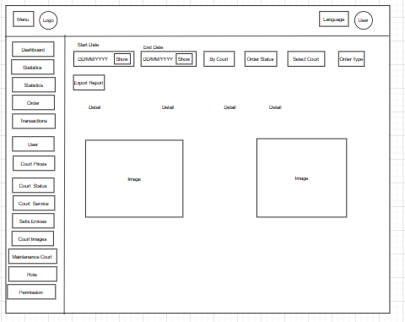

This screen allows the User to:

* Filter Data: Select a date range by choosing "Start Date" and "End Date" and clicking the "Show" button.
* Filter by Court, Order Status, and Order Type: Narrow down results further by selecting specific courts, order statuses, and order types.
* Export Report: Export the filtered data to a report file by clicking the "Export Report" button.
* View Detailed statistic: View detailed analysis presented through multiple detail sections and visual charts/images.

On the screen, the User can also:

* Navigate to Key Management Sections: Access main management sections through the left sidebar, including Dashboard, Statistics, Order, Transactions, User, Court Prices, Court Status, Court Service, Sell Services, Maintenance Court, Role, and Permission.
* Change Language: Switch the website’s language by clicking the "Language" button.

**Field Description**

| **Field Name** | **Description** |
| --- | --- |
| Menu | Sidebar menu with navigation options: Dashboard, Statistics, Order, Transactions, User, Court Prices, Court Status, Court Service, Maintenance Court, Role, Permission. |
| Language | Allows the user to select the language of the application (e.g., English, Vietnamese). |
| User | Displays the current user’s profile or logout option. |
| Start Date | Data type: date, format (e.g., DD/MM/YYYY). Allows the user to select the start date for statistics |
| End Date | Data type: date, format (e.g., DD/MM/YYYY). Allows the user to select the end date for statistics. |
| Show | Button opens a calendar for selection. |
| By Court | Data type: predefined options (e.g., list of courts). Allows the user to filter statistics by court |
| Order Status | Data type: predefined options (e.g., Completed, Pending). Allows the user to filter by order status. |
| Select Court | Data type: predefined options (e.g., list of courts). Allows the user to select a specific court for statistics. |
| Order Type | Data type: predefined options (e.g., Daily, Intensive). Allows the user to filter by order type. |
| Export Report | Button to export the statistical data as a report. |
| Detail | Displays detailed statistical data |
| Image | Displays visual representations (e.g., charts or graphs) of the statistics |

###### 

## 4. Non-Functional Requirements

### 4.1 External Interfaces

**User Interface:**

* The system must provide a **modern and user-friendly web interface** accessible via major browsers (Chrome, Firefox, Edge).
* The UI must follow **WCAG 2.1 accessibility standards**, ensuring usability for users with disabilities.
* Interface elements (buttons, menus, notifications) must be **responsive and mobile-friendly**, working seamlessly on desktop, tablet, and smartphone.

**Hardware Interface:**

* Compatible with common hardware platforms: **PCs, laptops, tablets, smartphones**.
* Must support integration with **time attendance devices** (e.g. fingerprint scanners) for staff check-in/out features (if implemented).

**Software / System Interface:**

* The system must support secure API integration with **external systems** (e.g., HRM or club membership systems).
* Must provide **RESTful API endpoints** for booking, user, payment, and inventory data exchange with partner services or mobile apps.

**Communication Interface:**

* All data exchange must be done over **HTTPS (TLS 1.2 or higher)** for security.
* The system must support **in-app notifications and reminders**, such as booking confirmations, payment alerts, and schedule changes.

### 4.2 Quality Attributes

#### 4.2.1 Usability

* **Standardized Interface**:  
   Must follow modern UI patterns (e.g., Google Material Design or IBM Carbon Design) for consistency.
* **Consistency & Branding**:  
   All screens must use the same **colors, font families, icons**, and layout system to ensure brand recognition and intuitive use.
* **Responsive Design**:  
   Interface must automatically adapt to different screen sizes, orientations, and resolutions.
* **Clear Navigation**:  
   Use **bottom navigation (mobile)** and/or **left sidebar menu (web)** to simplify access to features like “Book Court”, “My Bookings”, “Profile”, etc.
* **Interactive UX**:  
  + Search bars must show **instant (real-time)** suggestions/results.
  + Calendar pickers must highlight **available/unavailable time slots** dynamically.
* **Error Handling**:  
  + Display short, clear error messages in **red**.
  + Show **green success messages** when actions are completed.

#### 4.2.2 Reliability

* **Availability**:  
   System uptime must reach **99.95%**, except during scheduled maintenance.
* **Accuracy**:  
  + Booking and payment data must be **99.99% accurate**, especially when calculating total amounts and applying discounts.
  + User access rights (Owner, staff, guest) must always reflect current status.

#### 4.2.3 Performance

* **Response Time**:  
   95% of user interactions (e.g., search, booking, payment) must respond in under **2 seconds**.
* **Throughput**:  
   System must handle up to **500 concurrent transactions per second** during peak usage (e.g., holidays, weekends).
* **Capacity**:  
   Must support at least **10,000 concurrent users** and **1 million transactions/day** without crashing.
* **Resource Usage**:  
   CPU usage must stay below **75%** and RAM below **70%** under normal usage conditions.
* **Scalability**:  
   The system must allow **horizontal and vertical scaling**, ensuring stable performance when expanding to new courts, locations, or features (e.g.,, equipment rental).

#### 4.2.4 Maintainability

* **Modular Codebase**:  
   The backend/frontend code should be **modular and component-based**, allowing isolated updates without system-wide impact.
* **Seamless Upgrades**:  
   The system must support **hot deployment/automatic upgrade mechanisms** that do not disrupt ongoing bookings or sessions.
* **Technical Documentation**:  
  + Must include full documentation for:  
    - REST API
    - User manual (for club staff and end-users)
    - System architecture (for dev/IT team)

## 5. Requirement Appendix

### 5.1 Business Rules

| **ID** | **Business Rule** | **Description** |
| --- | --- | --- |
| BR-01 | Court Booking Limitations | Users can only hold one active booking for the same time slot. |
| BR-02 | Booking Payment Rule | A deposit or full payment must be completed before a booking is confirmed. |
| BR-03 | Refund Policy | Refunds are processed automatically, deducting the deposit amount. No refund if cancellation happens too close to the play time (within defined threshold). |
| BR-04 | User Role Access | Only Owners can create, update, or delete user roles. Managers and Staff have restricted access according to assigned permissions. |
| BR-05 | Maintenance Scheduling | Courts under maintenance cannot be booked. Courts must be deactivated during the maintenance period. |
| BR-06 | Service Availability | Only active services can be selected and ordered by users. Deactivated services are hidden from customer-facing screens. |
| BR-07 | Notification Delivery | Critical events (e.g., booking confirmation, payment success) must trigger real-time notifications via in-app and optionally email. |
| BR-08 | Session Timeout | User sessions expire after 30 minutes of inactivity for security reasons. |
| BR-09 | Student Discount Eligibility | Student discounts are granted only after email verification with a .edu.vn domain or submission of a valid student ID. |
| BR-10 | Financial Reporting | All revenue reports and transaction histories must be exportable into Excel format (.xlsx) for auditing and financial review. |

### 

### 5.2 Common Requirements

| **ID** | **Business Rule** | **Description** |
| --- | --- | --- |
| CR-01 | Cross-Platform Compatibility | The system must support web browsers (desktop/tablet/mobile) and mobile applications (Android). |
| BR-02 | Responsive Design | UI must adjust automatically across different screen sizes and devices. |
| BR-03 | Localization | The system must support Vietnamese and English languages, with easy switching. |
| BR-04 | QR Code Payment Integration | Payment system must support MB Bank QR payment generation and status verification. |
| BR-05 | Security Standards | Passwords must be encrypted. Sensitive user data must follow GDPR or equivalent local privacy protection standards. |
| BR-06 | Notification Management | Users should be able to mark notifications as read and manage notification preferences. |
| BR-07 | Error Handling | System must show clear error messages and guidance in case of failures (e.g., failed payment, failed booking). |
| BR-08 | Data Backup | Database must have scheduled backup at least once per day to prevent data loss. |
| BR-09 | System Availability | The system should maintain 99.5% uptime outside of scheduled maintenance windows. |
| BR-10 | Scalability | The system must be scalable to support future expansion to other cities or additional facilities. |

### 

### 5.3 Application Messages List

### 5.4 Other Requirements…

# IV. Software Design Description

## 1. System Design

### 1.1 System Architecture

#### 1.1.1 . Design

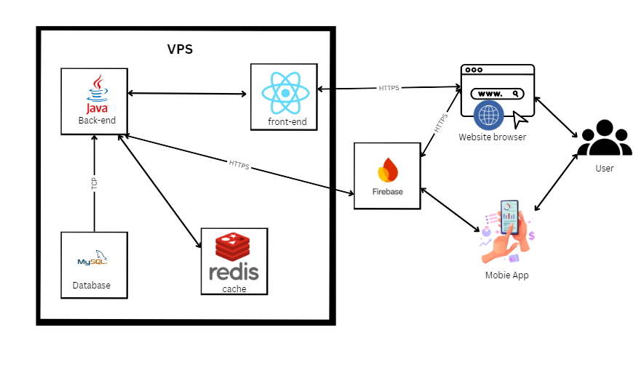

Figure 4.1: System Architecture

#### 1.1.2 . Component Explanation

**1.1.2.1 . Spring boot (Java 17)**



Java Spring Boot is a powerful software development framework used to build server-side HR management applications, APIs, and other back-end functionalities for the GF-HRMS system. It offers a flexible and easy-to-configure development environment and supports deployment across multiple platforms.

**1.1.2.2. React**



React is a JavaScript library used to develop the user interface for the GF-HRMS system. It helps build dynamic web interfaces that are easy to use and responsive to users.

**1.1.2.3. MySQL**



MySQL is a relational database management system (RDBMS) used to store and manage human resources data in the GF-HRMS system. It is known for its reliability, ease of use, and strong support for structured queries. MySQL also provides solid performance, scalability, and security for managing HR-related transactions and data.

**1.1.2.4. FireBase**



Firebase is a comprehensive platform developed by Google that provides cloud-based services for building and managing applications, including those related to human resources in the GF-HRMS system. It offers real-time database management, cloud storage, authentication services, and hosting. Firebase ensures seamless synchronization of HR data across multiple clients, improves application responsiveness, and enhances security with robust access control and authentication mechanisms.

**1.1.2.5. Redis  
  
   
 **Redis (Remote Dictionary Server) is a source-available, in-memory storage, used as a distributed, in-memory key–value database, cache and message broker, with optional durability. Because it holds all data in memory and because of its design, Redis offers low-latency reads and writes, making it particularly suitable for use cases that require a cache. Redis is the most popular NoSQL database, and one of the most popular databases overall. Redis is used in companies like Twitter, Airbnb, Tinder, Yahoo, Adobe, Hulu, Amazon and OpenAI.

### 1.2 Package Diagram

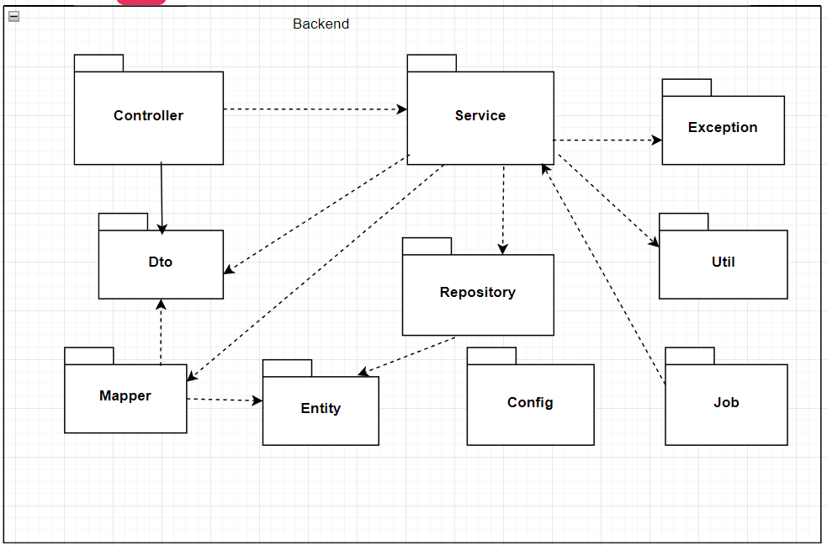  
Figure 4.2: Package Diagram backend  
Package Descriptions for backend

| No | Package | Description |
| --- | --- | --- |
| 01 | Controller | Process requests from clients |
| 02 | Service | Contains business logic (main business of the system) |
| 03 | Repository | Communicate directly with database |
| 04 | Dto | Helps control information display and validate data input. |
| 05 | Mapper | Converts between Entity and DTO |
| 06 | Entity | Represents tables in the database |
| 07 | Exception | Error management and handling (Exception handling). |
| 08 | Util | Utility classes (utility classes). |
| 09 | Config | System configuration (configuration) |
| 10 | Job | Defines jobs that run automatically over time |

### 

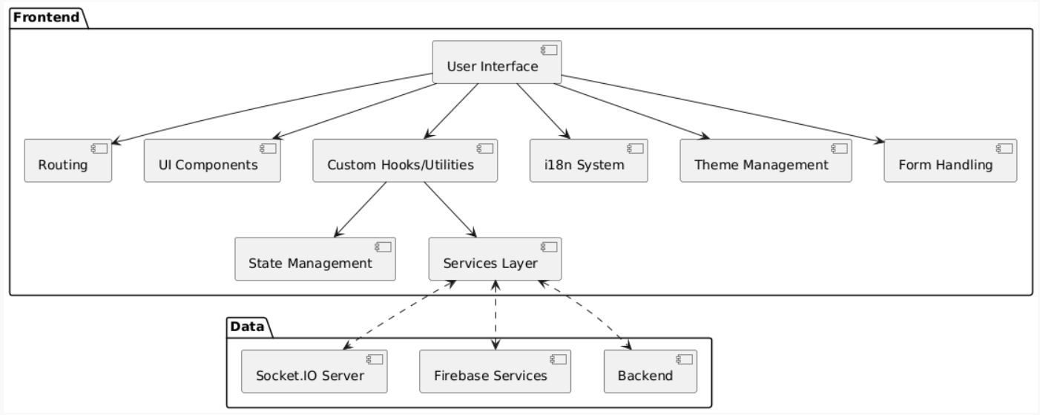  
Figure 4.2: Package Diagram Frontend  
Package Descriptions for Frontend

| No | Package | Description |
| --- | --- | --- |
| 01 | User Interface | Responsible for displaying the interface to the user, depends on many other packages to perform specific functionality |
| 02 | Routing | Manage Navigation between different pages or sections of the web when the user interacts, this package will determine what content to display |
| 03 | UI Components | Contains reusable user interface components. This UI will use components to display to the user. |
| 04 | State Management | Manage web states when data or web state changes, this package will update notifications to the relevant UI so they can re-render. |
| 05 | Services Layer | Responsible for communicating with BE or other data sources. These Services can make API calls to process the returned data. |
| 06 | Custom Hooks/Utilities | Contains Custom Hooks or utility functions used throughout the website to perform specific tasks or share logic. |
| 07 | i18n System | Responsible for displaying multilingual content |
| 08 | Theme Management | Manage the appearance of the website, allowing us to change colors, fonts, etc. |
| 09 | Form Handling | Handles the logic of creating, collecting, and validating data through user forms. |
| 10 | Socket.IO Server | Can be used for real-time communication between FE and BE |
| 11 | Firebase Services | Includes services: Cloud, Storage. Applies to receiving notifications and images. |
| 12 | Backend | Represents the Server-Side of the website, where we process business logic and data |

Figure 4.2: Package Diagram Mobile  
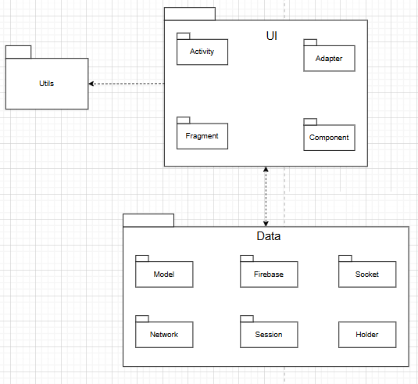

Package Descriptions for Mobile App

| No | Package | Description |
| --- | --- | --- |
| 01 | Activity | Contains Activity classes, which are the main components in Android applications, responsible for managing the user interface (UI) and handling user interactions with specific screens. |
| 02 | Adapter | Stores Adapter classes, used to connect data to interface components such as ListView, RecyclerView, which help display data in the form of lists or grids |
| 03 | Fragment | Contains Fragment classes, which are modular UI components that can be reused in Activities, helping to manage the interface flexibly, especially on devices with large screens. |
| 04 | Component | Includes reusable or modular components (such as UI components, custom views), which help increase reusability and better organize code. |
| 05 | Model | Stores data model classes, which represent the application's data structure, often used to store and process data from APIs or databases. |
| 06 | Firebase | Contains code related to integrating and using Firebase, such as database management (Firestore), user authentication, or push notifications (FCM). |
| 07 | Socket | Includes classes that handle socket connections (WebSocket or TCP), often used for real-time communication between clients and servers, for example for chat or live data updates. |
| 08 | Network | Contains classes related to network handling, such as calling APIs (usually using Retrofit, OkHttp), managing HTTP requests, and handling responses from the server. |
| 09 | Session | Manages user sessions, such as storing login information, authentication tokens, or session state in the application. |
| 10 | Holder | Usually contains ViewHolder classes, used in Adapters to optimize list display (for example, in RecyclerView), helping to reuse views and reduce rendering costs. |
| 11 | Utils | Includes utility classes, containing common support functions such as string processing, date and time formatting, or other utility functions used throughout the application. |

Table 4.1: Package Descriptions

## 2. Database Design

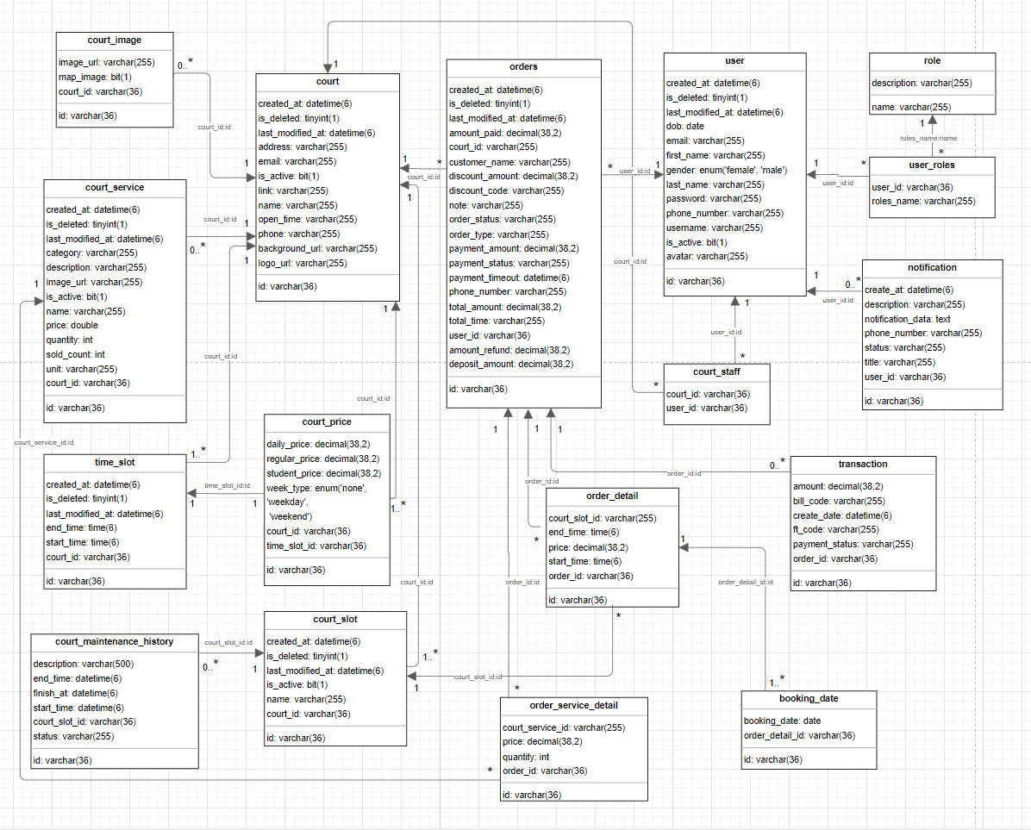

Table 4.2: Table Descriptions Database Design

### 2.1. Court

| No | Field | PK | FK | UN | NN | Description |
| --- | --- | --- | --- | --- | --- | --- |
| 1 | id | ✓ |  | ✓ | ✓ | Unique identifier for the court (UUID) |
| 2 | created_at |  |  |  | ✓ | Timestamp when the court record was created |
| 3 | last_modified_at |  |  |  | ✓ | Timestamp when the court record was last updated |
| 4 | is_deleted |  |  |  | ✓ | Flag indicating if the court is marked as deleted |
| 5 | name |  |  | ✓ | ✓ | Name of the court |
| 6 | address |  |  |  | ✓ | Physical address of the court |
| 7 | phone |  |  |  | ✓ | Contact phone number for the court |
| 8 | open_time |  |  |  |  | Operating hours of the court |
| 9 | is_active |  |  |  |  | Flag indicating if the court is currently active |
| 10 | email |  |  |  |  | Email contact for the court |
| 11 | link |  |  |  |  | Website or other relevant link |
| 12 | logo_url |  |  |  |  | URL to the court's logo image |
| 13 | background_url |  |  |  |  | URL to the court's background image |

### 2.2. Court Image

| No | Field | PK | FK | UN | NN | Description |
| --- | --- | --- | --- | --- | --- | --- |
| 1 | id | ✓ |  | ✓ | ✓ | Unique identifier for the court image (UUID) |
| 2 | court_id |  | ✓ |  | ✓ | Reference to the associated court |
| 3 | image_url |  |  |  | ✓ | URL to the image file |
| 4 | map_image |  |  |  |  | Flag: true = map/layout image; false = regular photo |

### 2.3. Court Service

| No | Field | PK | FK | UN | NN | Description |
| --- | --- | --- | --- | --- | --- | --- |
| 1 | id | ✓ |  | ✓ | ✓ | Unique identifier for the court service (UUID) |
| 2 | created_at |  |  |  | ✓ | Timestamp when the service record was created |
| 3 | last_modified_at |  |  |  | ✓ | Timestamp when the service record was last updated |
| 4 | is_deleted |  |  |  | ✓ | Flag indicating if the service is marked as deleted |
| 5 | court_id |  | ✓ |  | ✓ | Reference to the associated court |
| 6 | category |  |  |  | ✓ | Category of the service (e.g., Equipment, Refreshments) |
| 7 | name |  |  |  | ✓ | Name of the service |
| 8 | price |  |  |  | ✓ | Price of the service |
| 9 | quantity |  |  |  | ✓ | Available quantity |
| 10 | unit |  |  |  | ✓ | Unit of measure (e.g., hour, piece) |
| 11 | description |  |  |  |  | Detailed description |
| 12 | image_url |  |  |  |  | URL to an image representing the service |
| 13 | is_active |  |  |  | ✓ | Flag indicating if the service is currently available |
| 14 | sold_count |  |  |  |  | Counter tracking how many times the service has been sold |

### 2.4. Time Slot

| No | Field | PK | FK | UN | NN | Description |
| --- | --- | --- | --- | --- | --- | --- |
| 1 | id | ✓ |  | ✓ | ✓ | Unique identifier for the time slot (UUID) |
| 2 | created_at |  |  |  | ✓ | Timestamp when the time slot was created |
| 3 | last_modified_at |  |  |  | ✓ | Timestamp when the time slot was updated |
| 4 | is_deleted |  |  |  | ✓ | Flag indicating if the slot is deleted |
| 5 | court_id |  | ✓ |  | ✓ | Reference to the associated court |
| 6 | start_time |  |  |  | ✓ | Start time of the slot |
| 7 | end_time |  |  |  | ✓ | End time of the slot |

### 2.5. Court Slot

| No | Field | PK | FK | UN | NN | Description |
| --- | --- | --- | --- | --- | --- | --- |
| 1 | id | ✓ |  | ✓ | ✓ | Unique identifier for the court slot (UUID) |
| 2 | created_at |  |  |  | ✓ | Timestamp when the court slot was created |
| 3 | last_modified_at |  |  |  | ✓ | Timestamp when the court slot was updated |
| 4 | is_deleted |  |  |  | ✓ | Flag indicating if the court slot is deleted |
| 5 | court_id |  | ✓ |  | ✓ | Reference to the associated court |
| 6 | name |  |  |  | ✓ | Name of the court slot |
| 7 | is_active |  |  |  | ✓ | Flag indicating if the court slot is active |

### 2.6. Court Maintenance History

| No | Field | PK | FK | UN | NN | Description |
| --- | --- | --- | --- | --- | --- | --- |
| 1 | id | ✓ |  | ✓ | ✓ | Unique identifier for the maintenance record (UUID) |
| 2 | court_slot_id |  | ✓ |  | ✓ | Reference to the associated court slot |
| 3 | start_time |  |  |  | ✓ | Scheduled start time of maintenance |
| 4 | end_time |  |  |  | ✓ | Scheduled end time of maintenance |
| 5 | finish_at |  |  |  |  | Actual completion time |
| 6 | description |  |  |  |  | Description of the maintenance work |
| 7 | status |  |  |  |  | Current status (e.g., Scheduled, In Progress, Completed) |

### 2.7. Court Price

| No | Field | PK | FK | UN | NN | Description |
| --- | --- | --- | --- | --- | --- | --- |
| 1 | id | ✓ |  | ✓ | ✓ | Unique identifier for the court price (UUID) |
| 2 | court_id |  | ✓ |  | ✓ | Reference to the associated court |
| 3 | time_slot_id |  | ✓ |  | ✓ | Reference to the associated time slot |
| 4 | week_type |  |  |  | ✓ | Type of week (WEEKDAY or WEEKEND) |
| 5 | regular_price |  |  |  |  | Regular price for recurring customers |
| 6 | daily_price |  |  |  | ✓ | Daily price for walk-in customers |
| 7 | student_price |  |  |  |  | Discounted price for students |

### 2.8. Orders

| No | Field | PK | FK | UN | NN | Description |
| --- | --- | --- | --- | --- | --- | --- |
| 1 | id | ✓ |  | ✓ | ✓ | Unique identifier for the order (UUID) |
| 2 | created_at |  |  |  | ✓ | Timestamp when the order was created |
| 3 | last_modified_at |  |  |  | ✓ | Timestamp when the order was updated |
| 4 | is_deleted |  |  |  | ✓ | Flag indicating if the order is deleted |
| 5 | court_id |  |  |  | ✓ | Reference to the associated court |
| 6 | customer_name |  |  |  | ✓ | Name of the customer |
| 7 | phone_number |  |  |  | ✓ | Customer contact phone number |
| 8 | note |  |  |  |  | Additional notes |
| 9 | order_type |  |  |  | ✓ | Type of order (e.g., Regular, Fixed Booking) |
| 10 | order_status |  |  |  | ✓ | Current status of the order |
| 11 | payment_status |  |  |  | ✓ | Current payment status |
| 12 | total_time |  |  |  |  | Total time booked |
| 13 | discount_code |  |  |  |  | Discount code applied |
| 14 | total_amount |  |  |  | ✓ | Total amount |
| 15 | deposit_amount |  |  |  | ✓ | Required deposit |
| 16 | discount_amount |  |  |  |  | Discount amount |
| 17 | payment_amount |  |  |  |  | Amount to be paid |
| 18 | amount_paid |  |  |  |  | Amount already paid |
| 19 | amount_refund |  |  |  |  | Amount refunded |
| 20 | payment_timeout |  |  |  |  | Deadline for payment |
| 21 | user_id |  | ✓ |  |  | Reference to the associated user |

### 2.9. User

| No | Field | PK | FK | UN | NN | Description |
| --- | --- | --- | --- | --- | --- | --- |
| 1 | id | ✓ |  | ✓ | ✓ | Unique identifier for the user (UUID) |
| 2 | created_at |  |  |  | ✓ | Timestamp when the user was created |
| 3 | last_modified_at |  |  |  | ✓ | Timestamp when the user was updated |
| 4 | is_deleted |  |  |  | ✓ | Flag indicating if the user is deleted |
| 5 | username |  |  | ✓ |  | Username for login |
| 6 | password |  |  |  | ✓ | Hashed password |
| 7 | first_name |  |  |  |  | User's first name |
| 8 | last_name |  |  |  |  | User's last name |
| 9 | dob |  |  |  |  | Date of birth |
| 10 | email |  |  | ✓ |  | User's email address |
| 11 | phone_number |  |  | ✓ |  | User's phone number |
| 12 | gender |  |  |  |  | Enum: 'MALE', 'FEMALE', 'OTHER' |
| 13 | avatar |  |  |  |  | URL to profile picture |
| 14 | is_active |  |  |  | ✓ | Flag indicating if the account is active |

### 2.10. Role

| No | Field | PK | FK | UN | NN | Description |
| --- | --- | --- | --- | --- | --- | --- |
| 1 | name | ✓ |  | ✓ | ✓ | Unique identifier/name of the role |
| 2 | description |  |  |  |  | Description of the role & permissions |

### 2.11. User Roles

| No | Field | PK | FK | UN | NN | Description |
| --- | --- | --- | --- | --- | --- | --- |
| 1 | user_id | ✓ | ✓ |  | ✓ | Reference to the user |
| 2 | roles_name | ✓ | ✓ |  | ✓ | Reference to the role |

### 2.12. Notification

| No | Field | PK | FK | UN | NN | Description |
| --- | --- | --- | --- | --- | --- | --- |
| 1 | id | ✓ |  | ✓ | ✓ | Unique identifier for the notification (UUID) |
| 2 | create_at |  |  |  |  | Timestamp when the notification was created |
| 3 | description |  |  |  |  | Detailed content |
| 4 | notification_data |  |  |  |  | Additional structured data |
| 5 | phone_number |  |  |  |  | Related phone number |
| 6 | status |  |  |  |  | Status (e.g., Read, Unread) |
| 7 | title |  |  |  |  | Title or subject |
| 8 | user_id |  | ✓ |  |  | Reference to the associated user |

### 2.13. Court Staff

| No | Field | PK | FK | UN | NN | Description |
| --- | --- | --- | --- | --- | --- | --- |
| 1 | user_id | ✓ | ✓ |  | ✓ | Reference to the user |
| 2 | court_id | ✓ | ✓ |  | ✓ | Reference to the court |

### 2.14. Transaction

| No | Field | PK | FK | UN | NN | Description |
| --- | --- | --- | --- | --- | --- | --- |
| 1 | id | ✓ |  | ✓ | ✓ | Unique identifier (UUID) |
| 2 | amount |  |  |  | ✓ | Transaction amount |
| 3 | bill_code |  |  |  | ✓ | Reference billing code |
| 4 | create_date |  |  |  | ✓ | Timestamp when created |
| 5 | ft_code |  |  |  | ✓ | Financial transaction code |
| 6 | payment_status |  |  |  | ✓ | Payment status |
| 7 | order_id |  | ✓ |  |  | Reference to the associated order |

### 2.15. Order Detail

| No | Field | PK | FK | UN | NN | Description |
| --- | --- | --- | --- | --- | --- | --- |
| 1 | id | ✓ |  | ✓ | ✓ | Unique identifier (UUID) |
| 2 | court_slot_id |  |  |  | ✓ | Reference to the court slot |
| 3 | start_time |  |  |  | ✓ | Start time of the booking |
| 4 | end_time |  |  |  | ✓ | End time of the booking |
| 5 | price |  |  |  |  | Price for this booking |
| 6 | order_id |  | ✓ |  | ✓ | Reference to the associated order |

### 2.16. Order Service Detail

| No | Field | PK | FK | UN | NN | Description |
| --- | --- | --- | --- | --- | --- | --- |
| 1 | id | ✓ |  | ✓ | ✓ | Unique identifier (UUID) |
| 2 | court_service_id |  |  |  | ✓ | Reference to the court service |
| 3 | quantity |  |  |  | ✓ | Quantity ordered |
| 4 | price |  |  |  | ✓ | Price of the service |
| 5 | order_id |  | ✓ |  | ✓ | Reference to the associated order |

### 2.17. Booking Date

| No | Field | PK | FK | UN | NN | Description |
| --- | --- | --- | --- | --- | --- | --- |
| 1 | id | ✓ |  | ✓ | ✓ | Unique identifier (UUID) |
| 2 | booking_date |  |  |  | ✓ | Date of the booking |
| 3 | order_detail_id |  | ✓ |  | ✓ | Reference to the associated detail |

## 3. Detailed Design

### *3.1 Authentication and Authorization*

#### 3.1.1 User Registration

#### 3.1.1.1 Class Diagram

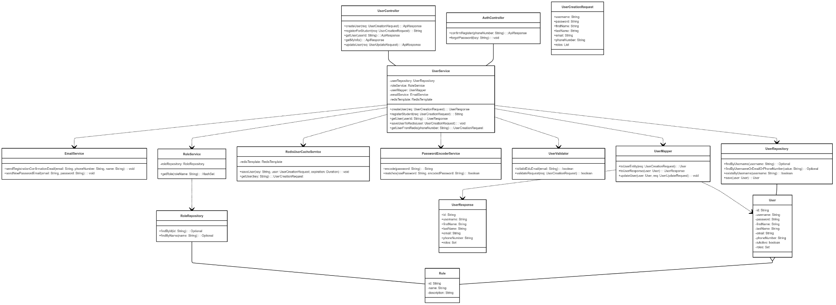

***link image: https://iili.io/3WtbzPa.png***

***3.1.1.2 Sequence Diagram***

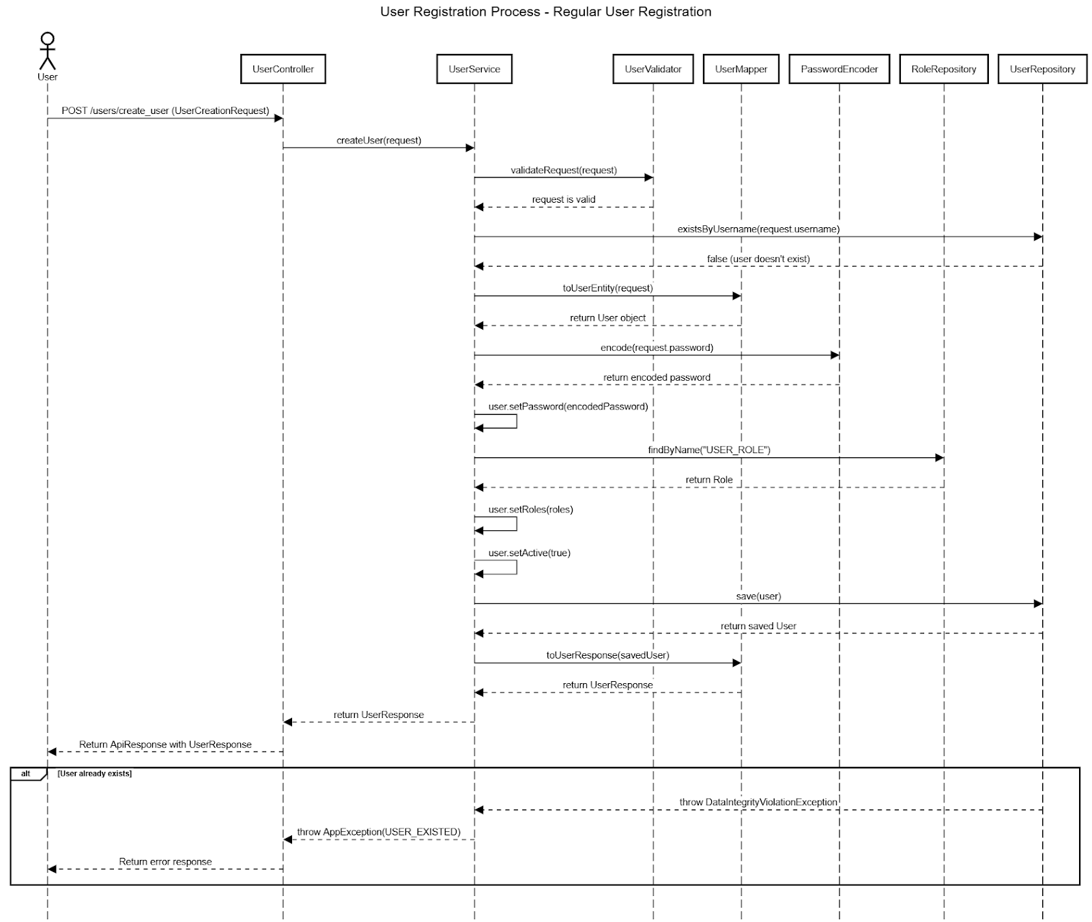

#### 3.1.2 Login

#### 3.1.2.1 Class Diagram

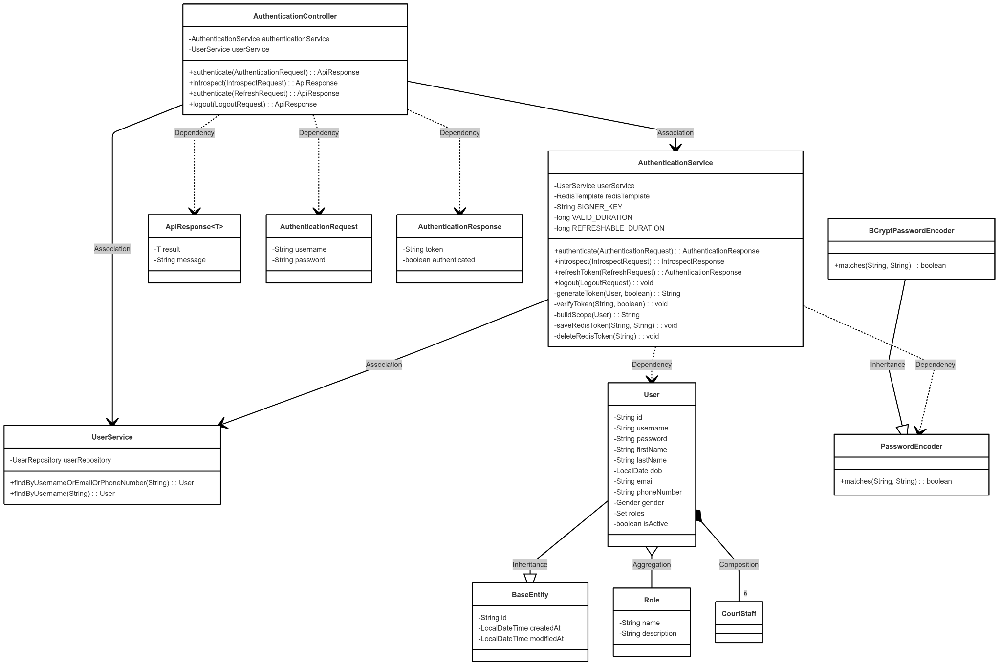

#### 3.1.2.2 Sequence Diagram

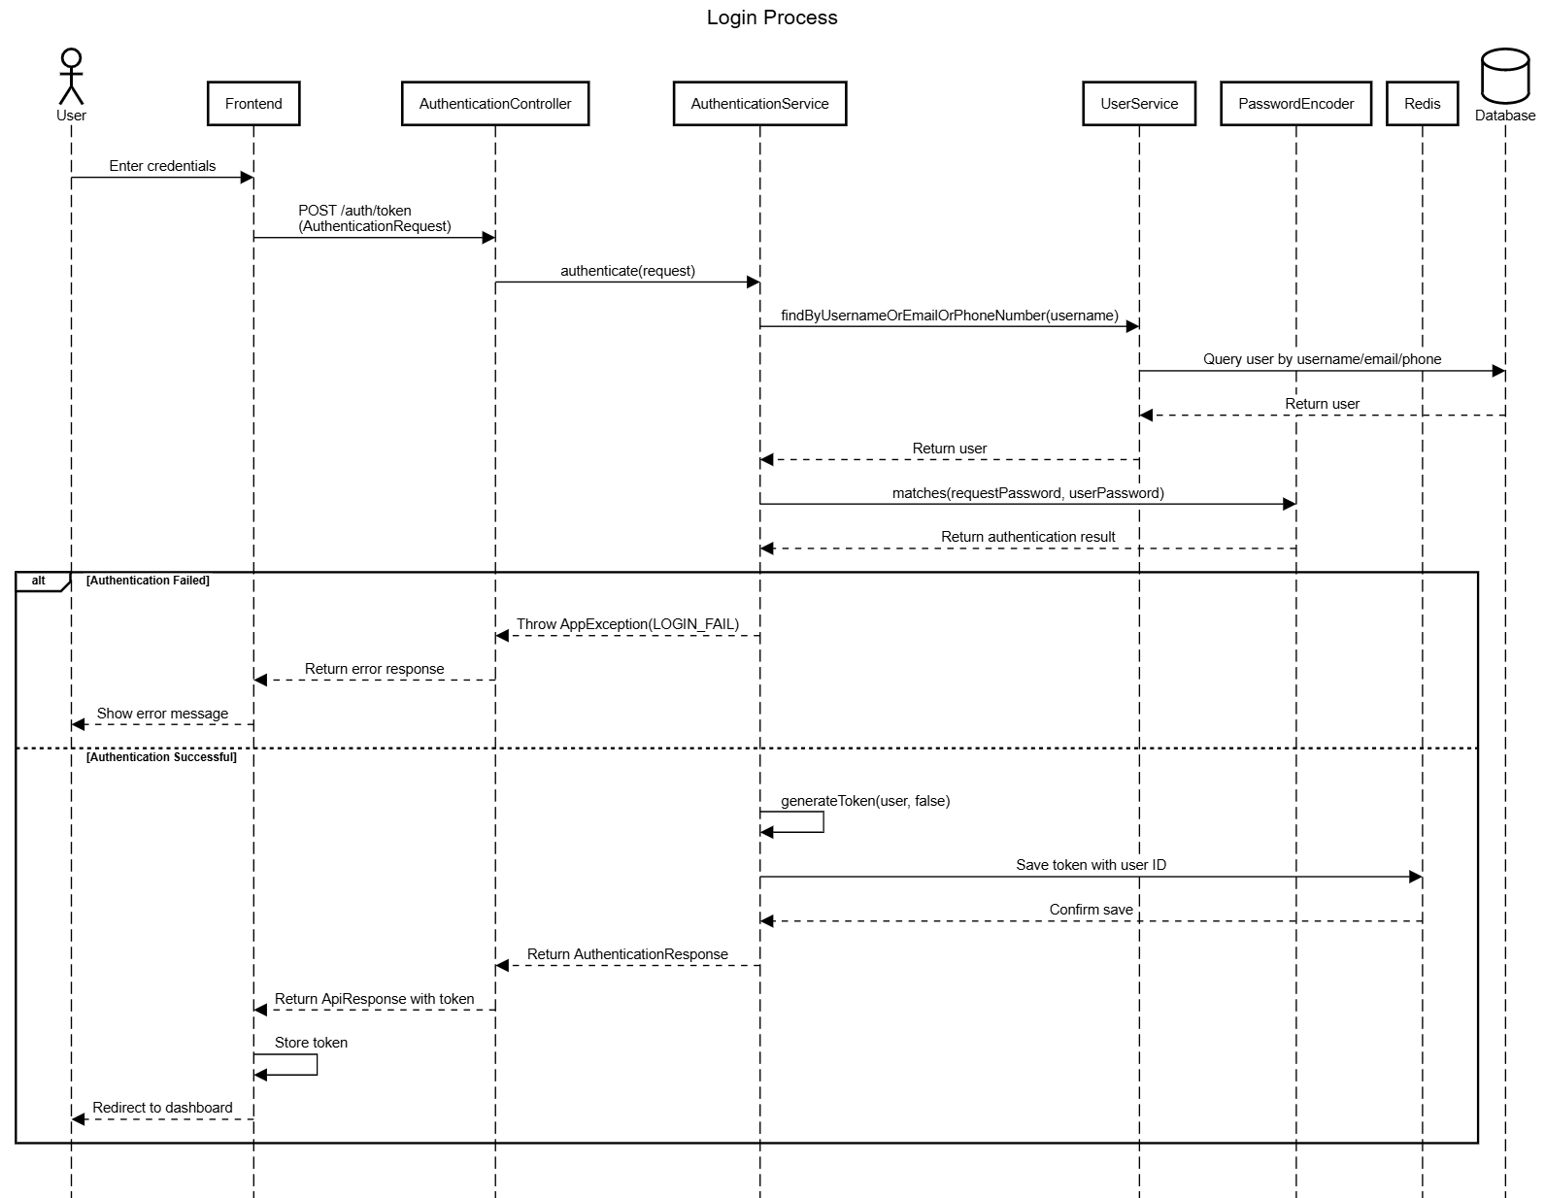

### *3.2 User Management*

#### 3.2.1 Class diagram

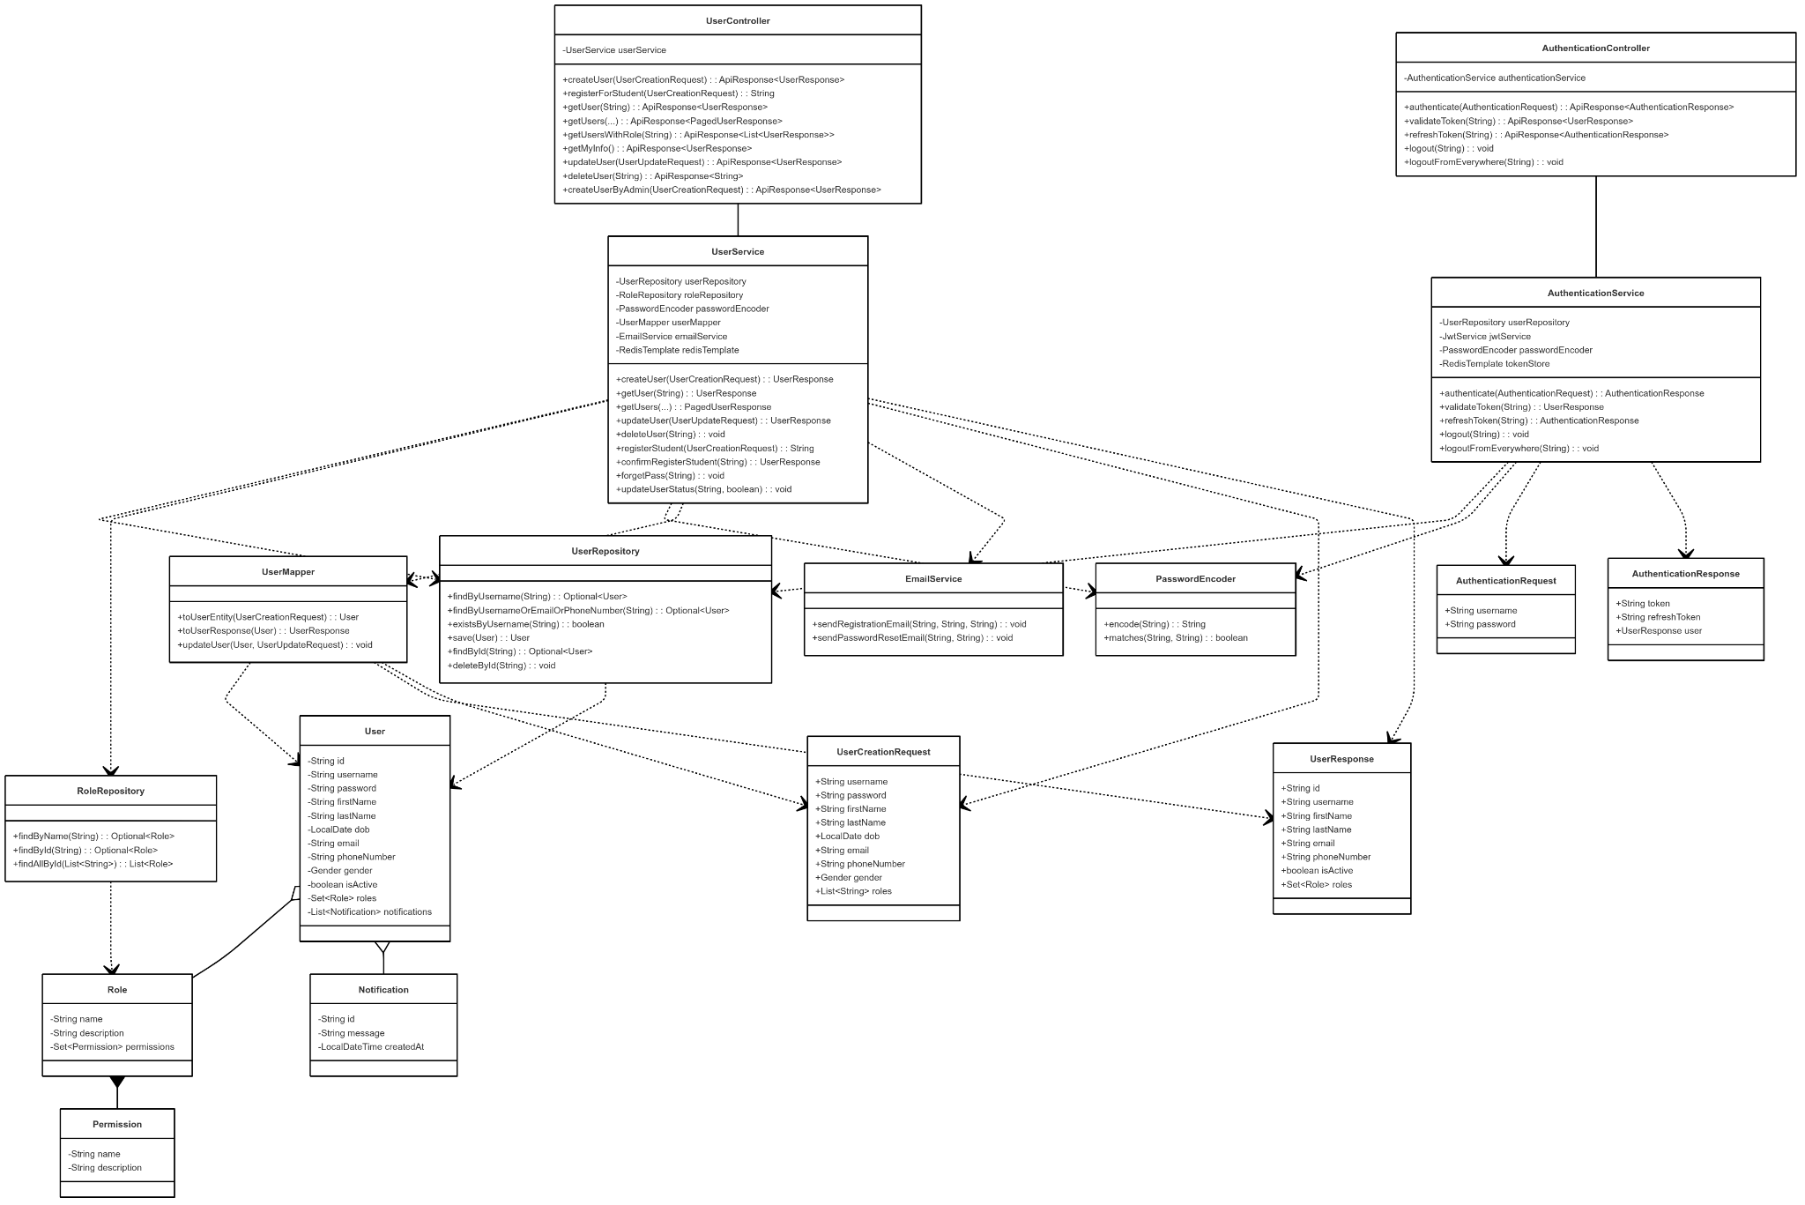

link image: https://iili.io/3WbXMyN.png

##### ***3.2.2 Sequence Diagram***

##### ***3.2.2.1 Basic Profile Management***

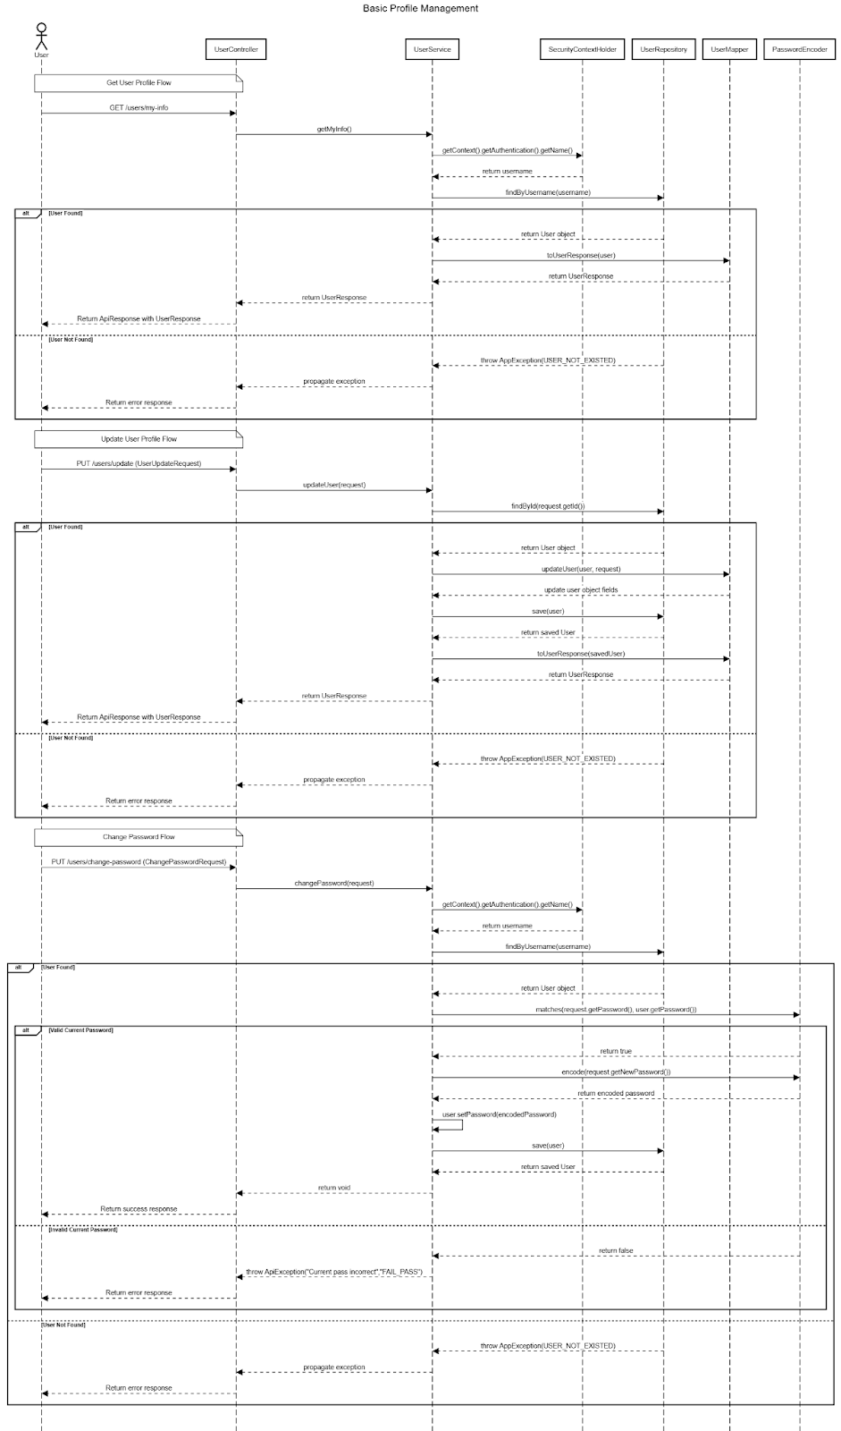

##### ***3.2.2.2 Student Registration Process***

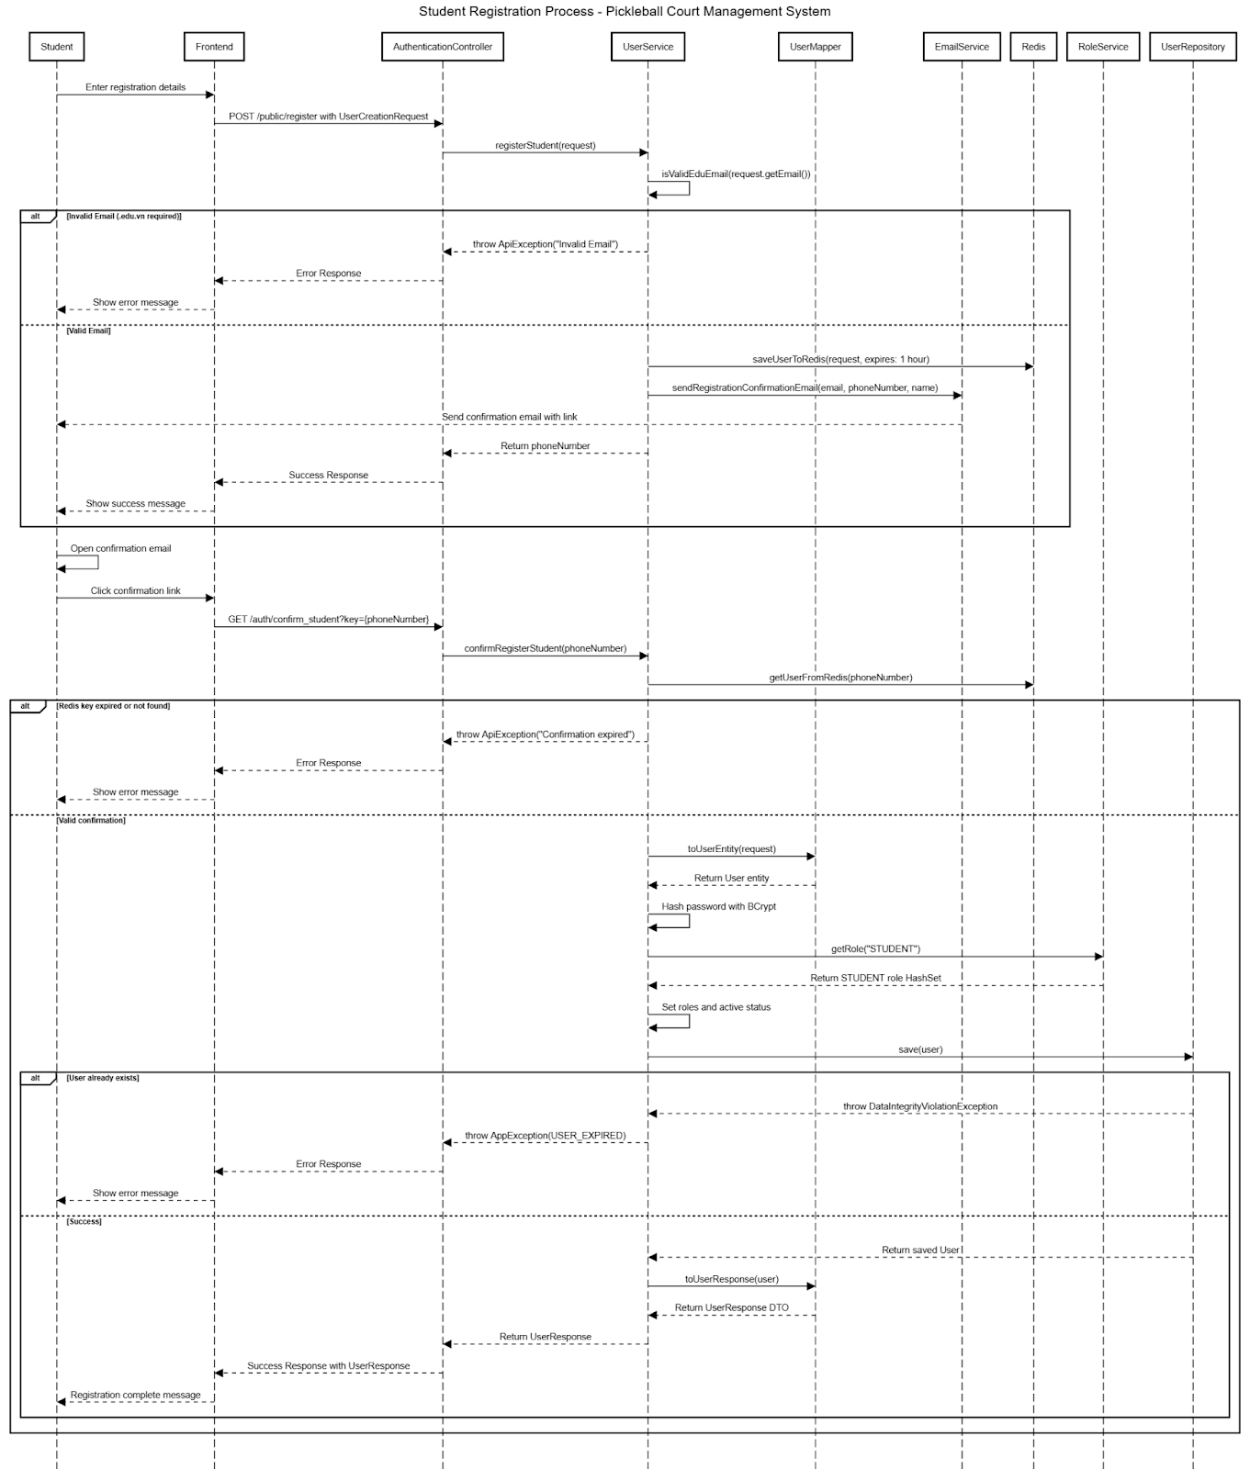

##### ***3.2.2.3 Password Recovery Flow***

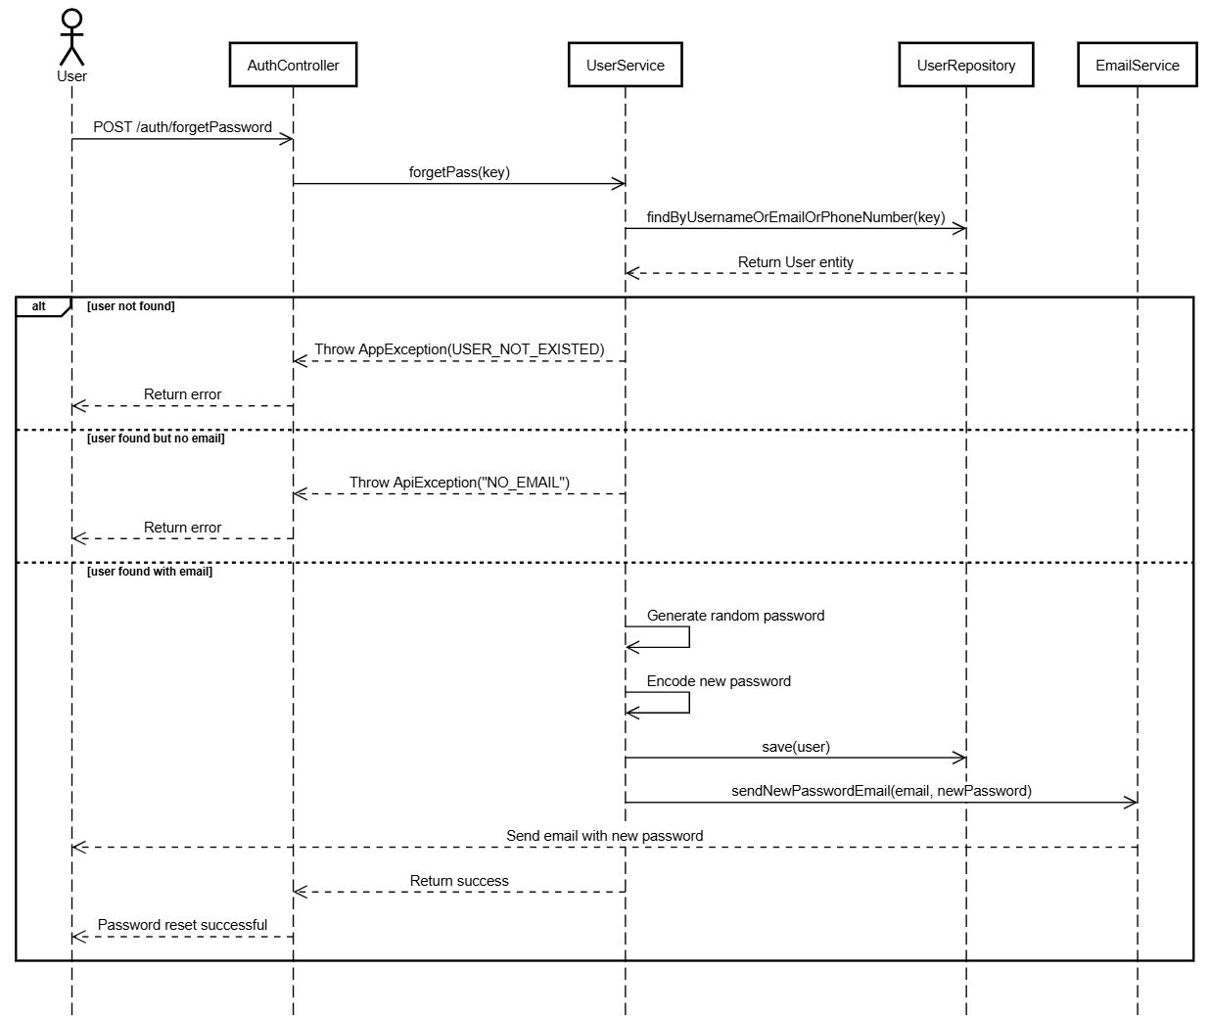

##### ***3.2.2.4 Admin User Management***

##### ***3.2.2.4.1 Get All Users Flow***

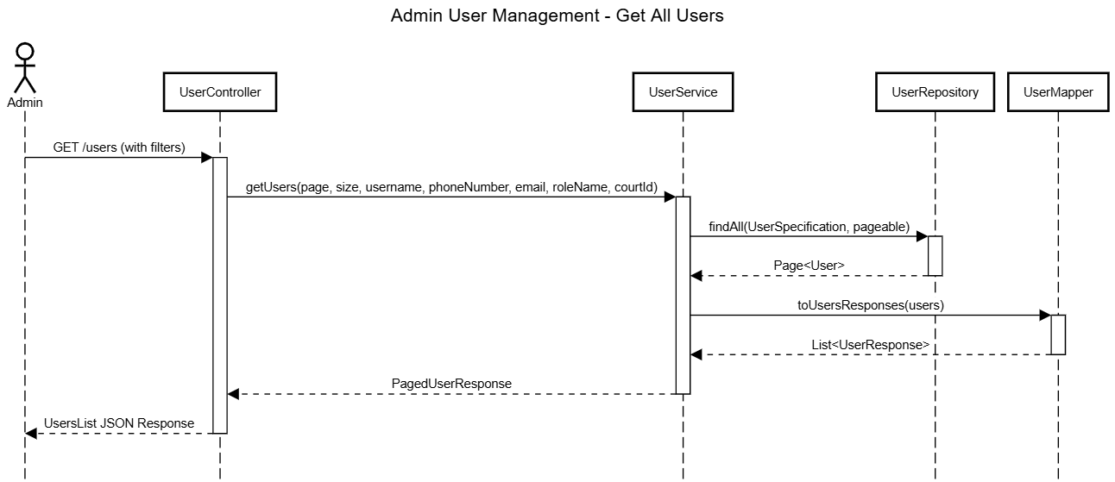

##### ***3.2.2.4.2 Get Specific User Flow***

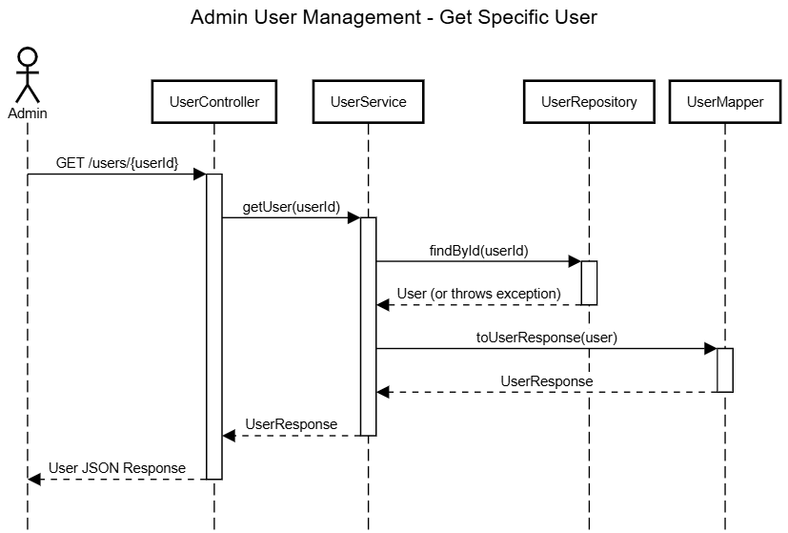

##### ***3.2.2.4.3 Create User Flow***

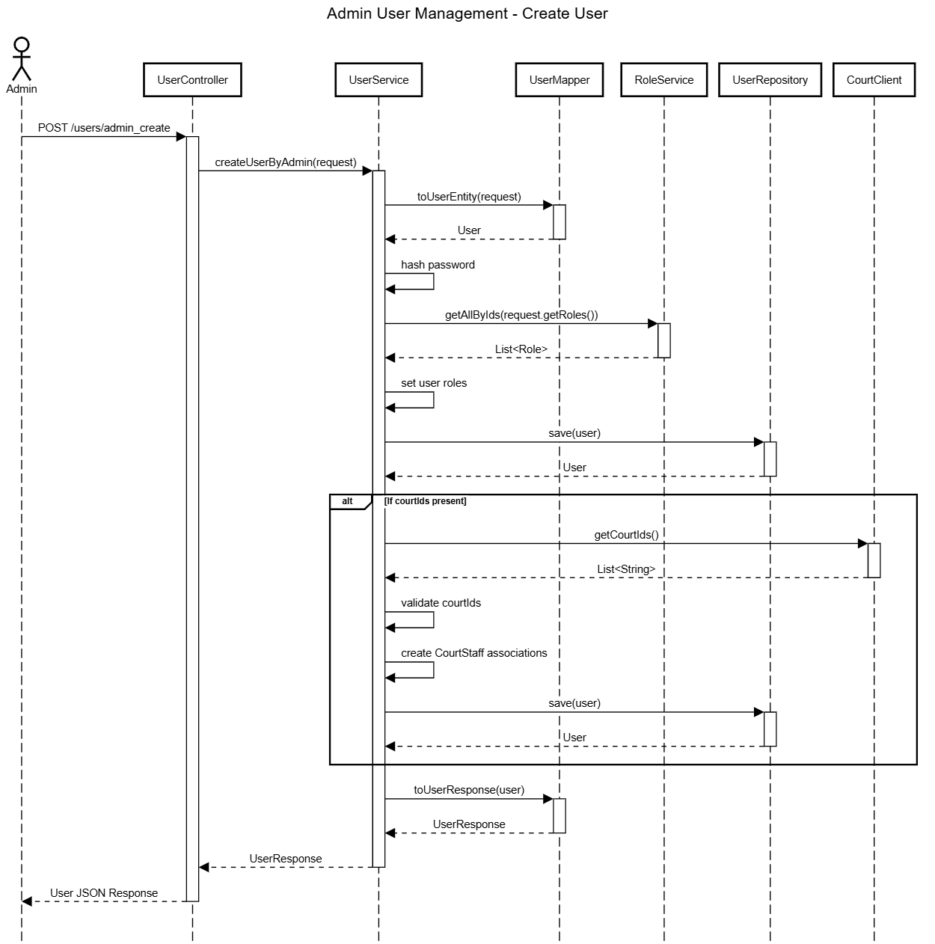

##### ***3.2.2.4.4 Update User Flow***

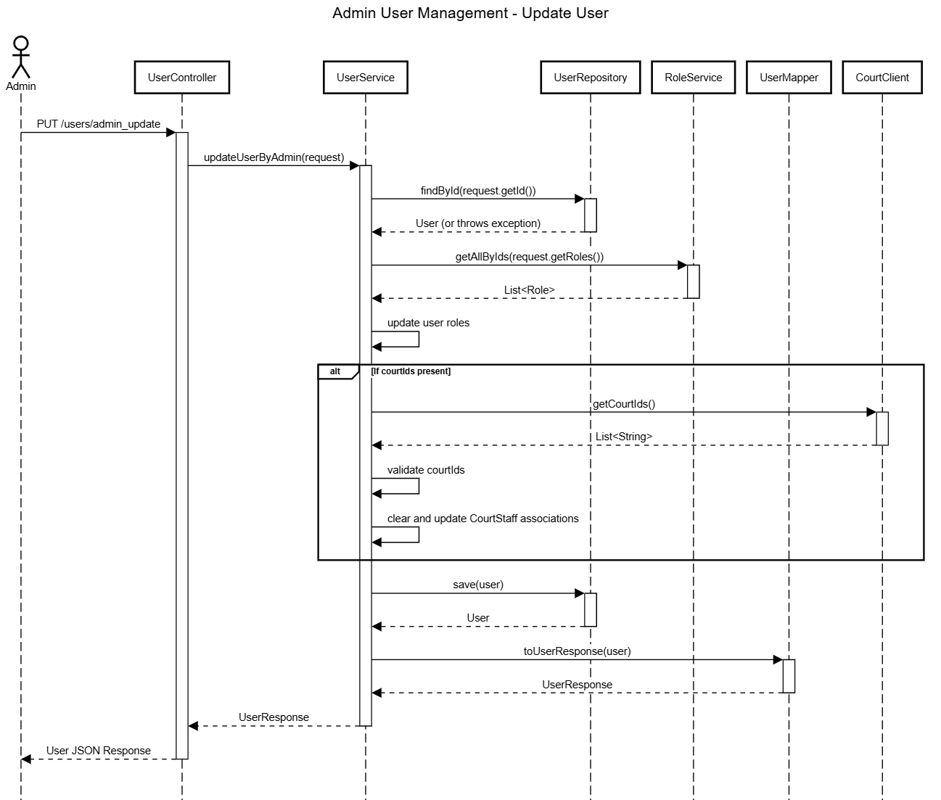

##### ***3.2.2.4.5 Delete User Flow***

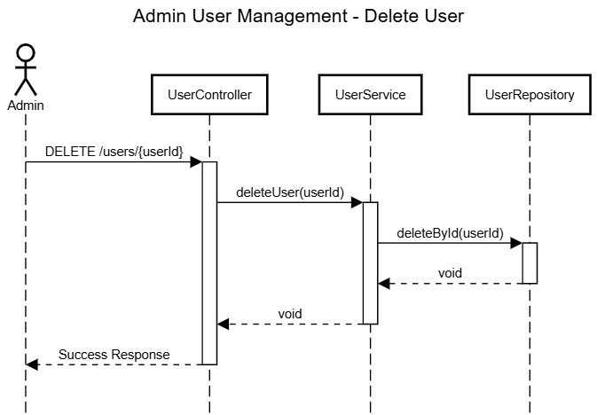

##### ***3.2.2.4.6 Activate/Deactivate User Flow***

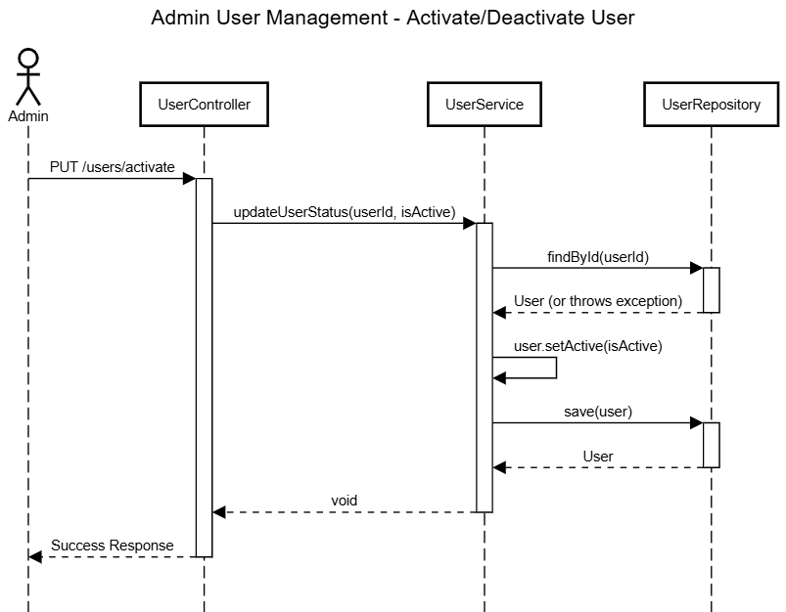

#### 3.2.3 Court management

##### ***3.2.3.1 Create court and Setup***

##### ***3.2.3.1.1 Class Diagram***

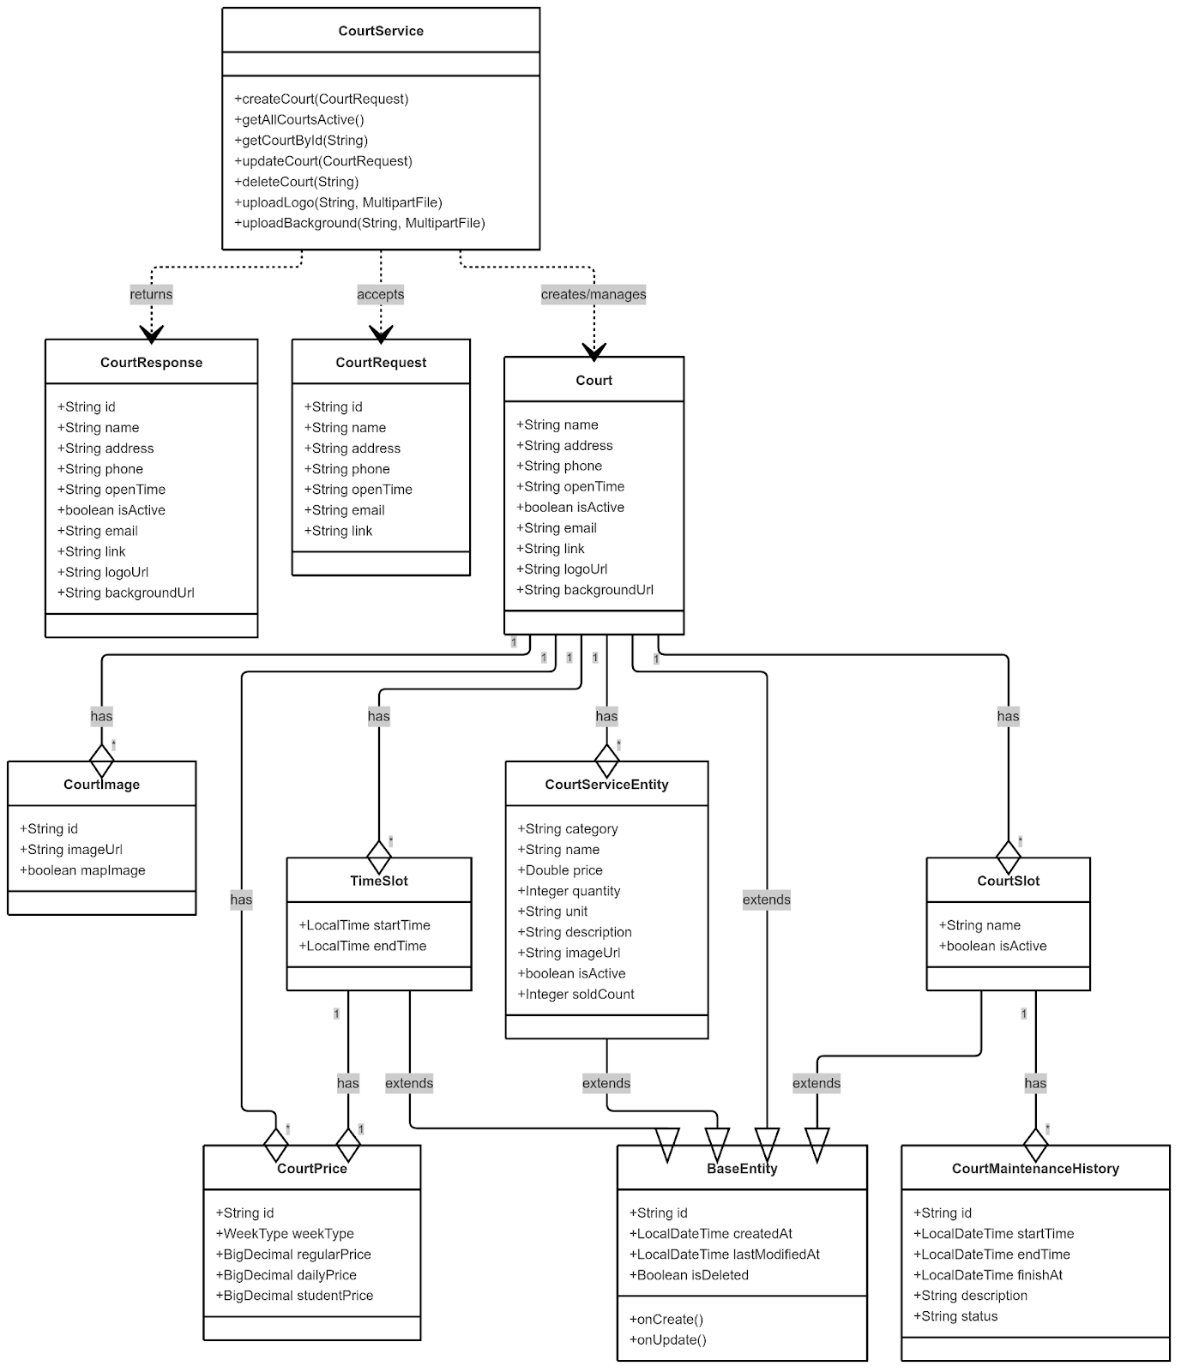

##### ***3.2.3.1.2 Sequence Diagram***

##### ***3.2.3.1.2.1 Create court***

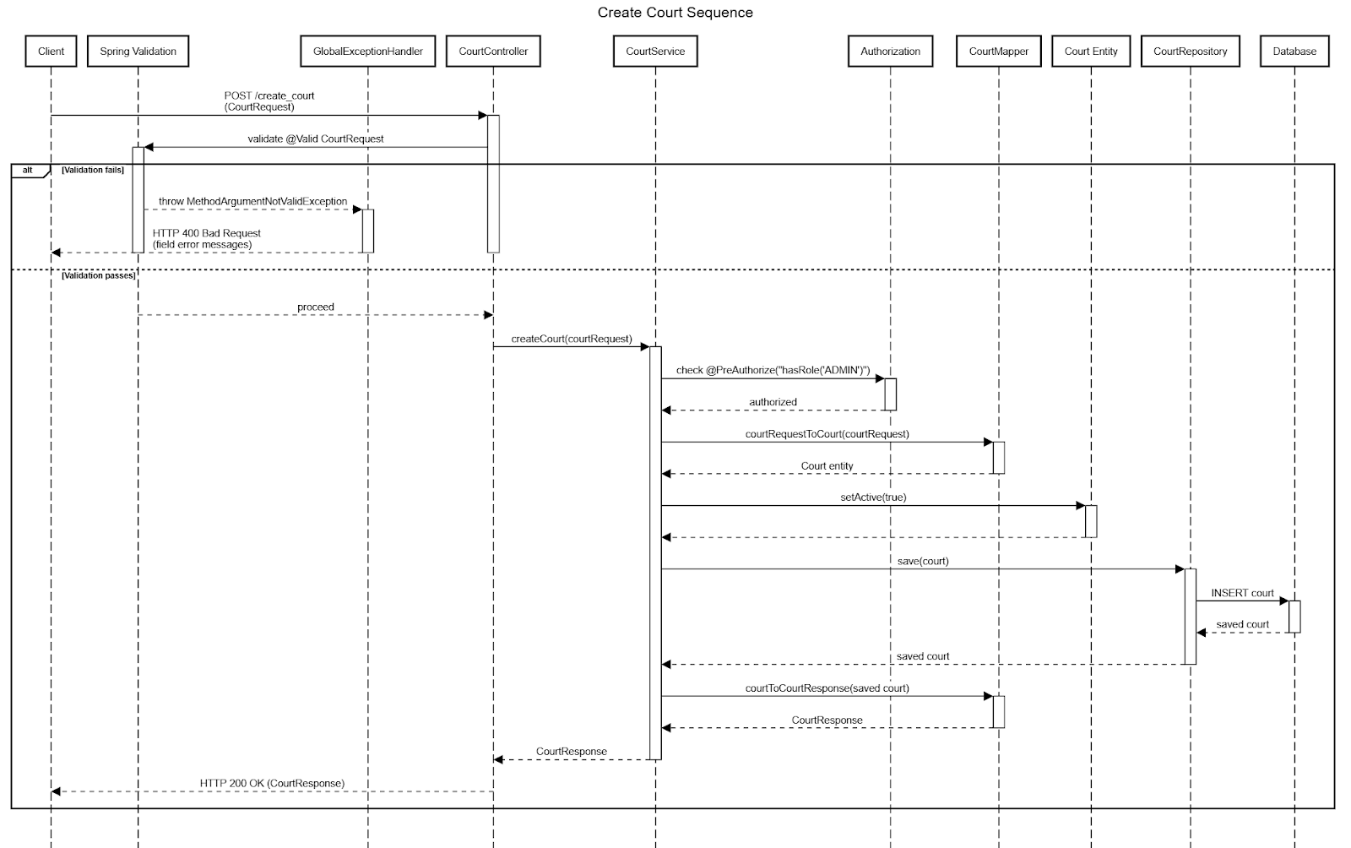

##### ***3.2.3.1.2.2 Court Image Upload***

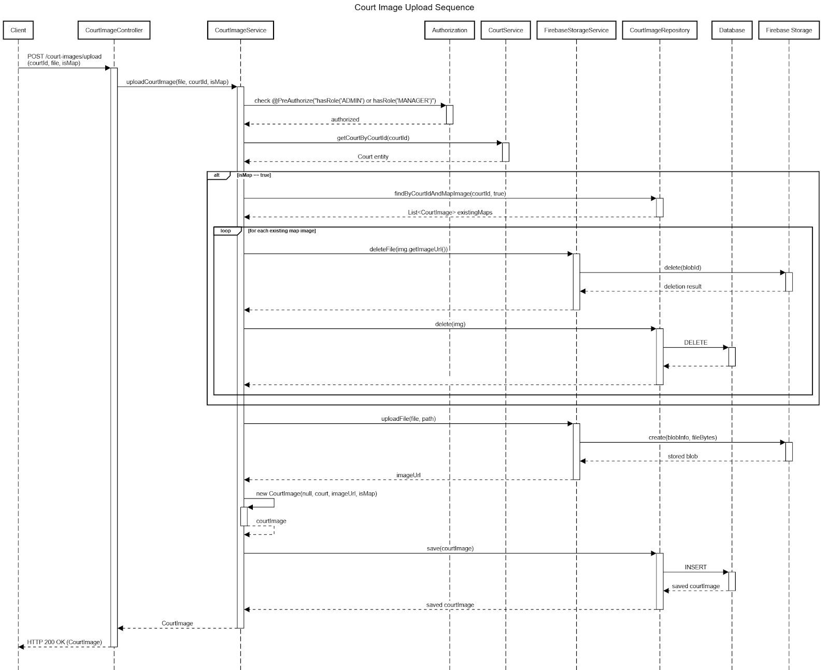

##### ***3.2.3.2 Court Slot Configuration***

##### ***3.2.3.2.1 Class Diagram***

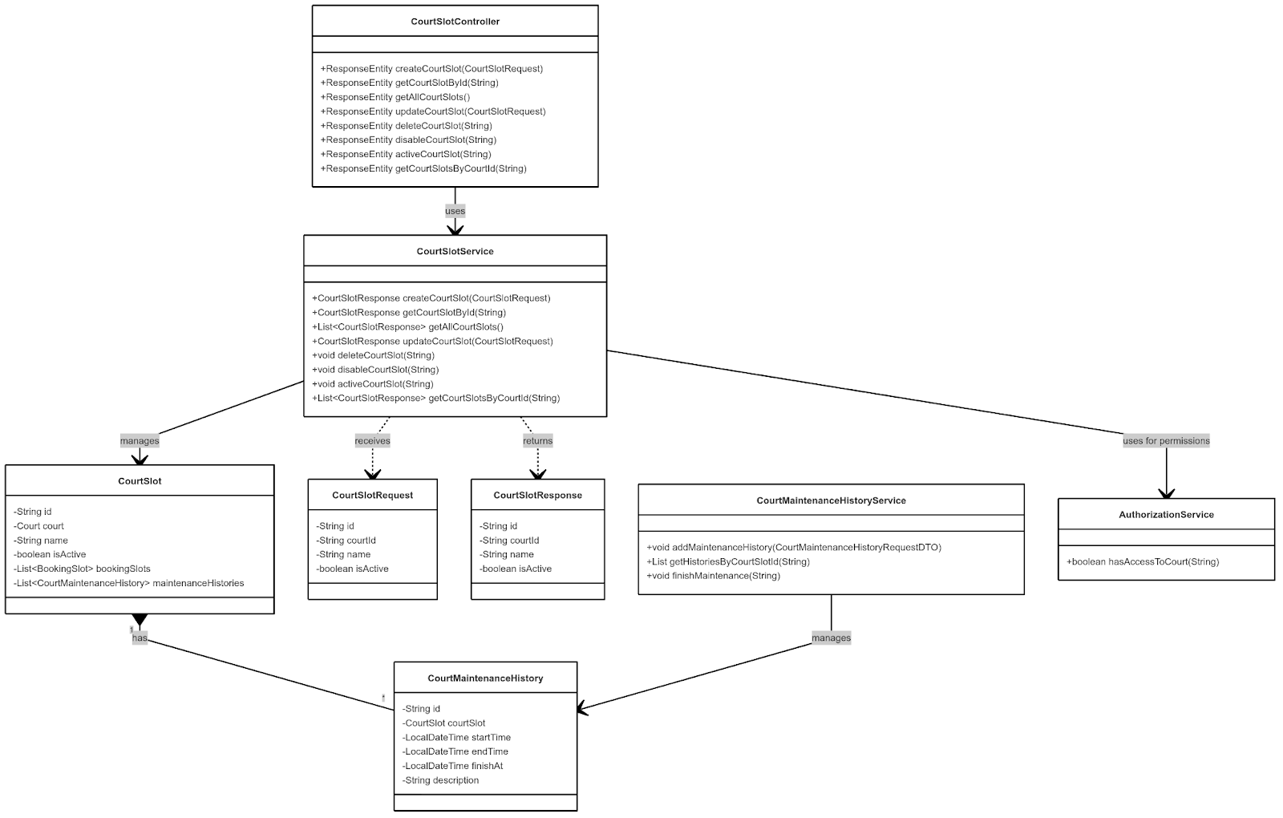

##### ***3.2.3.2.2 Sequence Diagram***

##### ***3.2.3.2.2.1 Court Slot Creation***

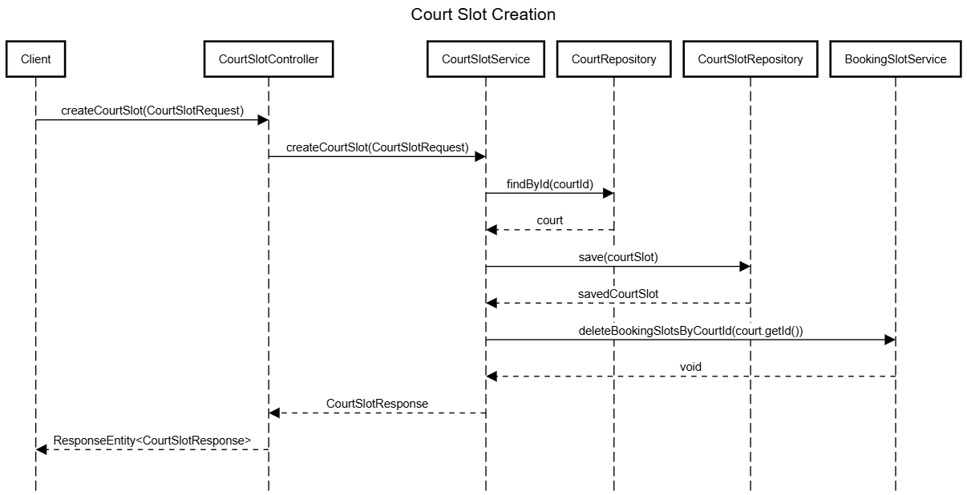

##### ***3.2.3.2.2 Court Maintenance Scheduling***

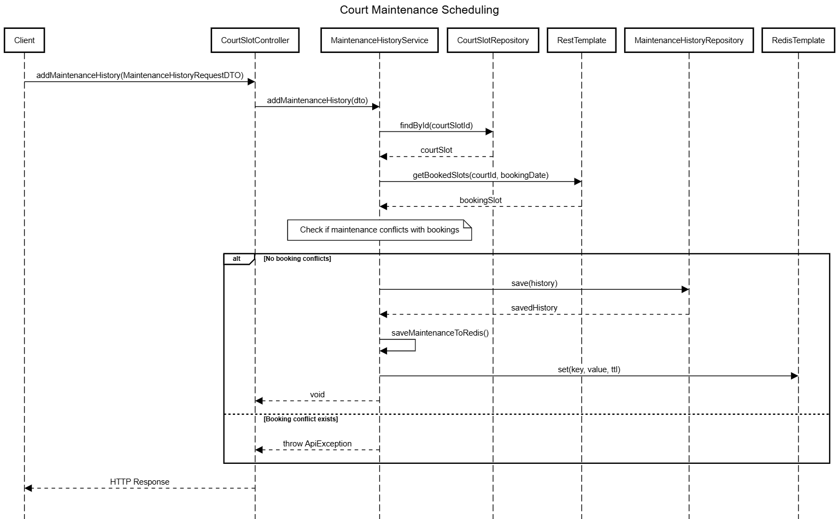

##### ***3.2.3.3 Court Availability Management***

##### ***3.2.3.3.1 Class Diagram***

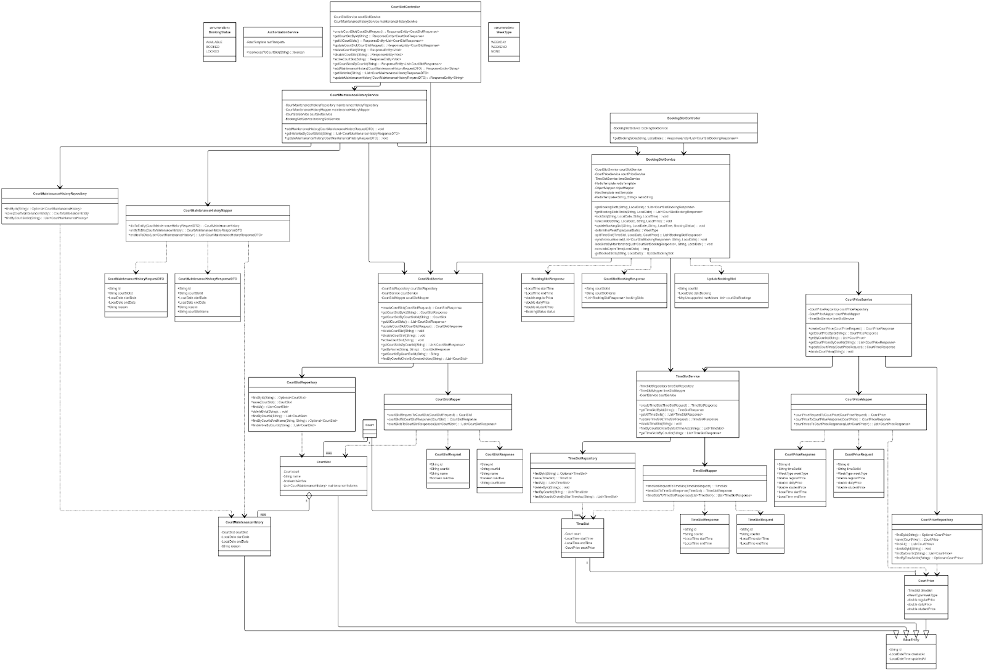

link image: https://iili.io/3E2o5B9.png

##### ***3.2.3.3.2 Sequence Diagram***

##### ***3.2.3.3.2.1 Update Booking Slots***

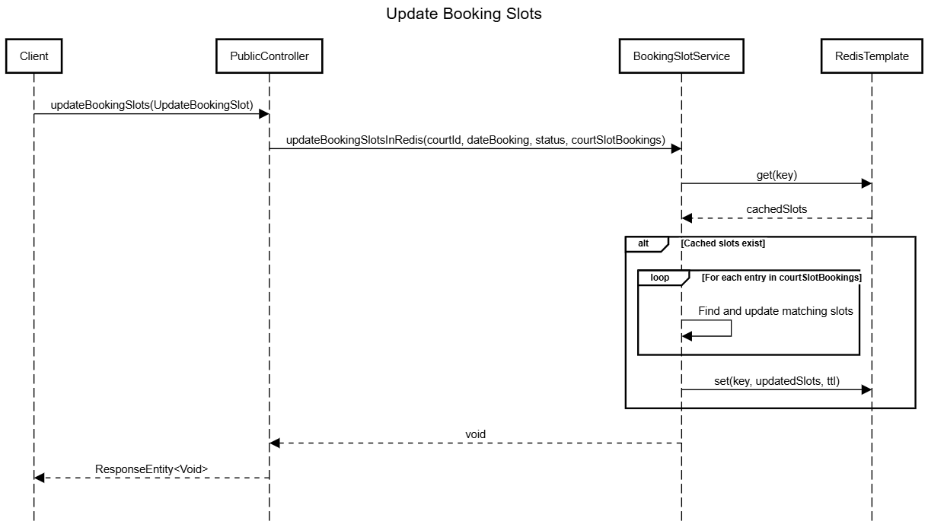

##### ***3.2.3.4 Court Pricing Structure***

##### ***3.2.3.4.1 Class Diagram***

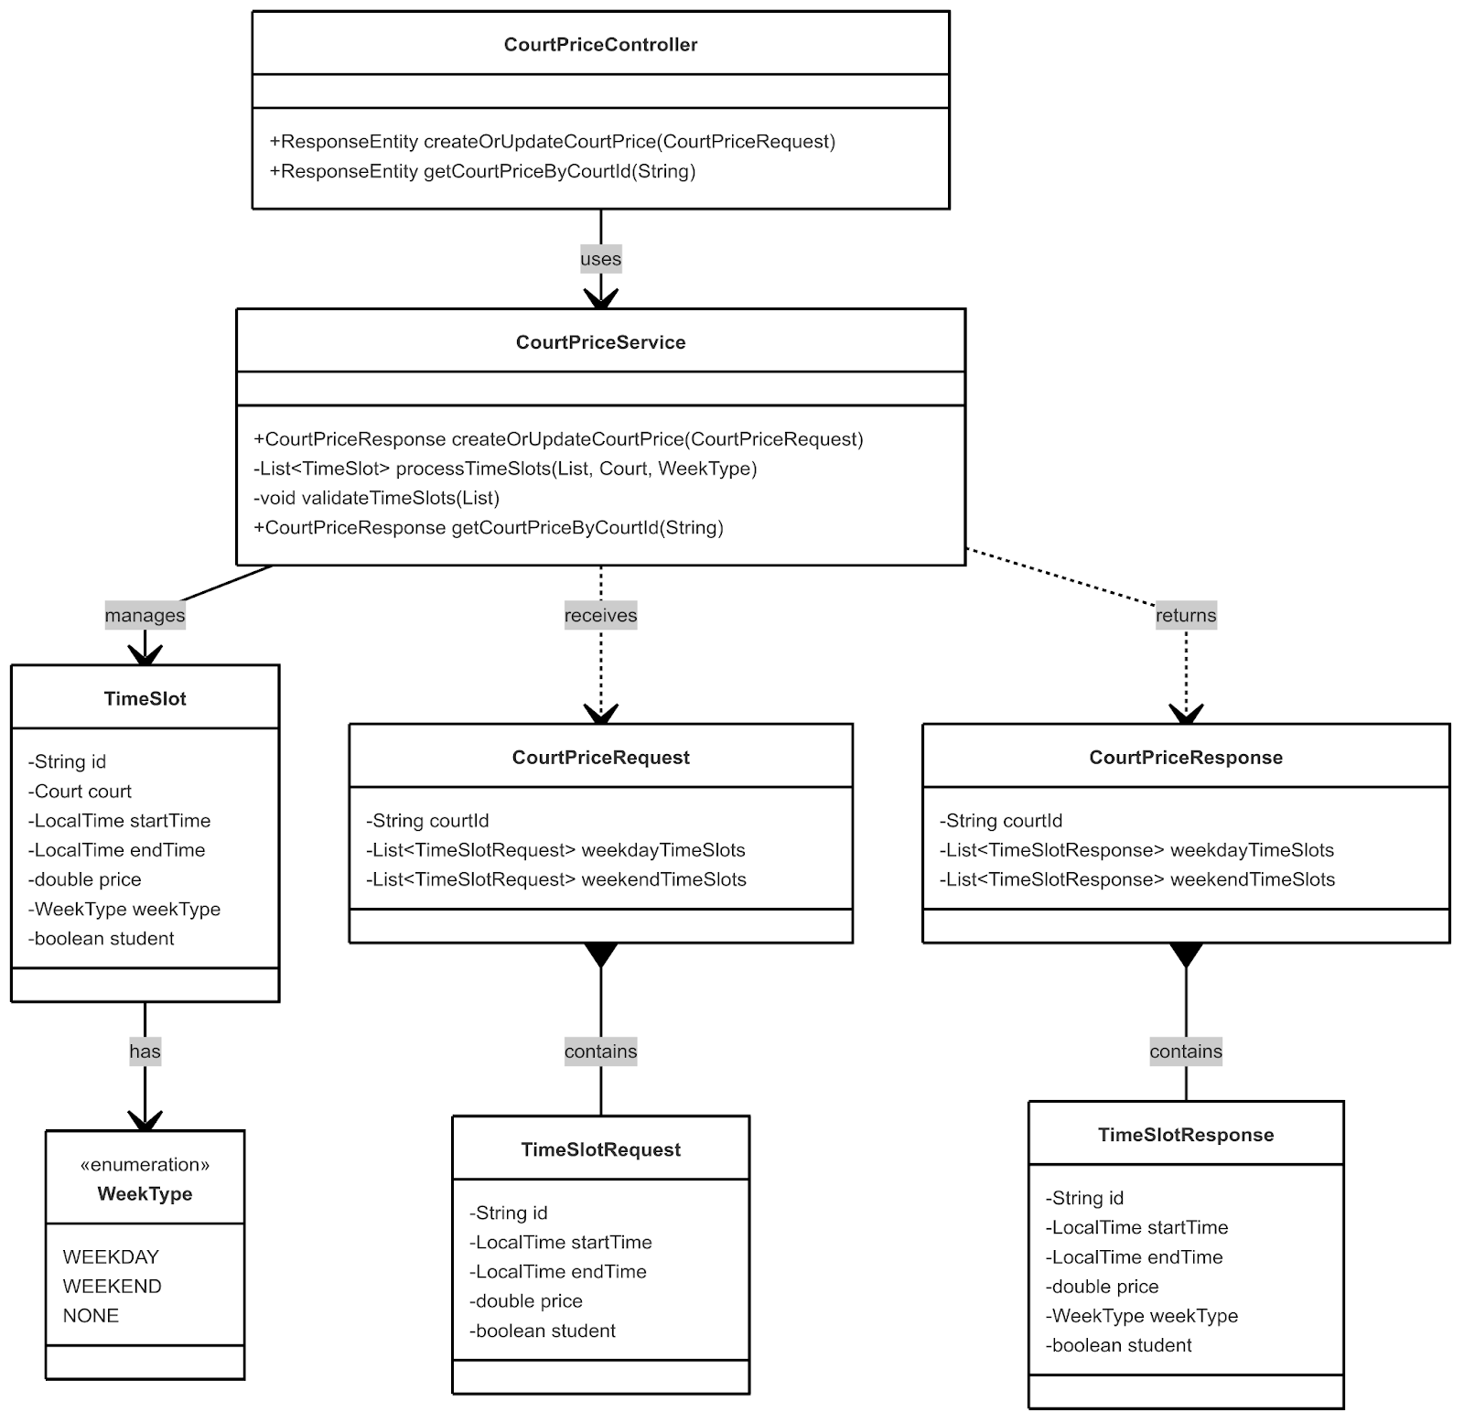

##### ***3.2.3.4.2 Sequence Diagram***

##### ***3.2.3.4.2.1 Court Price Configuration***

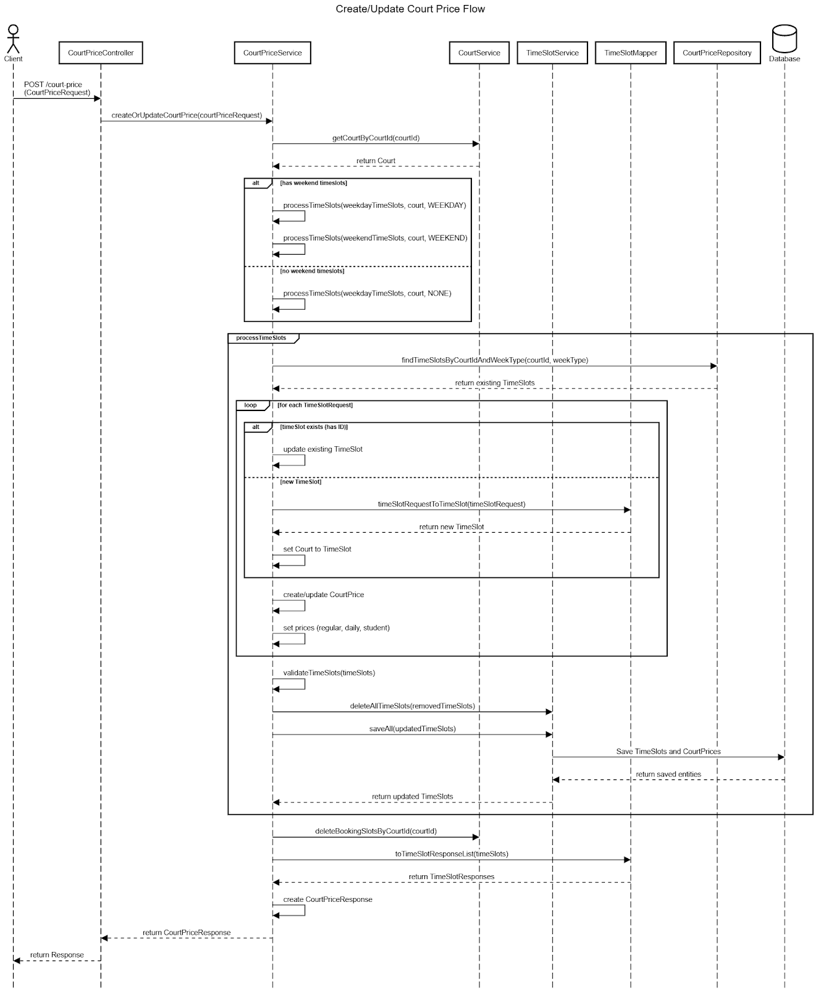

##### ***3.2.3.4.2.2 Get Court Prices***

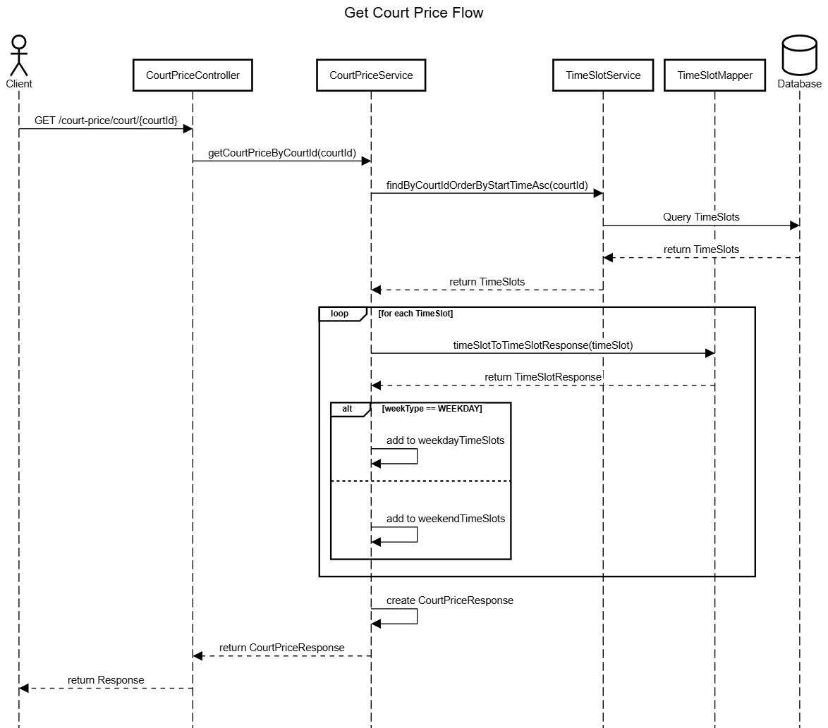

##### ***3.2.4 Booking System***

##### ***3.2.4.1 Daily Booking Creation Process***

##### ***3.2.4.1.1 Class Diagram***

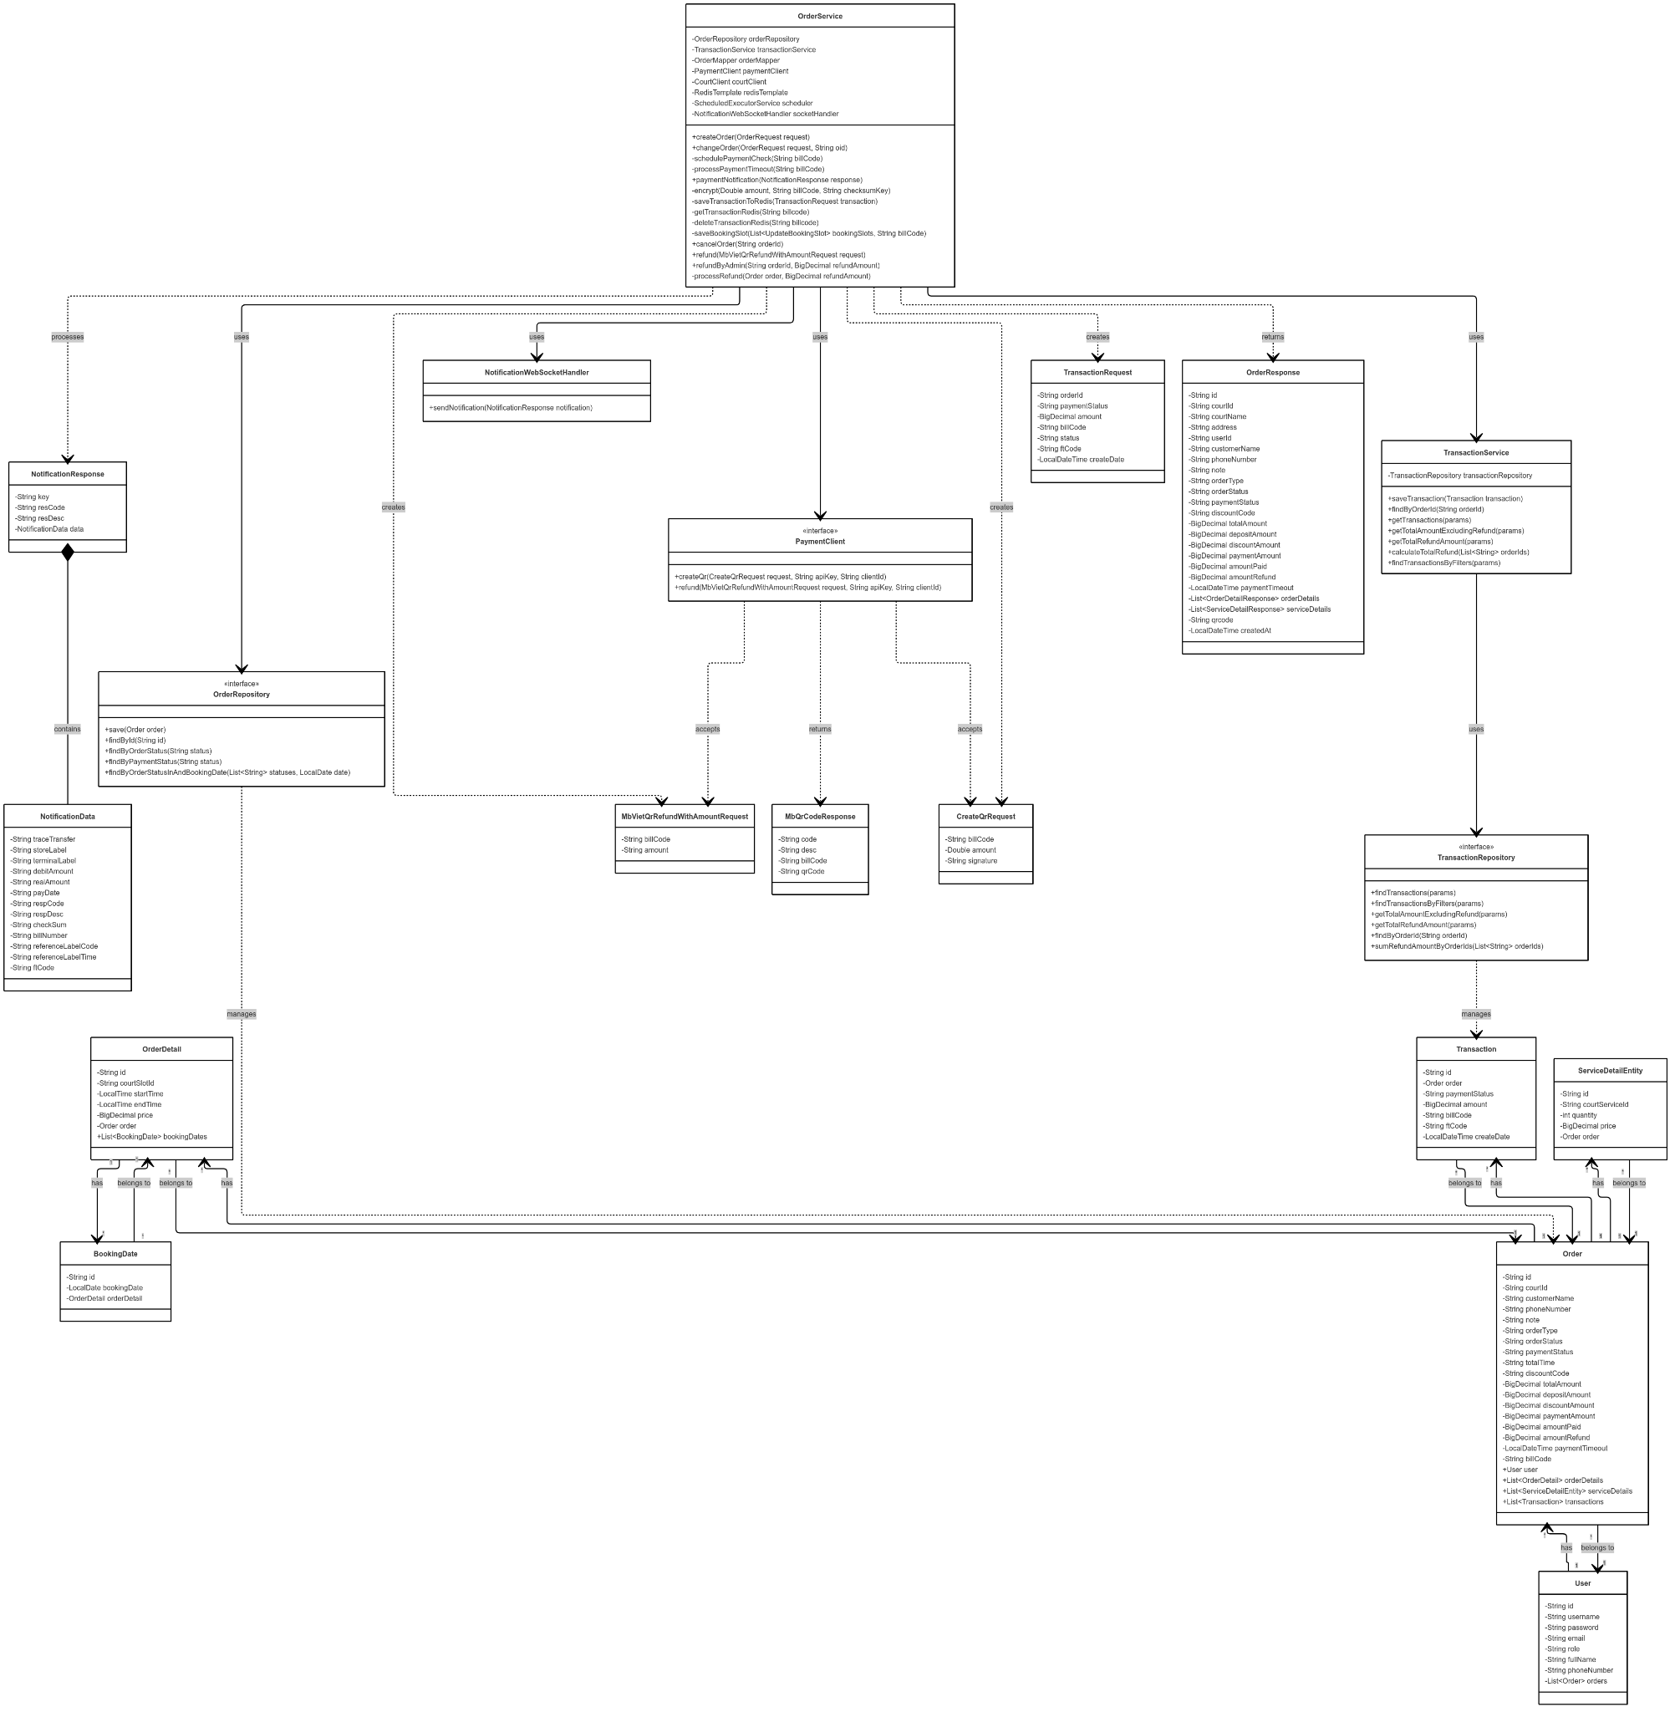

Link image: https://iili.io/3WUOWG9.png

##### ***3.2.4.1.2 Sequence Diagram***

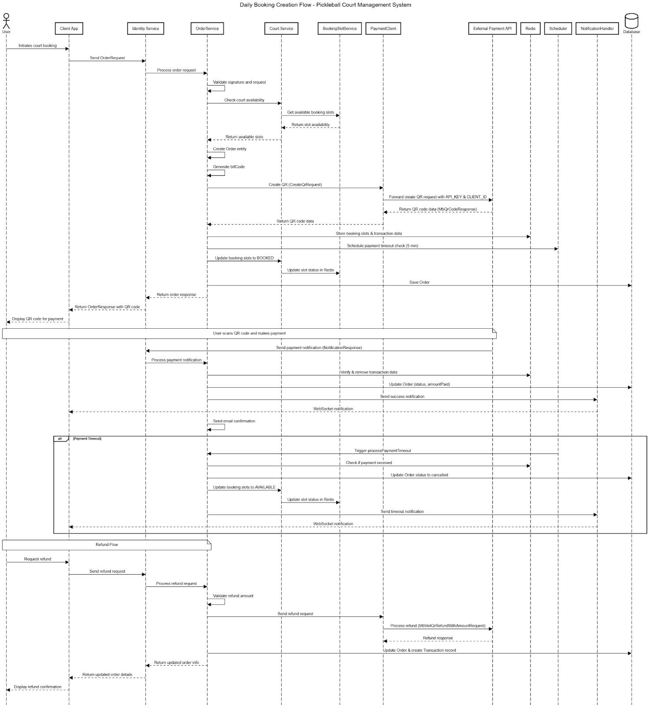

Link image: https://iili.io/3WXXkOl.png

##### 

##### ***3.2.4.2 Slot Availability Checking***

##### ***3.2.4.2.1 Class Diagram***

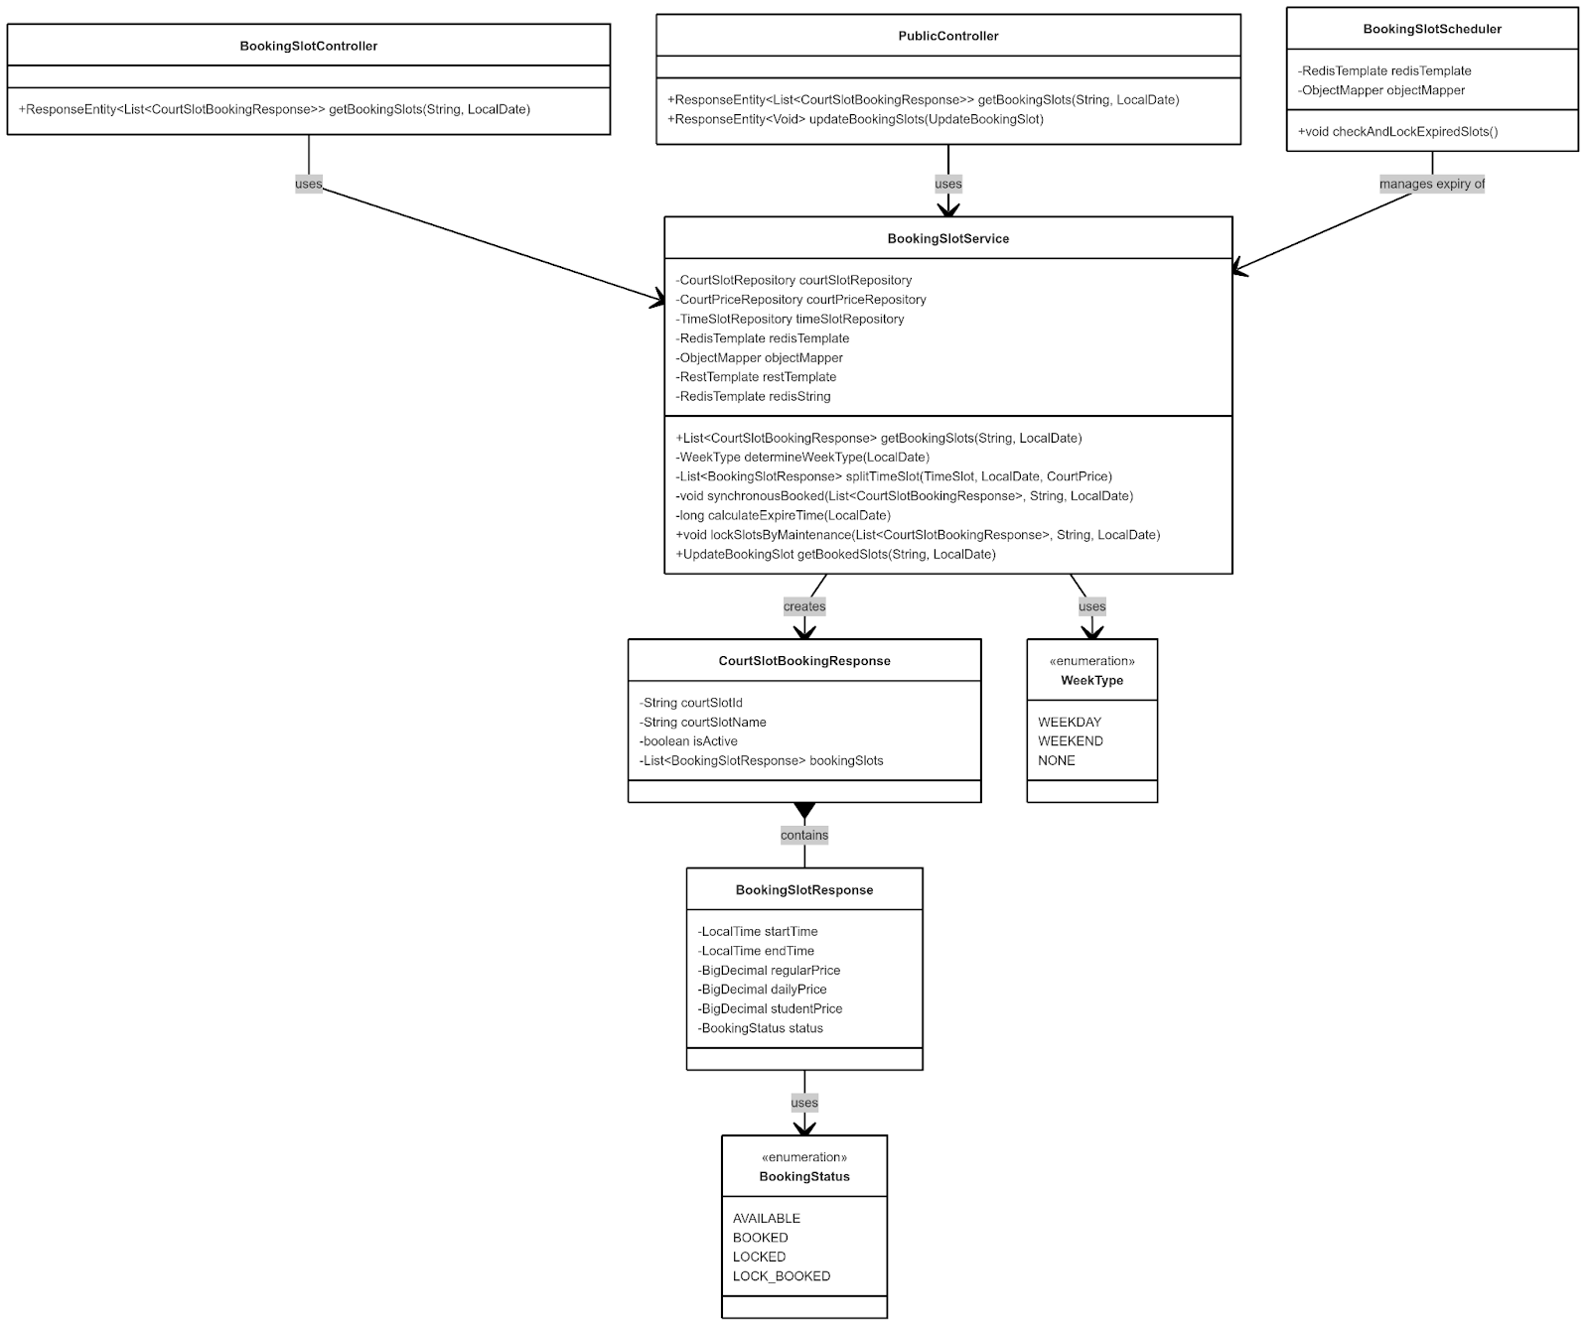

##### ***3.2.4.2.2 Sequence Diagram***

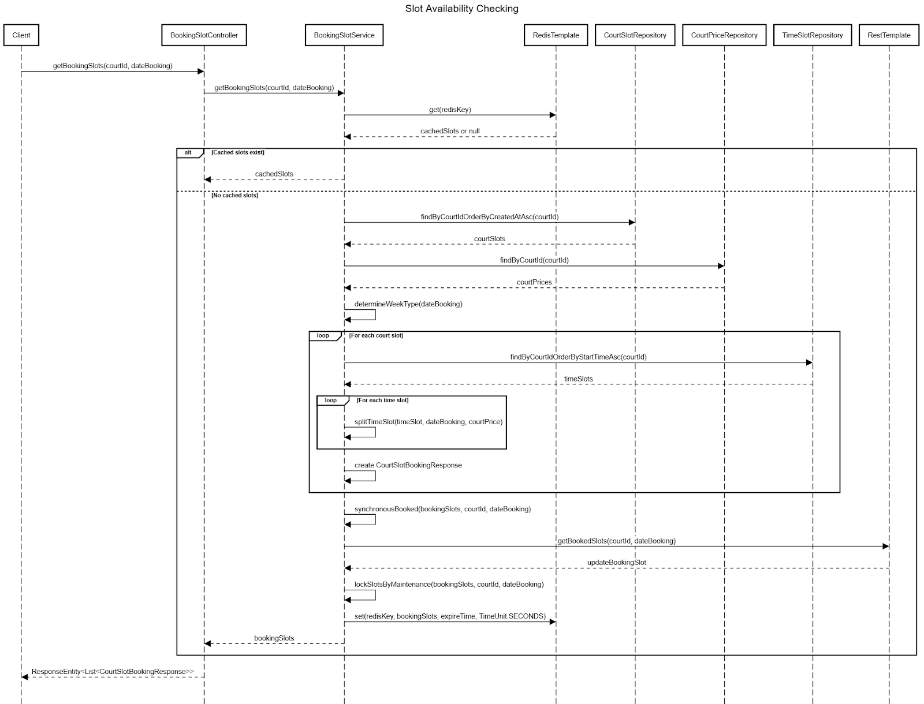

##### ***3.2.4.4 Booking Status Transitions***

##### ***3.2.4.4.1 Class Diagram***

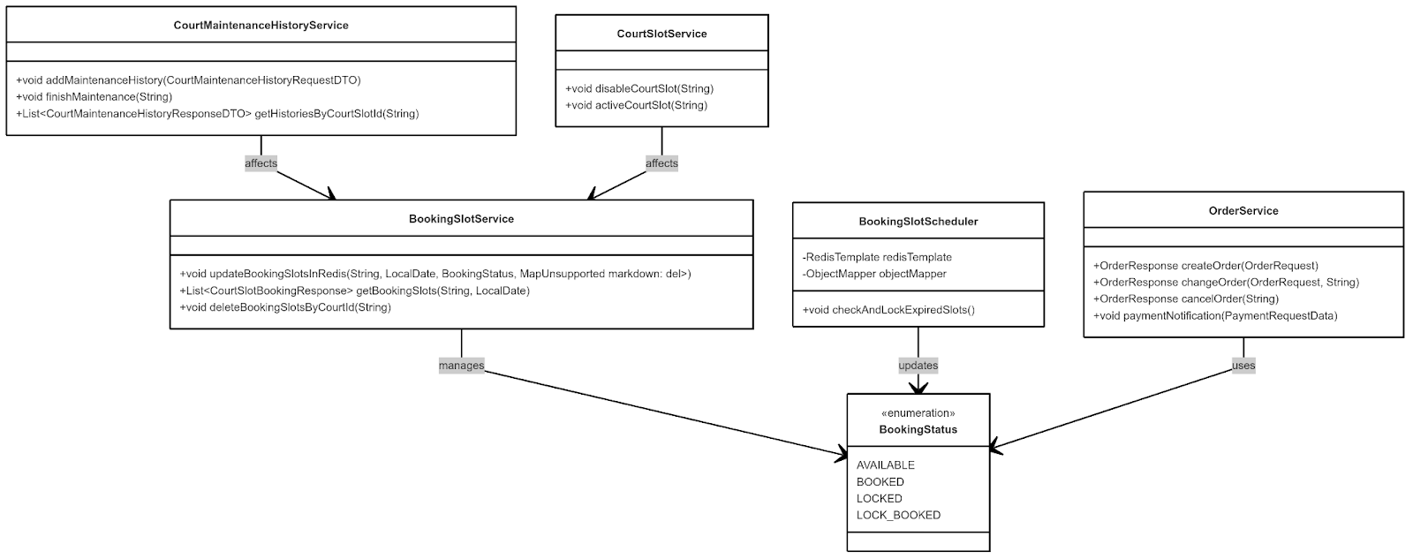

##### ***3.2.4.4.2 Sequence Diagram***

